CS practice project report template

Project Name: Wu Jing Movie Word Count

Your Name: Letian Andy Zhang

# Problem definition

## 1.1 What is the project about? (What is it? Why you want to do it? Possible applications)

To Count the words used in Wu Jing’s movies after Zhan Lang comments in Douban. It provide us an evaluation of movie watchers to Wu Jing, and it may explain his success.

## 1.2 What are the success criteria? (What are your goals that will guide you through design and implementation and can be evaluated)

The words in the word count are meaningful.

# Design overview

How to solve the problem in part 1? You need to design your software system, design about the input, process, and output parts.

Please list the Identifier tables if needed.

INPUT:

NONE

PROCESS

Describe your key algorithms in flowchart or pseudocode.

Key algorithm 1:

FOR i<-1 TO 7

Result=Cipintongji(WebSiteList)

Key algorithm2:

WORD=ReadWord(WebSite,Jieba)

WORDS<-WORDS+WORD

Key algorithm 3:

……

OUTPUT:

WORDCLOUD

# Implementation

List the key techniques used in your software, like arrays, searching, sorting, dictionaries, python modules (third-party, like matplotlib, numpy, scipy, sklearn etc.)

Tech #1:Jieba

Why you use tech 1 in your project?

To split Chinese words

How do you use it? Put your code screenshots here.



Tech #2: wordcloud

Why you use tech 2 in your project?

To show results in a intuitive way

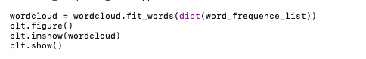How do you use it? Put your code screenshots here.

Tech #3: spider

Why you use tech 3 in your project?

To get comments from websites

How do you use it? Put your code screenshots here.

……

# Results

Show the outcomes/results of your projects

**I had results in a word cloud. However, I am unable to show it to you.**

1. **My OS got updated to macOS Catalina, which is not compatible with Anaconda, where my code runs properly.**
2. **IDLE won’t run my code for some reason, “unable to get local issuer certificate”**
3. **You can run it in Spyder in your computer**

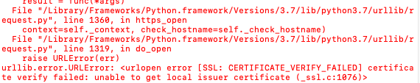

# Evaluation and conclusion

Evaluate the project based on your success criteria in Part 1.

Successful.

What is the conclusion of the project?

Turns out many people liked Wu Jing movies because they love their county!

# References

List all the materials you referred to.

NONE