Assignment 1

Class Diagram and Description

By Arion Barzoucas-Evans s3650046

Ya-Huai Lai (Loso) s3579161

# Class Diagram

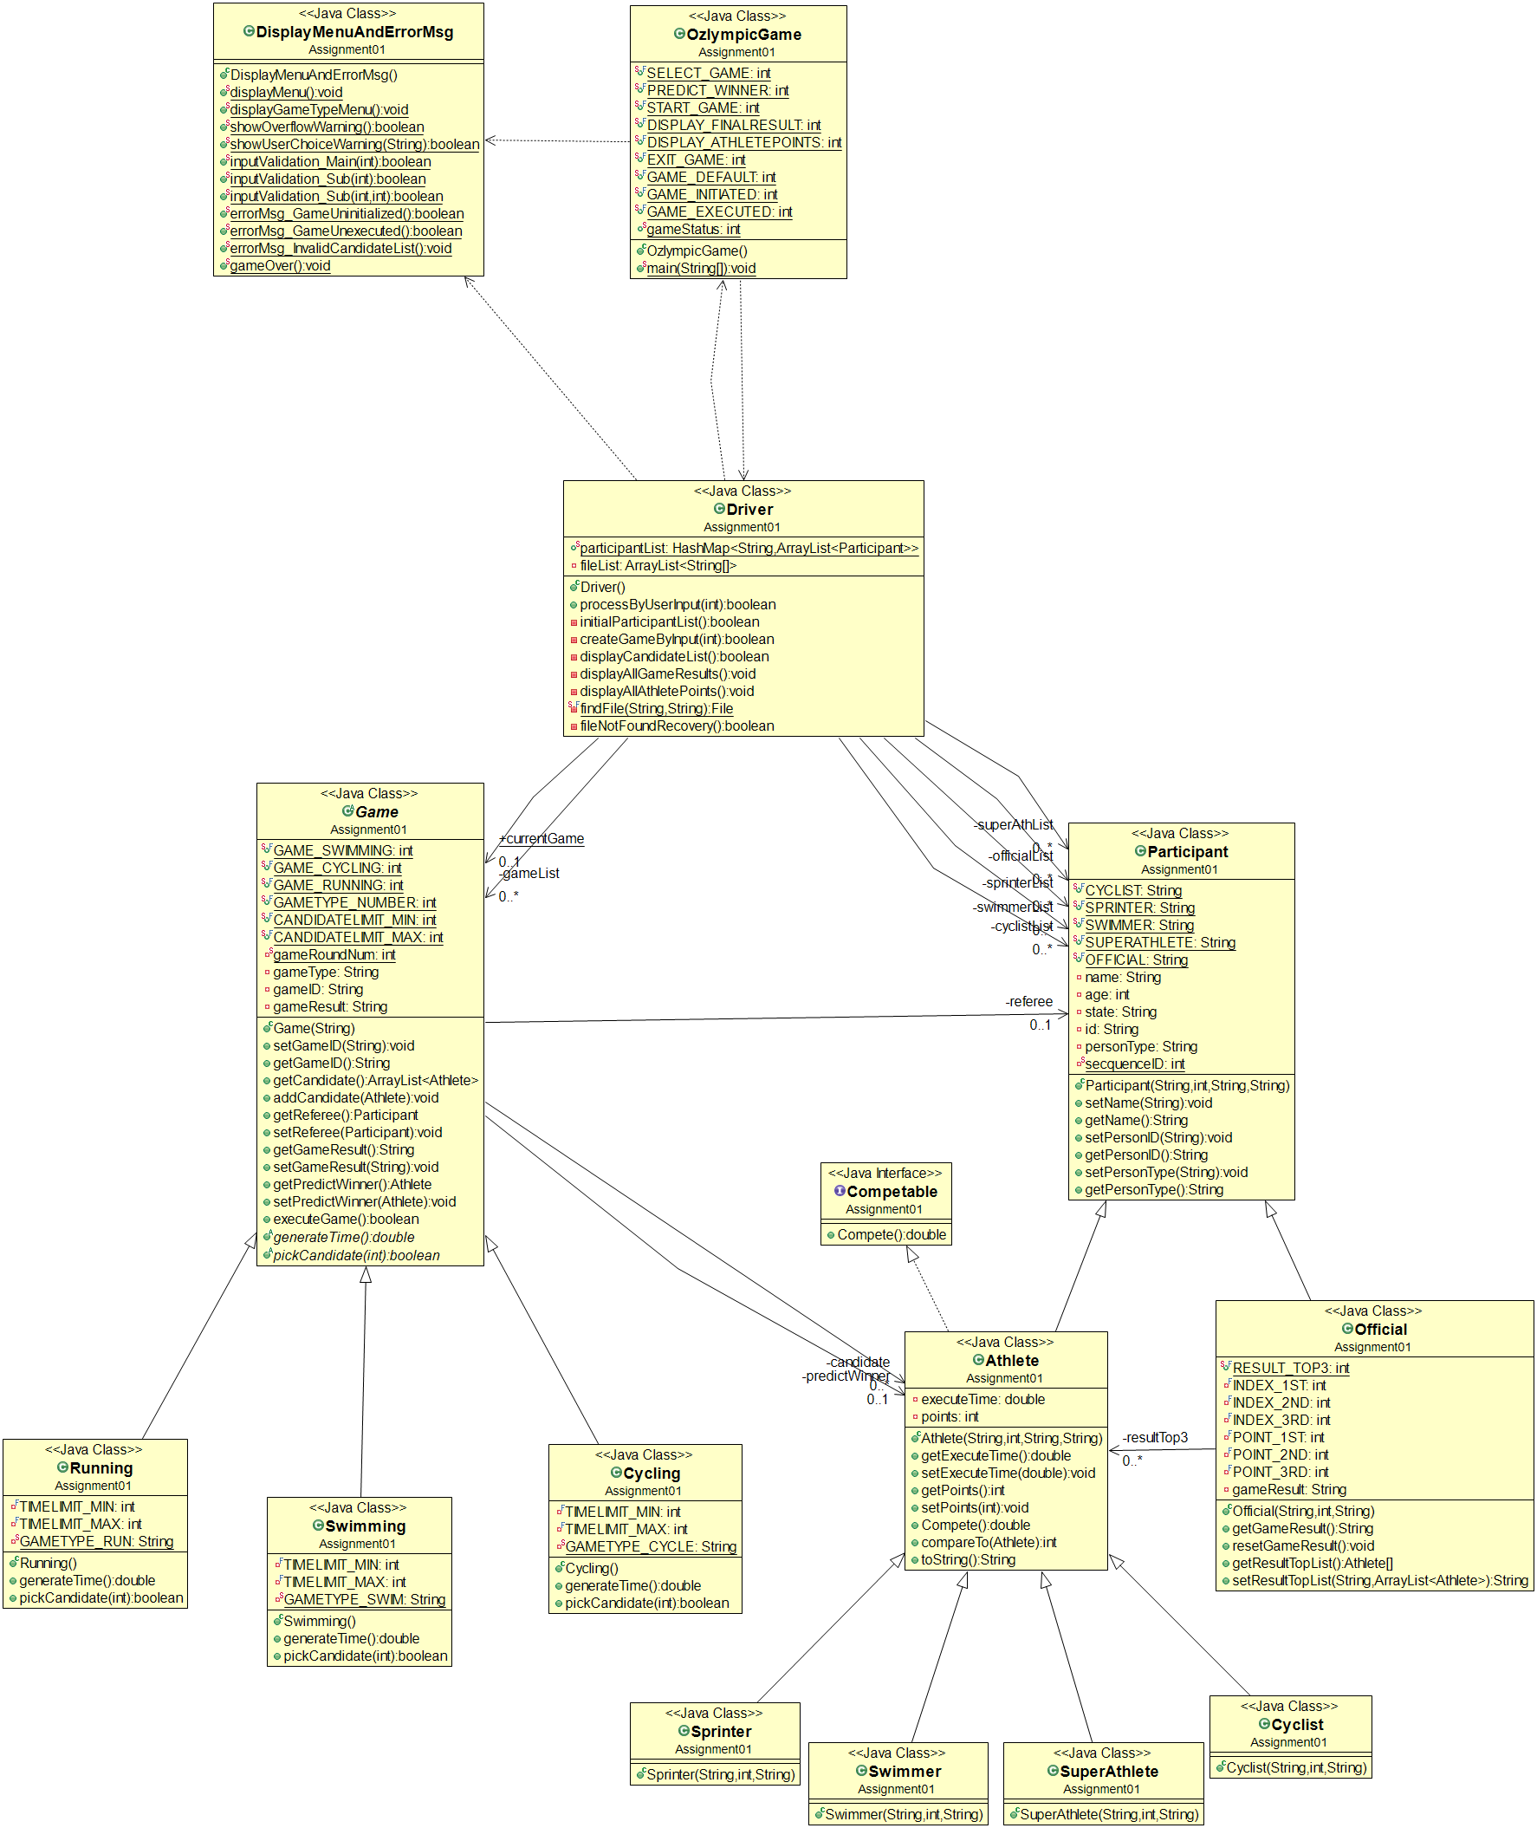

# Description

User interaction occurs in the Driver class. The user can select a game, make a prediction, start the game, check the final results of all games, and check the points of all athletes.

Information regarding the games, athletes, and user predictions are stored in the corresponding objects as well as the referee object.

The list of athletes and officials is imported through a csv file which is read by the Driver class. Only swimmers, sprinters, cyclists, super-athletes, and officials will be read into the program. The user has no control over object creation, other than through the set menu options.

The driver class manages the games through the Game and Participant classes. A different time is generated for each athlete in the appropriate Game subclass which is then stored in the corresponding Athlete object. The top three athletes are awarded points by the referee in the Official class in proportion to their position in the race. The points are also stored in the Athlete objects.

During the execution of each game, the user’s prediction is checked against the winner of the game. If the user is correct, a ‘Congratulations’ message is displayed. User input is entered through the Driver class and the prediction is checked in the appropriate Game subclass.

# Team Experience Feedback

***Arion***: This being my first ever group assignment, I could not have asked for a better team member. Loso is very experienced and has great coding technique as well as general programming knowledge. She helped me a lot during the course of this project and I have gained a lot of knowledge and experience thanks to her. She was easy to work with and very cooperative. Overall, it was a very positive experience.

***Loso*** : Actually I am impressed by Arion as I knew his major is in Mathematics and not IT or CS. He has great logic ability, could easily catch up with my design ideas and give me suggestions or push me to think further. Even though he does not have great coding technique, I could feel that he got very involved in our assignment. As a result, I am satisfied with our cooperation.