Assignment 3

1.

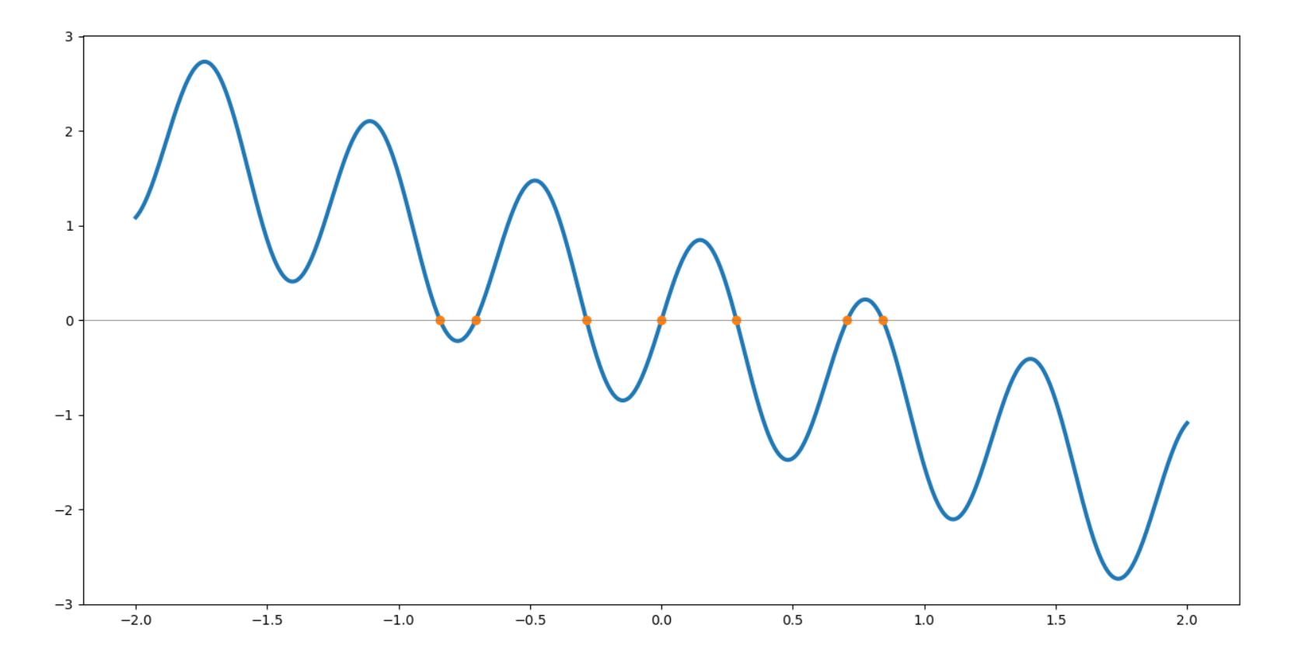

For this function f(x) = sin(10x)-x, there are 7 zeros.

2.

a).

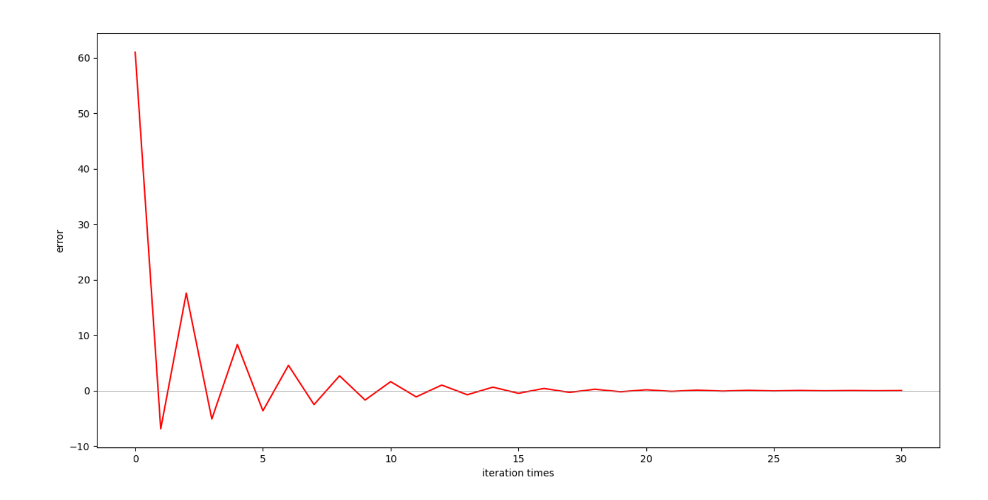

The errors for the odd iteration is negative, and it is getting close to zero when the odd iteration times goes up.

The errors for the even iteration is positive, and it is getting close to zero when the even iteration times goes up.

b).

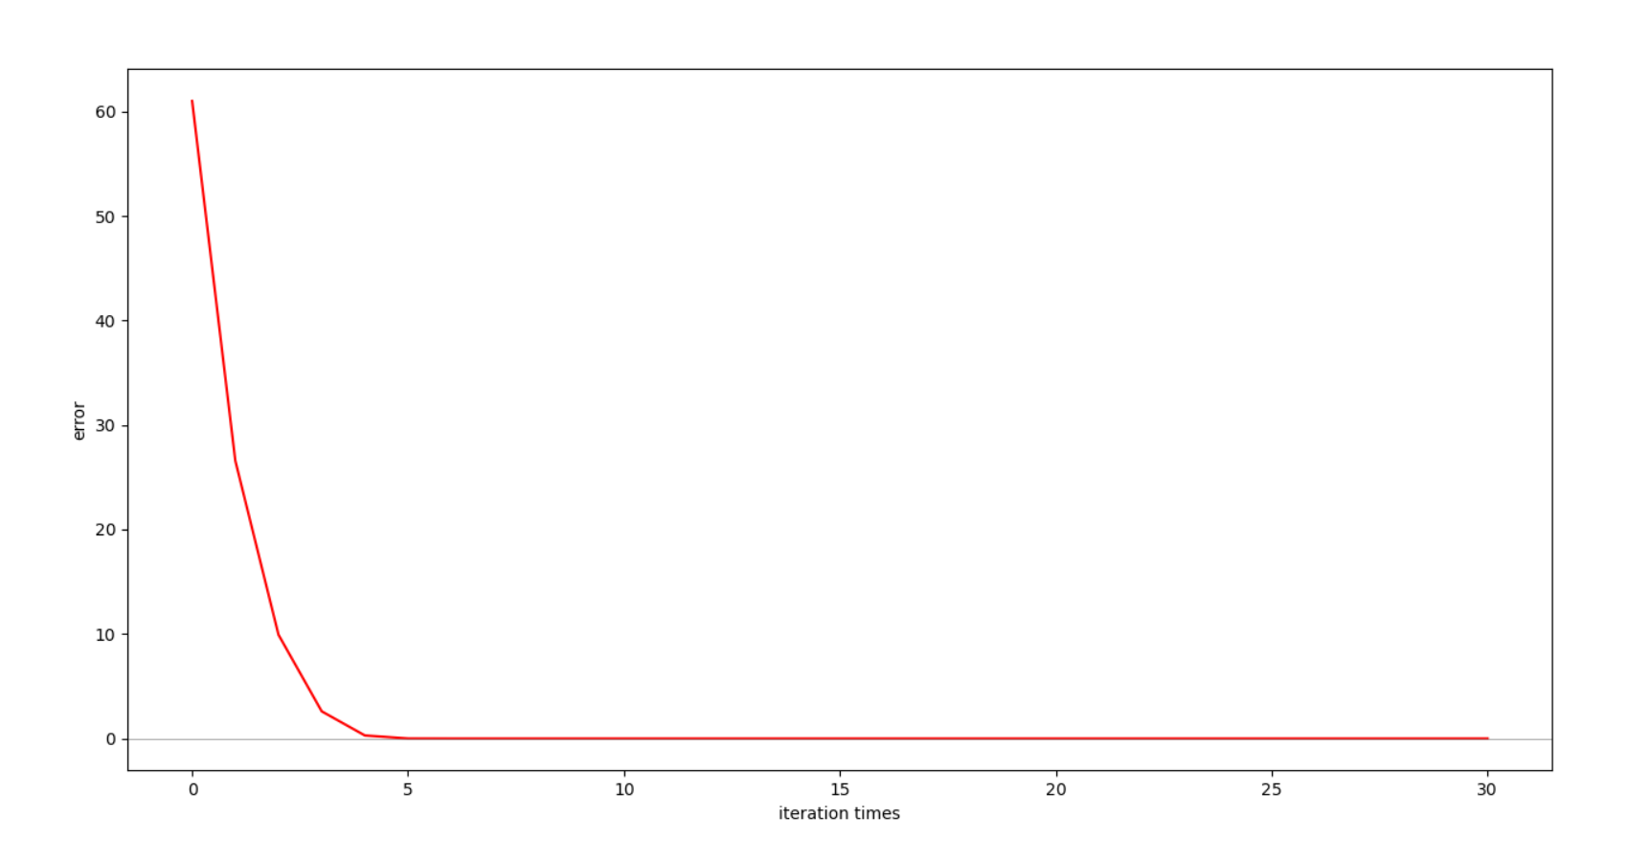

Comparing the plot for a) and the plot for b), we can easily find that the second algorithm converging fast.

The convergence rate of the second algorithm is quadratic.

