
Jira Printer

Thank you for downloading my program! I hope it will help you to make your life a little bit easier.

Preparation
At the time being there is no possibility to use Jira directly in the program. That is why you need to export your Jira Issues in a separate file.

- Log in your Jira account.
- Go to „Filters“ and choose or create a filter for your Jira Issues.
- Apply the filter of your choice.
- Go to „Export issues“ and choose „Export CSV (all fields)“.
- Save the file where you can find it.

That is it! Now you are ready to use the program. If you have problems exporting your issues, there is a screenshot in appendix to help you.

Export
- In Jira Printer program open your saved .csv file.
- Then choose a name to use for saving with „Save as“ button.
You will then see, that your name of choise is not directly used. As the program will save two separate files for stories and epic respectively, your name of choice will have „_stories“ and „_epics“ suffixes.
- Press „Export“ button.
- When the file is saved the program will aknowledge it.
The rendered Jira cards can be found under the names from the step 2. Open them in Browser of your choice and print the page.
Now you only need to cut them and you are done! I wish you successful planning!

Improvements
If you have ideas or suggestions to improve the program, I will be happy to hear it!

Appendix
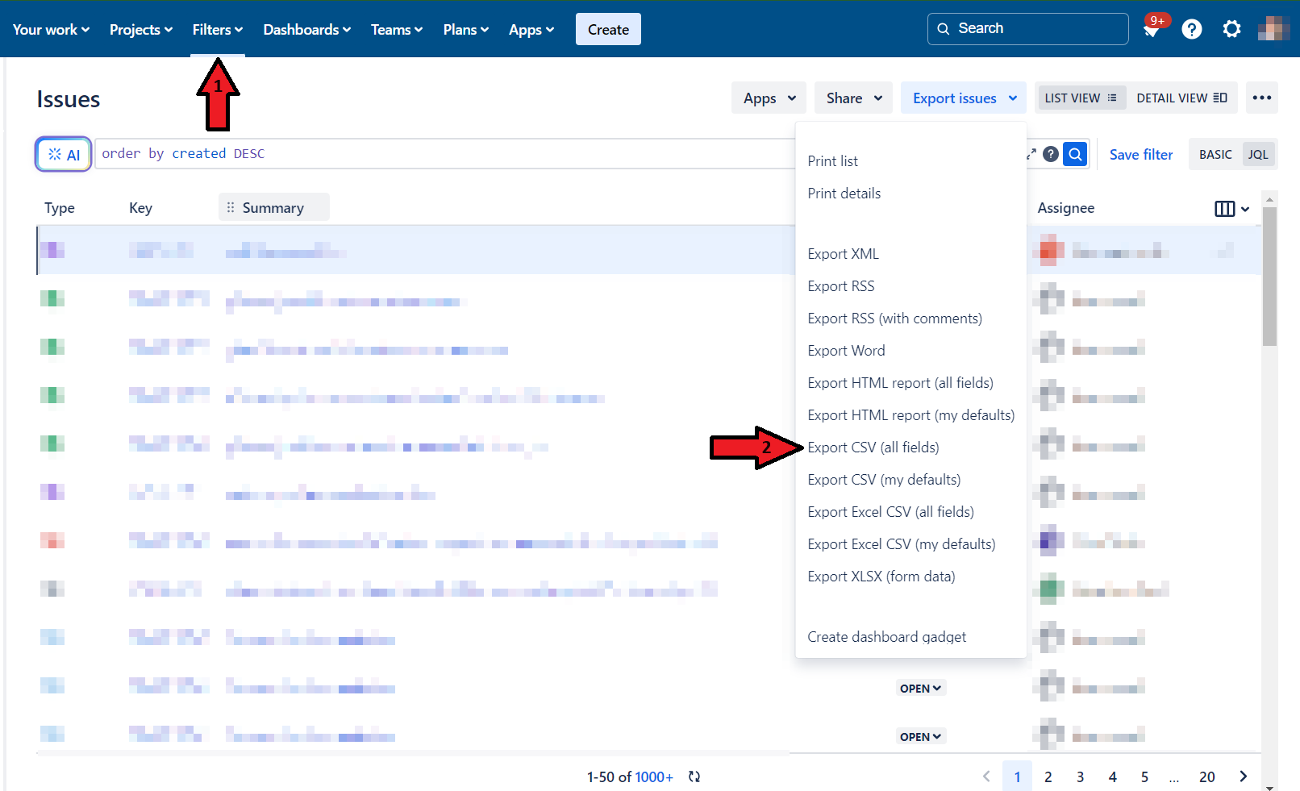
In the Jira software you can find Filters where the arrow 1 is pointing. After choosing and applying the filter, go to „Export issues“ and choose the options arrow 2 is pointing to. Save the file.

