ФЕДЕРАЛЬНОЕ ГОСУДАРСТВЕННОЕ АВТОНОМНОЕ ОБРАЗОВАТЕЛЬНОЕ УЧРЕЖДЕНИЕ ВЫСШЕГО ОБРАЗОВАНИЯ  
«РОССИЙСКИЙ УНИВЕРСИТЕТ ТРАНСПОРТА»  
(РУТ (МИИТ))

Институт транспортной техники и систем управления

Кафедра «Управление и защита информации»

ОТЧЁТ  
О ПРАКТИЧЕСКОЙ РАБОТЕ № 2

По дисциплине «Языки программирования»

Выполнил: ст. гр. ТКИ – 241

Байло А.В.

Проверил: к.т.н., доц.

Васильева М. А.

Москва 2023

**Задание:** Написать архитектуру Университета, содержащего классы группа, студент, преподаватель, дисциплина, с использованием Smart-pointers

**Код программы:**

#include "Teacher.h"

Teacher::Teacher(std::string name, std::string graduate)

:teacherName(name) , graduate(graduate), subject(nullptr)

{

}

std::shared_ptr<Subject> Teacher::getSubject()

{

return this->subject;

}

void Teacher::setSubject(std::shared_ptr<Subject> subject)

{

this->subject = subject;

}

void Teacher::setGroup(std::shared_ptr<Group> group)

{

this->groups.emplace_back(group);

}

std::ostream& operator<<(std::ostream& os, const Teacher& teacher)

{

return os << teacher.teacherName;

}

#pragma once

#include <string>

#include <iostream>

#include <memory>

#include <vector>

class Subject;

class Group;

/**

* @brief class Teacher

*

*/

class Teacher

{

public:

/**

* @brief Construct a new Teacher object

*

* @param name teacher's name

* @param graduate teacher's graduate

*/

Teacher(std::string name, std::string graduate);

/**

* @brief Get the Subject object taught by the teacher

*

* @return std::shared_ptr<Subject> a pointer to subject object

*/

std::shared_ptr<Subject> getSubject();

/**

* @brief Set the Subject object taught by the teacher

*

* @param subject pointer to Subject object to teach

*/

void setSubject(std::shared_ptr<Subject> subject);

/**

* @brief Set the Group object taught by the teacher

*

* @param group pointer to group object to teach

*/

void setGroup(std::shared_ptr<Group> group);

/**

* @brief overload << operator

*

* @param os output stream

* @param teacher teacher object to put into stream

* @return std::ostream& stream which contains teacher object

*/

friend std::ostream& operator<<(std::ostream& os, const Teacher& teacher);

private:

std::shared_ptr<Subject> subject;

const std::string teacherName;

std::string graduate;

std::vector<std::shared_ptr<Group>> groups;

};

#include "group.h"

#include <cinttypes>

#include <initializer_list>

#include <iostream>

#include <memory>

#include <string>

#include <vector>

Group::Group(std::string groupName)

:groupName(groupName)

{

}

void Group::addStudent(std::shared_ptr<Student>& student)

{

students.emplace_back(student);

student->setGroup(shared_from_this());

}

void Group::setSubject(std::shared_ptr<Subject> subject, std::shared_ptr<Teacher> teacher)

{

subjects.emplace_back(subject);

teacher->setGroup(shared_from_this());

}

std::ostream& operator<<(std::ostream& os,const Group& group)

{

os << group.groupName << "\n";

for(auto it = group.students.cbegin(); it < group.students.cend(); it++)

{

if(auto student = it->lock())

{

os << *it->lock() << "\n";

}

}

return os;

}

void Group::deleteStudent(std::shared_ptr<Student>& student)

{

for (auto it = students.cbegin();it < students.cend(); it++)

{

if (it->lock() == student)

{

students.erase(it);

}

}

student->setGroup(nullptr);

}

std::string Group::toString()

{

return groupName;

}

#include "student.h"

#include <initializer_list>

#include <memory>

#include <string>

#include <algorithm>

#include "subject.h"

#pragma once

class Subject;

class Student;

/**

* @brief class Group

*

*/

class Group

: public std::enable_shared_from_this<Group>

{

public:

/**

* @brief Construct a new Group object

*

* @param groupName group's name

*/

Group(std::string groupName);

/**

* @brief function which adds student to the group

*

* @param student pointer to student object to add

*/

void addStudent(std::shared_ptr<Student>& student);

/**

* @brief function which deletes student from group

*

* @param student pointer to student object to delete

*/

void deleteStudent(std::shared_ptr<Student>& student);

/**

* @brief Set the Subject object to the group

*

* @param subject pointer to subject object which to set

* @param teacher pointer to teacher object whict to set

*/

void setSubject(std::shared_ptr<Subject> subject, std::shared_ptr<Teacher> teacher);

/**

* @brief function which convert group object to std::string

*

* @return std::string group object

*/

std::string toString();

/**

* @brief overload << operator

*

* @param os output stream

* @param group group object to put into stream

* @return std::ostream& stream which contains group object

*/

friend std::ostream& operator<<(std::ostream& os,const Group& group);

private:

std::vector<std::weak_ptr<Student>> students;

std::string groupName;

std::vector<std::weak_ptr<Subject>> subjects;

};

#include "student.h"

#include <exception>

Student::Student(std::string studentName,size_t studentAge, size_t recordBookNumber)

:studentName(studentName) , age(studentAge) , recordBookNumber(recordBookNumber) , group(nullptr)

{

}

void Student::setGroup(std::shared_ptr<Group> group)

{

this->group = group;

}

std::ostream& operator<<(std::ostream& os, const Student& Student)

{

os << Student.studentName << "\t" << Student.age << "\t" << Student.recordBookNumber;

return os;

}

std::shared_ptr<Group> Student::getGroup()

{

return group;

}

#pragma once

#include <iostream>

#include <memory>

#include <string>

#include <vector>

class Group;

/**

* @brief class Student

*

*/

class Student

{

public:

/**

* @brief Construct a new Student object

*

* @param studentName student's name

* @param studentAge student's age

* @param recordBookNumber students's recordBookNumber

*/

Student(std::string studentName,size_t studentAge, size_t recordBookNumber);

/**

* @brief Set the Group object to student

*

* @param group pointer to the group to which the student belongs

*/

void setGroup(std::shared_ptr<Group> group);

/**

* @brief Get the Group object

*

* @return std::shared_ptr<Group> a pointer to the group to which the student belongs

*/

std::shared_ptr<Group> getGroup();

/**

* @brief overload << operator

*

* @param os output stream

* @param student student object to put into stream

* @return std::ostream& stream which contains student object

*/

friend std::ostream& operator<<(std::ostream& os, const Student& student);

private:

std::shared_ptr<Group> group;

std::string studentName;

size_t age;

size_t recordBookNumber;

};

#include "subject.h"

Subject::Subject(std::string subjectName)

:subjectName(subjectName)

{

}

void Subject::setTeacher(std::shared_ptr<Teacher>& teacher)

{

subjectTeachers.emplace_back(teacher);

teacher->setSubject(shared_from_this());

}

void Subject::deleteTeacher(std::shared_ptr<Teacher>& teacher)

{

for (auto it = subjectTeachers.cbegin();it < subjectTeachers.cend(); it++)

{

if (it->lock() == teacher)

{

subjectTeachers.erase(it);

}

}

teacher->setSubject(nullptr);

}

std::ostream& operator<<(std::ostream& os,const Subject& subject)

{

os << subject.subjectName << "\n";

for(auto it = subject.subjectTeachers.cbegin(); it < subject.subjectTeachers.cend(); it++)

{

if(auto teacher = it->lock())

{

os << *it->lock() << "\n";

}

}

return os;

}

#include "Teacher.h"

#include <memory>

#include <vector>

#pragma once

class Teacher;

/**

* @brief class Subject

*

*/

class Subject:public std::enable_shared_from_this<Subject>

{

public:

/**

* @brief Construct a new Subject object by its name

*

* @param subjectName name of the subject

*/

Subject(std::string subjectName);

/**

* @brief overload << operator

*

* @param os output stream

* @param subject subject object to put into stream

* @return std::ostream& stream which contains subject object

*/

friend std::ostream& operator<<(std::ostream& os,const Subject& subject);

/**

* @brief Set teacher to subject

*

* @param teacher teacher which teaches Subject

*/

void setTeacher(std::shared_ptr<Teacher>& teacher);

/**

* @brief delete Teacher from Subject (Subject may cantains more than 1 teacher)

*

* @param teacher a pointer to Teacher object to delete

*/

void deleteTeacher(std::shared_ptr<Teacher>& teacher);

private:

std::vector<std::weak_ptr<Teacher>> subjectTeachers;

const std::string subjectName;

};

**Тесты:**

#include <cstddef>

#include <iostream>

#include "group.h"

#include "group.cpp"

#include "student.h"

#include "student.cpp"

#include "subject.h"

#include "subject.cpp"

#include "Teacher.h"

#include "Teacher.cpp"

#include <gtest/gtest.h>

#include <memory>

class Student;

class Teacher;

class Subject;

class Group;

/**

* Tests consist of 3 parts

1) create a object and use some method

2) create actual and expected values

3) ASSERT

*

*/

TEST(GroupMetodsTest, addStudentTets)

{

Group defaultGroup ("TKI");

Student defaultStudent("Ivan" , 20 , 1234);

std::shared_ptr<Student> defaultSharedStudent = std::make_shared<Student>(defaultStudent);

std::shared_ptr<Group> defaultSharedGroup = std::make_shared<Group>(defaultGroup);

defaultSharedGroup->addStudent(defaultSharedStudent);

std::shared_ptr<Group> actual = defaultSharedGroup;

std::shared_ptr<Group> expected = defaultSharedStudent->getGroup();

ASSERT_EQ(actual, expected);

}

TEST(GroupMetodsTest, deleteStudentTest)

{

Group defaultGroup ("TKI");

Student defaultStudent("Ivan" , 20 , 1234);

std::shared_ptr<Student> defaultSharedStudent = std::make_shared<Student>(defaultStudent);

std::shared_ptr<Group> defaultSharedGroup = std::make_shared<Group>(defaultGroup);

defaultSharedGroup->addStudent(defaultSharedStudent);

defaultSharedGroup->deleteStudent(defaultSharedStudent);

std::shared_ptr<Group> actual = defaultSharedStudent->getGroup();

std::shared_ptr<Group> expected = nullptr;

std::string actualStr = defaultSharedGroup->toString();

std::string expectedStr = "TKI";

ASSERT_EQ(actual, expected);

ASSERT_EQ(actualStr, expectedStr);

}

TEST(GroupMetodsTest, setSubjectTest)

{

Teacher defaultTeacher("IvanIvanovich", "Doctor");

Group defaultGroup ("TKI");

Subject defaultSubject("Math");

std::shared_ptr<Teacher> defaultSharedTeacher = std::make_shared<Teacher>(defaultTeacher);

std::shared_ptr<Subject> defaultSharedSubject = std::make_shared<Subject>(defaultSubject);

std::shared_ptr<Group> defaultSharedGroup = std::make_shared<Group>(defaultGroup);

defaultSharedSubject->setTeacher(defaultSharedTeacher);

defaultSharedGroup->setSubject(defaultSharedSubject, defaultSharedTeacher);

std::shared_ptr<Group> actual = defaultSharedGroup;

std::shared_ptr<Group> expected = defaultSharedGroup;

ASSERT_EQ(actual, expected);

}

TEST(SubjectMetodsTest, setTeacherTest)

{

Teacher defaultTeacher("IvanIvanovich", "Doctor");

Subject defaultSubject("Math");

std::shared_ptr<Teacher> defaultSharedTeacher = std::make_shared<Teacher>(defaultTeacher);

std::shared_ptr<Subject> defaultSharedSubject = std::make_shared<Subject>(defaultSubject);

defaultSharedSubject->setTeacher(defaultSharedTeacher);

std::shared_ptr<Subject> actual = defaultSharedTeacher->getSubject();

std::shared_ptr<Subject> expected = defaultSharedSubject;

ASSERT_EQ(actual, expected);

}

TEST(SubjectMetodsTest, deleteTeacherTest)

{

Teacher defaultTeacher("IvanIvanovich", "Doctor");

Subject defaultSubject("Math");

std::shared_ptr<Teacher> defaultSharedTeacher = std::make_shared<Teacher>(defaultTeacher);

std::shared_ptr<Subject> defaultSharedSubject = std::make_shared<Subject>(defaultSubject);

defaultSharedSubject->setTeacher(defaultSharedTeacher);

defaultSharedSubject->deleteTeacher(defaultSharedTeacher);

std::shared_ptr<Subject> actual = defaultSharedTeacher->getSubject();

std::shared_ptr<Subject> expected = nullptr;

ASSERT_EQ(actual, expected);

}

int main(int argc, char **argv)

{

testing::InitGoogleTest(&argc, argv);

return RUN_ALL_TESTS();

}

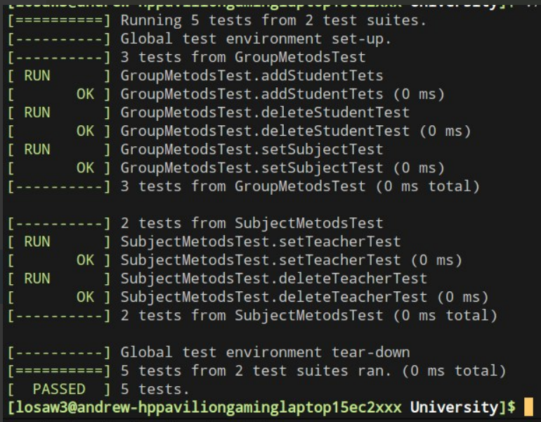

Рисунок 1 – прохождение тестов

**Uml- диаграмма**

Рисунок 2 – Uml-диаграмма проекта



Рисунок 3 – approve задания