ОТЧЕТ
По дисциплине «Основы информационной безопасности»
Студента специалитета 2 курса группы БИСО-03-19
Юсупова Константина Максимовича
РТУ МИРЭА 2020
Практика №3

Задание 1.
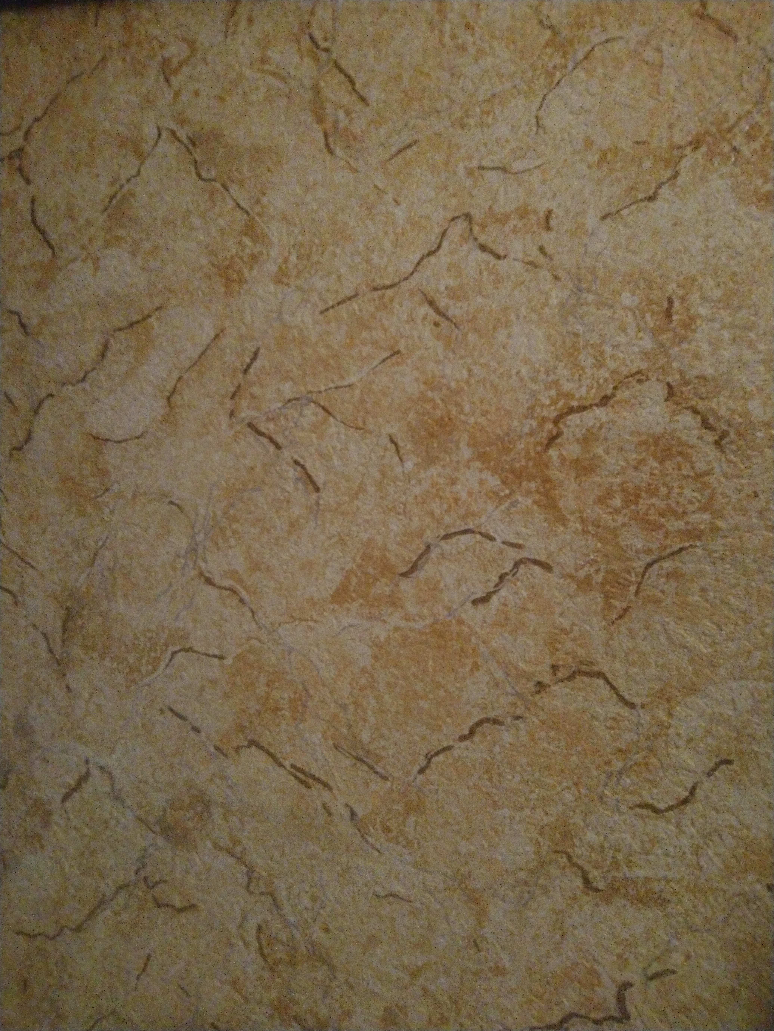
Мною была сделана фотография стены со включенным геотегом. Вот данные Exif:
create | 2020-10-11T20:40:54+00:00
ApertureValue | 200/100
BrightnessValue | -143/100
ColorSpace | 1
ComponentsConfiguration | 1, 2, 3, 0
DateTime | 2020:10:11 23:38:01
DateTimeDigitized | 2020:10:11 23:38:01
DateTimeOriginal | 2020:10:11 23:38:01
ExifImageLength | 4144
ExifImageWidth | 5520
ExifOffset | 186
ExifVersion | 48, 50, 50, 48
ExposureMode | 0
ExposureProgram | 0
ExposureTime | 1/33
Flash | 24
FlashPixVersion | 48, 49, 48, 48
FNumber | 200/100
FocalLength | 4220/1000
FocalLengthIn35mmFilm | 24
GPSDateStamp | 2020:10:11
GPSImgDirection | 12/1
GPSImgDirectionRef | M
GPSInfo | 667
GPSTimeStamp | 20/1, 38/1, 1/1
InteroperabilityIndex | R98
InteroperabilityOffset | 637
InteroperabilityVersion | 48, 49, 48, 48
ISOSpeedRatings | 678
Make | QCOM-AA
MeteringMode | 1
Model | QCAM-AA
Orientation | 6
ResolutionUnit | 2
SceneCaptureType | 0
SceneType | 1
SensingMethod | 2
ShutterSpeedValue | 5059/1000
SubSecTime | 658961
SubSecTimeDigitized | 658961
SubSecTimeOriginal | 658961
WhiteBalance | 0
XResolution | 72/1
YCbCrPositioning | 1
YResolution | 72/1
modify | 2020-10-11T20:40:54+00:00
ApertureValue | 200/100
BrightnessValue | -143/100
ColorSpace | 1
ComponentsConfiguration | 1, 2, 3, 0
DateTime | 2020:10:11 23:38:01
DateTimeDigitized | 2020:10:11 23:38:01
DateTimeOriginal | 2020:10:11 23:38:01
ExifImageLength | 4144
ExifImageWidth | 5520
ExifOffset | 186
ExifVersion | 48, 50, 50, 48
ExposureMode | 0
ExposureProgram | 0
ExposureTime | 1/33
Flash | 24
FlashPixVersion | 48, 49, 48, 48
FNumber | 200/100
FocalLength | 4220/1000
FocalLengthIn35mmFilm | 24
GPSDateStamp | 2020:10:11
GPSImgDirection | 12/1
GPSImgDirectionRef | M
GPSInfo | 667
GPSTimeStamp | 20/1, 38/1, 1/1
InteroperabilityIndex | R98
InteroperabilityOffset | 637
InteroperabilityVersion | 48, 49, 48, 48
ISOSpeedRatings | 678
Make | QCOM-AA
MeteringMode | 1
Model | QCAM-AA
Orientation | 6
ResolutionUnit | 2
SceneCaptureType | 0
SceneType | 1
SensingMethod | 2
ShutterSpeedValue | 5059/1000
SubSecTime | 658961
SubSecTimeDigitized | 658961
SubSecTimeOriginal | 658961
WhiteBalance | 0
XResolution | 72/1
YCbCrPositioning | 1
YResolution | 72/1
colorspace | 2
ApertureValue | 200/100
BrightnessValue | -143/100
ColorSpace | 1
ComponentsConfiguration | 1, 2, 3, 0
DateTime | 2020:10:11 23:38:01
DateTimeDigitized | 2020:10:11 23:38:01
DateTimeOriginal | 2020:10:11 23:38:01
ExifImageLength | 4144
ExifImageWidth | 5520
ExifOffset | 186
ExifVersion | 48, 50, 50, 48
ExposureMode | 0
ExposureProgram | 0
ExposureTime | 1/33
Flash | 24
FlashPixVersion | 48, 49, 48, 48
FNumber | 200/100
FocalLength | 4220/1000
FocalLengthIn35mmFilm | 24
GPSDateStamp | 2020:10:11
GPSImgDirection | 12/1
GPSImgDirectionRef | M
GPSInfo | 667
GPSTimeStamp | 20/1, 38/1, 1/1
InteroperabilityIndex | R98
InteroperabilityOffset | 637
InteroperabilityVersion | 48, 49, 48, 48
ISOSpeedRatings | 678
Make | QCOM-AA
MeteringMode | 1
Model | QCAM-AA
Orientation | 6
ResolutionUnit | 2
SceneCaptureType | 0
SceneType | 1
SensingMethod | 2
ShutterSpeedValue | 5059/1000
SubSecTime | 658961
SubSecTimeDigitized | 658961
SubSecTimeOriginal | 658961
WhiteBalance | 0
XResolution | 72/1
YCbCrPositioning | 1
YResolution | 72/1
sampling-factor | 2x2,1x1,1x1
ApertureValue | 200/100
BrightnessValue | -143/100
ColorSpace | 1
ComponentsConfiguration | 1, 2, 3, 0
DateTime | 2020:10:11 23:38:01
DateTimeDigitized | 2020:10:11 23:38:01
DateTimeOriginal | 2020:10:11 23:38:01
ExifImageLength | 4144
ExifImageWidth | 5520
ExifOffset | 186
ExifVersion | 48, 50, 50, 48
ExposureMode | 0
ExposureProgram | 0
ExposureTime | 1/33
Flash | 24
FlashPixVersion | 48, 49, 48, 48
FNumber | 200/100
FocalLength | 4220/1000
FocalLengthIn35mmFilm | 24
GPSDateStamp | 2020:10:11
GPSImgDirection | 12/1
GPSImgDirectionRef | M
GPSInfo | 667
GPSTimeStamp | 20/1, 38/1, 1/1
InteroperabilityIndex | R98
InteroperabilityOffset | 637
InteroperabilityVersion | 48, 49, 48, 48
ISOSpeedRatings | 678
Make | QCOM-AA
MeteringMode | 1
Model | QCAM-AA
Orientation | 6
ResolutionUnit | 2
SceneCaptureType | 0
SceneType | 1
SensingMethod | 2
ShutterSpeedValue | 5059/1000
SubSecTime | 658961
SubSecTimeDigitized | 658961
SubSecTimeOriginal | 658961
WhiteBalance | 0
XResolution | 72/1
YCbCrPositioning | 1
YResolution | 72/1

