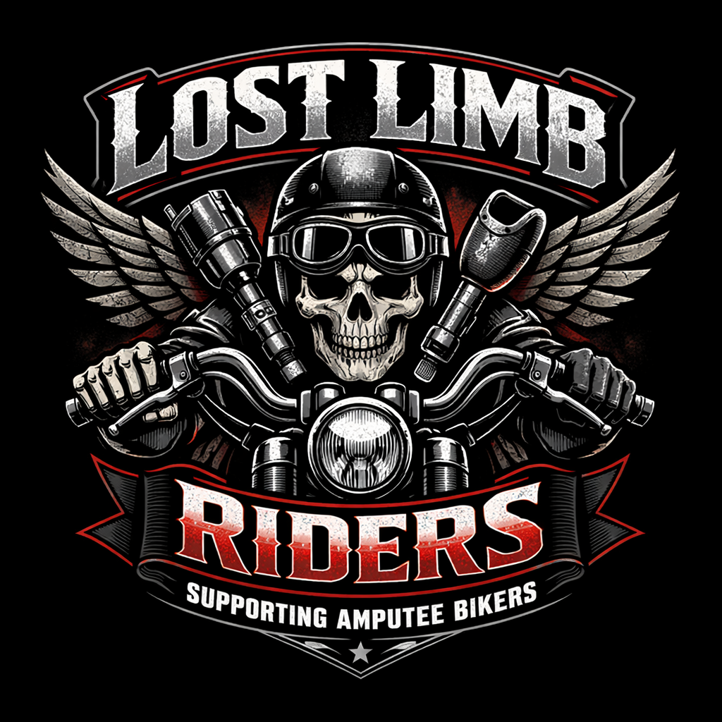
Lost Limb Riders
Building Hope, Independence, and Community
for Amputees and People with Disabilities
────────────────────────────────────────────────────────────
Proposal Prepared by:
John Thompson, Founder
Date:
July 2026
Contact:
Lost Limb Riders
514 N 6th St, Fort Dodge, IA 50501
515-890-5765
general_llr@outlook.com
────────────────────────────────────────────────────────────
I CAN. I WILL.

Table of Contents
1. Our Story
2. Our Mission
3. The Vision
4. How the Funds Will Help
5. Why We're Asking for Help
6. How People Can Get Involved
7. Closing

1. Our Story
John Thompson knows what it feels like to lose everything and have to rebuild from nothing.
A serious illness led to the amputation of his right leg below the knee. The surgery saved his life, but it also thrust him into a world most people never see — a world of hospital rooms, rehabilitation centers, phantom pain, prosthetic fittings, and the slow, grueling work of learning to walk again.
During those early days of recovery, John faced something just as painful as the physical loss: isolation. He didn’t know another amputee. He had never seen someone with a prosthetic leg living a full, active life. He had no roadmap, no community, and no one who truly understood what he was going through.
That changed when he connected with a community of bikers who accepted him as one of their own. They didn’t treat him like a patient. They didn’t feel sorry for him. They treated him like a rider — someone who belonged. They showed him that losing a limb didn’t mean losing his life. It meant finding a different road. And on that road, the people around him were proof that community doesn’t require a common diagnosis — it requires a common bond.
That experience planted a seed.
John realized that what had helped him most wasn’t a medication or a medical device — it was people. People who didn’t care about his diagnosis. People who judged him by the rider he was, not the leg he lost. People who made him feel like he still belonged.
Lost Limb Riders was born from that conviction.
John believes that no amputee should ever have to face the journey alone. Not in the hospital. Not in rehabilitation. Not at home. Not on the hardest days or the best ones. Every person who loses a limb deserves to know that there is a community waiting for them — people who will stand beside them, ride with them, and remind them that their life is far from over.
That is why Lost Limb Riders exists.
────────────────────────────────────────────────────────────

2. Our Mission
Lost Limb Riders exists to provide hope, peer support, mentorship, education, and opportunity to amputees and people with disabilities.
Our mission is built on a simple but powerful belief: no one should have to navigate limb loss alone.
Through peer visitation, mentorship programs, community rides, and fundraising events, we work to help amputees and people with disabilities regain confidence, independence, and a sense of belonging.
We serve:
- Recent amputees recovering from traumatic, medical, or congenital limb loss
- Long-term amputees seeking connection and community
- Families and caregivers who need support and understanding
- Veterans and first responders living with limb differences
- Children and young people born with or acquired limb differences
What makes us different:
We are not a clinical program. We are not a hospital. We are a community of people who have lived the experience and choose to show up for others. The motorcycle aspect of our organization is not incidental — it is central. Riding together breaks down barriers. It transforms the conversation from illness and loss into freedom, adventure, and capability. It shows the world — and more importantly, it shows new amputees — that life after limb loss is not smaller. It is different. And it can be extraordinary.
────────────────────────────────────────────────────────────

3. The Vision
Lost Limb Riders envisions an annual fundraising ride and community event in Iowa that brings together amputees, people with disabilities, motorcyclists, families, businesses, healthcare providers, and community supporters.
This event will be more than a fundraiser. It will be a celebration of life after limb loss.
What the event will include:
- A scenic motorcycle ride open to all riders — amputee and non-amputee alike
- A community gathering with food, music, and activities for families
- Vendor booths featuring prosthetic companies, adaptive equipment providers, and disability services
- Live testimonials from amputees sharing their stories of recovery and resilience
- A kids’ area and family-friendly programming
- Opportunities for healthcare providers to connect with the community they serve
- Sponsorship and partnership opportunities for local and regional businesses
Why Iowa:
Iowa is home. It is where John Thompson rebuilt his life. It is where the need exists for this kind of community — in cities and in rural towns, in hospitals and in homes, across every age group and every background. Iowa has a strong tradition of community, generosity, and people showing up for each other. Lost Limb Riders will be another expression of that tradition.
The goal is to grow the event year after year, building recognition, expanding reach, and deepening impact — until every amputee in Iowa and beyond knows that Lost Limb Riders exists and that they have a place with us.
────────────────────────────────────────────────────────────

4. How the Funds Will Help
Every dollar raised by Lost Limb Riders goes directly toward serving amputees and people with disabilities. Our programs are designed to address the real, practical challenges that people face during and after limb loss.
Prosthetic Assistance
Prosthetic limbs and components are expensive. Insurance often covers only a portion of the cost, and many amputees face gaps of thousands of dollars. Lost Limb Riders will help bridge that gap by providing financial assistance for prosthetic components, maintenance, and upgrades.
Adaptive Equipment
Beyond prosthetics, amputees often need adaptive equipment to return to daily life — modified tools, vehicle adaptations, home modifications, and specialized gear. Our fund will help cover these essential items.
Transportation to Medical Appointments
Recovery requires consistent medical care, and getting to appointments can be a significant barrier — especially in rural Iowa. Lost Limb Riders will provide transportation assistance so that no one misses a critical appointment because they can’t get there.
Emergency Assistance
Life doesn’t pause for recovery. When amputees face unexpected financial hardships — a car repair, a utility bill, an urgent medical need — Lost Limb Riders will be there with emergency assistance to help them stay on their feet.
Peer Mentoring
Our peer mentoring program matches new amputees with experienced ones who have walked the same road. Funding will support training, coordination, and the resources mentors need to be effective and compassionate guides.
Educational Programs
We will develop and deliver educational programs for amputees, families, healthcare providers, and the general public. These programs will cover topics like prosthetic care, adaptive living, mental health, and community resources.
Scholarships for Rehabilitation
For amputees who need additional rehabilitation services — physical therapy, occupational therapy, counseling, or vocational training — Lost Limb Riders will offer scholarships to help cover the cost of those services when insurance and personal resources fall short.
────────────────────────────────────────────────────────────

5. Why We’re Asking for Help
Lost Limb Riders is John Thompson’s mission, but it cannot be built alone.
John is a survivor, an advocate, and a leader. He has the vision, the passion, and the lived experience to drive this organization forward. What he is seeking now is guidance from people who have done this before.
There are community leaders, event organizers, and experienced fundraisers in Iowa who have successfully built and run charitable events — people like the organizers of the Angel Ride and similar community-driven fundraising efforts. John is reaching out to these individuals and organizations to ask for their wisdom, their mentorship, and their partnership.
What we are asking for:
- Mentorship from experienced nonprofit leaders and event organizers who can share what they’ve learned about building community support, securing sponsorships, and running successful fundraising events
- Guidance on best practices for nonprofit governance, financial management, and event planning
- Partnerships with hospitals, rehabilitation centers, healthcare providers, and businesses that share our commitment to serving people with disabilities
- Connections to community networks, media outlets, and civic organizations that can help amplify our message
What we are not asking for:
We are not asking anyone to take over our mission. This is John’s vision, John’s story, and John’s organization. We are asking for the kind of support that helps good ideas become great outcomes — the kind of guidance that comes from people who know what it takes to turn a mission into a movement.
John has never been afraid to ask for help when the cause is bigger than himself. He knows that the strongest organizations are built not by one person, but by a community of people who believe in the same thing.
────────────────────────────────────────────────────────────

6. How People Can Get Involved
Lost Limb Riders welcomes everyone who shares our belief that no amputee should face the journey alone. There are many ways to be part of what we’re building.
Volunteer
Volunteers are the backbone of Lost Limb Riders. We need people for peer visits, event planning, administration, outreach, and more. You don’t have to be an amputee to volunteer — you just have to care.
Sponsor
Businesses and organizations can sponsor rides, events, and programs. Sponsorship provides essential funding while giving sponsors visibility in a growing, community-driven organization. Sponsorship packages are available for businesses of all sizes.
Donate
Every dollar makes a difference. Donations fund prosthetics, adaptive equipment, transportation, emergency assistance, peer mentoring, education, and rehabilitation scholarships. All donations are tax-deductible.
Join the Planning Committee
We are building a planning committee for our inaugural annual ride and community event. If you have experience in event planning, marketing, fundraising, logistics, or community organizing — or if you simply want to help — we want you at the table.
Spread the Word
Tell people about Lost Limb Riders. Share our story. Connect us with amputees, families, healthcare providers, and community leaders who might benefit from or support our mission. The more people who know we exist, the more lives we can reach.
Refer Someone
If you know an amputee — recent or long-term — who could benefit from peer support, community, or resources, please connect them with us. No one should have to figure this out alone.
────────────────────────────────────────────────────────────

7. Closing
Losing a limb doesn’t mean losing your future. Sometimes it simply means discovering a different road to travel — and no one should have to travel it alone.
John Thompson has lived that truth every day since his amputation. He has faced surgeries, rehabilitation, phantom pain, and the slow, difficult work of rebuilding his life. He has also experienced the profound impact of community — of being surrounded by people who understand, who care, and who refuse to let him quit.
Lost Limb Riders is John’s way of paying that forward.
Every amputee who receives a peer visit, every new rider who discovers they can still ride, every person who finds community and hope through our programs — that is the mission in action. That is what your support makes possible.
John Thompson’s motto has carried him through the hardest moments of his life. It is the foundation of everything he builds.
“I CAN. I WILL.”
He invites you to be part of this journey. Whether you ride, volunteer, donate, sponsor, or simply spread the word — you are helping build something that will outlast any one of us. You are helping ensure that the next person who loses a limb in Iowa will not face it alone.
Thank you for your time. Thank you for your consideration. And if you ever want to ride with us — you’re welcome.
────────────────────────────────────────────────────────────
Lost Limb Riders
Building Hope, Independence, and Community for Amputees and People with Disabilities
Founder: John Thompson
514 N 6th St, Fort Dodge, IA 50501
515-890-5765
general_llr@outlook.com
I CAN. I WILL.

