Software Architecture Document

CS Cloud

Jerome BG

Version 1.0

August 13 2015
Revision History

The revision history cycle begins once changes or enhancements are requested after the initial version of the Software Architecture Document has been completed.

Date | Version | Description | Author
09/13/2015 | 1.0 | Initial version | Jerome BG

Architectural Goals and Constraints
Server side
The CS Cloud Server will be launched from a command line and communicate with clients and the CS Cloud Log Server using WCF.Net 4.5 web services and clients . The server will persist CS Command data using a SQL Server 2008 Database Server .

The CS Cloud Log Server will be launched from a command line and communicate with clients and the CS Cloud Server using WCF.Net 4.5 web services and clients . The log server will persist log data a SQL Server 2008 Database Server .

The CS Cloud Admin Web Application will be hosted on IIS using the ASP.Net MVC 4 framework . The web application will communicate with the CS Cloud Server and CS Cloud Log Server using WCF.Net 4.5 web service clients .

Client Side
The CS Cloud Clients will be launched from a command line and communicate with the CS Cloud Server and the CS Cloud Log Server using WCF.Net 4.5 web service clients .

Security
CS Cloud Clients will authenticate each session with the CS Cloud Server using a static password and client-specific client name .

The CS Cloud Admin Web Application will have a single administrator using a static password .

The CS Log Server will not be secured .

The Server 2008 Database Server will be accessed using the Windows User account .

Persistence

Data will be persisted on a single SQL Server 2008 Database Server .

Reliability/Availability

The CS Cloud Server will be run on demand .

CS Cloud Clients will be run on demand .

The CS Log Server will be hosted on IIS and use the machine’s default application pool settings .

The CS Admin Web Application will be hosted on IIS and use the machine’s default application pool settings .

Performance

There are no performance constrains , although the WCF services and clients are use default timeout values which could result in faulted connections . These values are configurable at runtime and can be altered without the need for re-deployment . The exception is that the CS Cloud Server will be initially configured to allow CS Cloud Clients 24 hours to execute commands , given the unpredictable time needed for executing commands such as COMPILE and TEST .

Assumptions

- The CS Cloud Server , CS Cloud Log Server and CS Cloud Web Application will be installed on a machine with the .Net 4.5 framwork, IIS 7 and SQL Server 2008 installed and an open internet connection
- CS Cloud Clients will be deployed on machines with the .Net 4.5 framwork installed and an open internet connection
- CS Cloud Clients will have none blank names

Use Cases
This is a list of use-cases that represent major functionality of the final system:
- Remote .net project compilation and unit testing
- Basic monitoring of CS Cloud Clients
- Logging of communication between the CS Cloud Server and CS Cloud Clients

Object View

The following objects span the CS Cloud Server , CS Cloud Web Application , CS Cloud Log Server and CS Cloud Client .

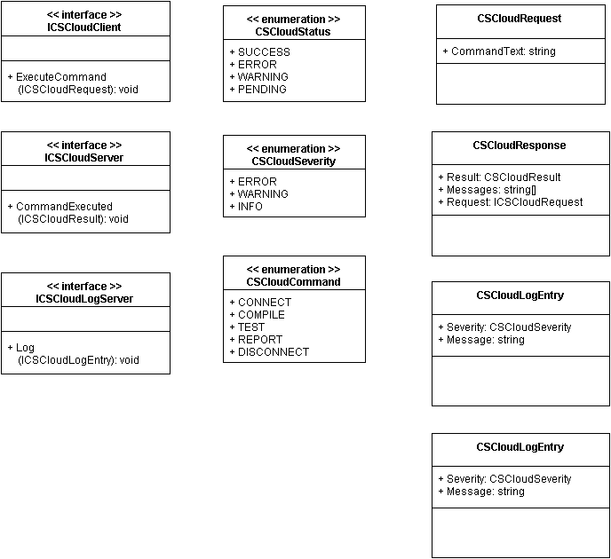

Data View

The log messages and CS Command data, including basic CS Client data will be persisted .

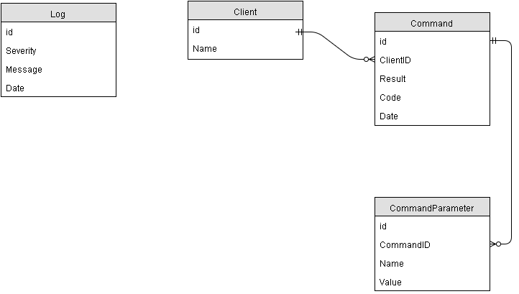

Deployment View
The CS Cloud Server , CS Cloud Web Application , CS Cloud Log Server and SQL Server 2008 will be deployed to a local , internet accessible machine . CS Cloud Client applications will be deployed on remote machines .

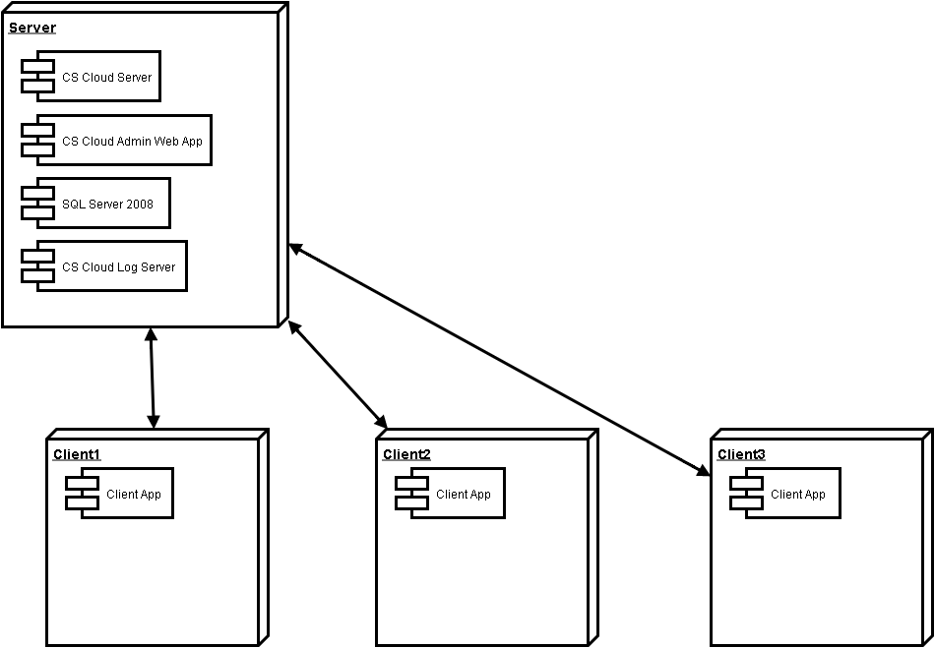

Issues and concerns
- This document and all pieces of this system are under development and in no way production ready .
  - Currently testable components include the CS Cloud Server , CS Cloud Web Application ( log viewing only ) , CS Cloud Log Server and CS Cloud Client ( no commands are actually executed )

