deadman’s draw++
System Design Documentation

Student ID: a1939751
Author: Raj Rathod

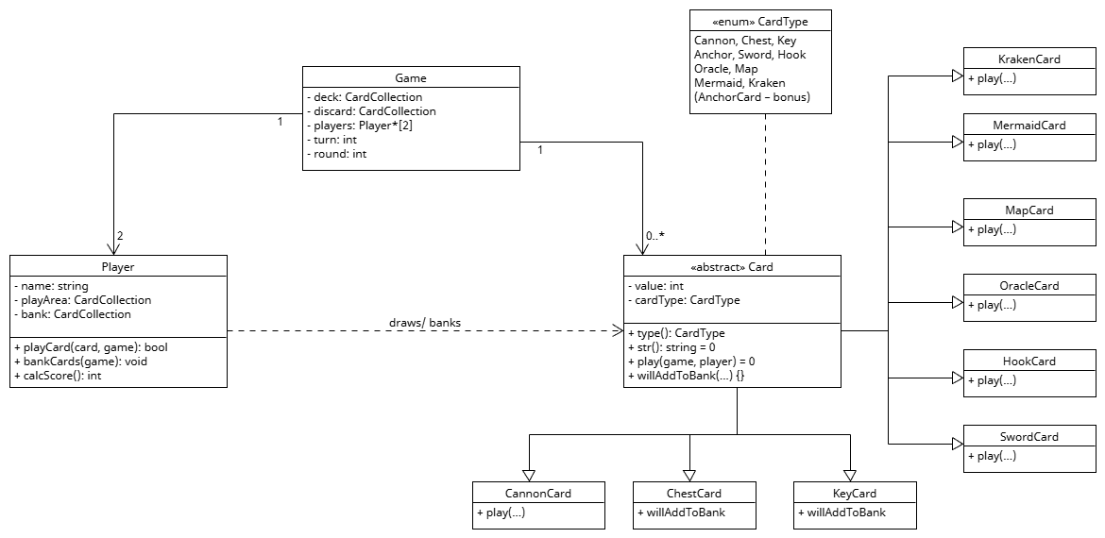Class Design
- All necessary classes need to be included to allow the program to function

Associations/ Multiplicity
- Only 1 game may exist at any given time
- For simplicity, a game cannot have more than 2 players
- Games cannot be played without 2 players
- Each game may consist of 0 to many cards (ideally a pack of 52)
- Players depend on Cards to play a Game
- Different card suits inherit from the abstract class, Card

Attributes and Methods
- Game: Must manage card deck, discard pile, players, turns, and rounds of the game
- Players: Must have a name, play area for cards, bank to store bankCards
- Card: Abstract class to allow all other suits to inherit common attributes and methods such as value, type, play(), etc.
- Enum CardType relies on the existence of Card

External Considerations
- Anchor suit?

