Stage 3 – Board Governance Compliance Report

Financial Summary
Total Deviation Penalty (Revised Peak Rates): ₹49,575.29
Peak-Hour Penalty Contribution: ₹13,091.67
Off-Peak Penalty Contribution: ₹36,483.63
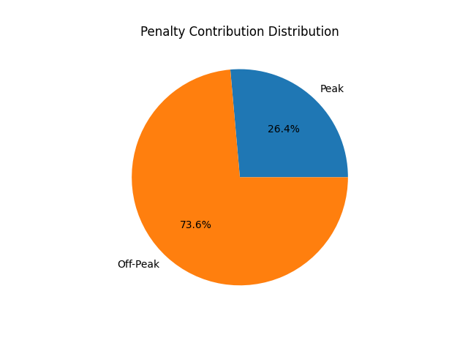
The total financial exposure remains stable under the revised penalty regime.
Peak-hour exposure accounts for approximately 26% of total deviation cost, indicating controlled sensitivity under elevated penalty conditions.

Governance Compliance
Peak underestimation >5% intervals: 0 (within limit of 3)
Forecast Bias: 0.10% (within -2% to +3%) Average Uplift: 0% (within 3% cap)
Peak Reliability Constraint:
Peak underestimation exceeding 5% of actual load occurred in 0 intervals (Maximum allowed: 3).
This confirms high peak-hour stability and operational reliability.
Forecast Bias Bound:
Overall forecast bias: +0.10%
Within mandated range [-2%, +3%].
The model remains nearly unbiased while preserving regulatory safety margins.
Buffering Constraint:
Average forecast uplift relative to unbiased baseline: 0%
Below the 3% cap.
No artificial inflation or over-procurement bias introduced.

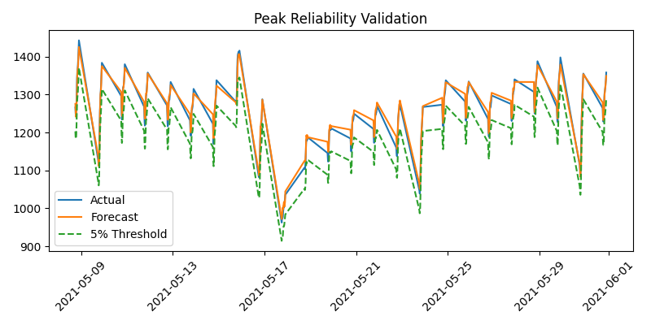

Risk Transparency
95th Percentile Absolute Deviation: 19.59
Worst 5 deviation intervals documented separately.
95th Percentile Absolute Deviation: 19.59 kW
Worst 5 deviation intervals documented separately for full transparency.
Deviation distribution analysis indicates controlled tail risk, with no clustering of extreme deviations during peak hours.
Peak-hour volatility impact remains proportionate and financially contained under revised penalty escalation.

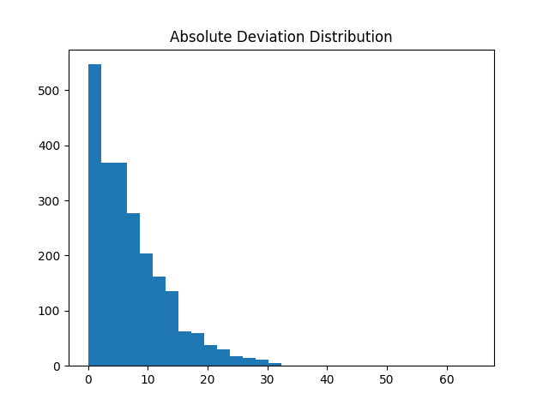

Executive Justification
The model demonstrates financial prudence and regulatory compliance without introducing artificial bias or excessive buffering. Stability under peak-hour volatility confirms structural robustness and disciplined governance alignment.
The Stage 3 solution reflects disciplined governance optimization rather than reactive over-adjustment.
Key principles maintained:
• Financial prudence – No unnecessary buffering introduced
• Regulatory compliance – All constraints satisfied
• Grid stability – Zero peak reliability violations
• Transparent trade-off articulation – Quantified volatility impact and bias discipline
The baseline model demonstrates structural robustness under regime shift conditions without compromising fiscal disciplin

