实现在下方弹出对话框

1. 建立anim文件夹

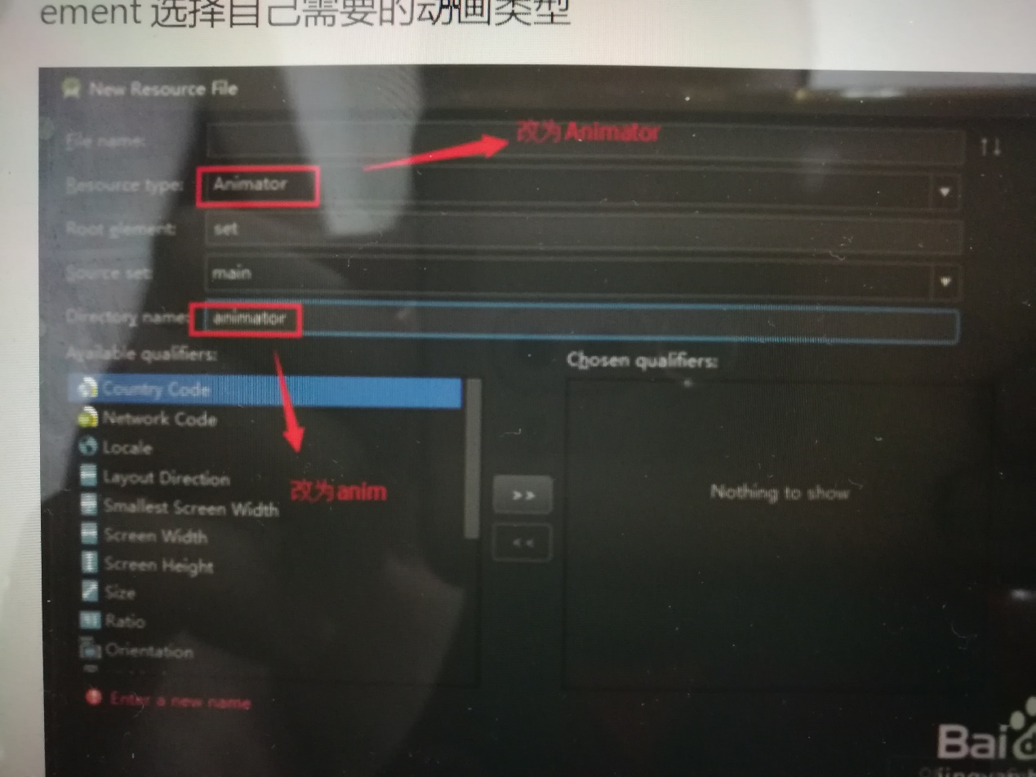

在下面添加；两个xml

actionsheet_dialog_in.xml对话框弹入

*<?***xml version="1.0" encoding="utf-8"***?>*<**set xmlns:android="http://schemas.android.com/apk/res/android"**>  
 <**scale  
 android:fromYScale="0"  
 android:toYScale="1.0"  
 android:fromXScale="0"  
 android:toXScale="1.0"  
  
 android:duration="500"  
 android:pivotX="50%"  
 android:pivotY="50%"** />  
 <**alpha  
 android:fromAlpha="0.5"  
 android:toAlpha="1.0"  
 android:duration="500"** />  
</**set**>

actionsheet_dialog_out.xml对话框弹出

*<?***xml version="1.0" encoding="utf-8"***?>*<**set xmlns:android="http://schemas.android.com/apk/res/android"**>  
 <**scale  
 android:fromYScale="1.0"  
 android:toYScale="0"  
 android:fromXScale="1.0"  
 android:toXScale="0"  
  
 android:duration="500"  
 android:pivotX="50%"  
 android:pivotY="50%"** />  
 <**alpha  
 android:fromAlpha="1.0"  
 android:toAlpha="0.5"  
 android:duration="500"** />  
</**set**>

Value文件夹下styles.xml添加

<**style name="ActionSheetDialogStyle" parent="@android:style/Theme.Dialog"**>  
  
 *<!-- 背景透明 -->* <**item name="android:windowBackground"**>@android:color/transparent</**item**>  
 <**item name="android:windowContentOverlay"**>@null</**item**>  
 *<!-- 浮于Activity之上 -->* <**item name="android:windowIsFloating"**>true</**item**>  
 *<!-- 边框 -->* <**item name="android:windowFrame"**>@null</**item**>  
 *<!-- Dialog以外的区域模糊效果 -->* <**item name="android:backgroundDimEnabled"**>true</**item**>  
 *<!-- 无标题 -->* <**item name="android:windowNoTitle"**>true</**item**>  
 *<!-- 半透明 -->* <**item name="android:windowIsTranslucent"**>true</**item**>  
 *<!-- Dialog进入及退出动画 -->* <**item name="android:windowAnimationStyle"**>@style/ActionSheetDialogAnimation</**item**>  
</**style**>  
*<!-- ActionSheet进出动画 -->*<**style name="ActionSheetDialogAnimation" parent="@android:style/Animation.Dialog"**>  
 <**item name="android:windowEnterAnimation"**>@anim/actionsheet_dialog_in</**item**>  
 <**item name="android:windowExitAnimation"**>@anim/actionsheet_dialog_out</**item**>  
</**style**>

评星

star_layout.xml

*<?***xml version="1.0" encoding="utf-8"***?>*<**RelativeLayout xmlns:android="http://schemas.android.com/apk/res/android"  
 android:layout_width="fill_parent"  
 android:layout_height="100dip"  
 android:background="@color/white"** >  
  
  
 <**RatingBar  
 android:id="@+id/ratingbar"  
 android:layout_width="match_parent"  
 android:layout_height="wrap_content"  
 android:layout_alignParentTop="true"  
 android:layout_toLeftOf="@+id/submitStar"  
 android:layout_toStartOf="@+id/submitStar"  
 android:gravity="center"  
 android:numStars="5"  
 android:progressTint="@color/yellow"  
 android:rating="0"  
 android:secondaryProgressTint="@color/colorAccent"  
 android:stepSize="1"** />  
  
 <**Button  
 android:id="@+id/submitStar"  
 android:layout_width="wrap_content"  
 android:layout_height="50dp"  
 android:layout_below="@id/ratingbar"  
 android:layout_alignParentEnd="true"  
 android:layout_alignParentRight="true"  
 android:text="提交评星"** />  
</**RelativeLayout**>

Java文件

参数

**private** Dialog **dialog**;*//对话框布局*

**private** View **inflate**;

**private** RatingBar **mRatingBar**;*//评星所用*

函数

**public void** toStar(View view){  
 **dialog** = **new** Dialog(**this**,R.style.***ActionSheetDialogStyle***);  
 *//填充对话框的布局* **inflate** = LayoutInflater.*from*(**this**).inflate(R.layout.***star_layout***, **null**);  
 *//初始化控件* **submitStar** = (Button) **inflate**.findViewById(R.id.***submitStar***);  
 **mRatingBar** = (RatingBar) **inflate**.findViewById(R.id.***ratingbar***);  
 *//将布局设置给Dialog* **dialog**.setContentView(**inflate**);  
 *//获取当前Activity所在的窗体* Window dialogWindow = **dialog**.getWindow();  
 *//设置Dialog从窗体底部弹出* dialogWindow.setGravity( Gravity.***BOTTOM***);  
 *//获得窗体的属性* WindowManager.LayoutParams lp = dialogWindow.getAttributes();  
 lp.**y** = 20;*//设置Dialog距离底部的距离  
// 将属性设置给窗体* dialogWindow.setAttributes(lp);  
 **dialog**.show();*//显示对话框* **mRatingBar**.setOnRatingBarChangeListener(**new** RatingBar.OnRatingBarChangeListener() {  
  
 @Override  
 **public void** onRatingChanged(RatingBar ratingBar, **float** rating, **boolean** fromUser) {  
 Toast.*makeText*(MainActivity.**this**, **"评价了"** + rating + **"星"**, Toast.***LENGTH_SHORT***).show();  
 }  
 });  
 **submitStar**.setOnClickListener(**new** View.OnClickListener() {  
  
 @Override  
 **public void** onClick(View v) {  
 Toast.*makeText*(MainActivity.**this**,**"提交成功"**,Toast.***LENGTH_SHORT***).show();  
 **dialog**.dismiss();  
 }  
 });  
 }

显示xml文件添加

<**ImageView  
 android:id="@+id/star"  
 android:layout_width="30dp"  
 android:layout_height="30dp"  
 android:layout_above="@+id/TextView02"  
 android:layout_alignParentEnd="true"  
 android:layout_alignParentRight="true"  
 android:background="@drawable/star"  
 android:onClick="toStar"  
 android:padding="2dip"** />

评价

显示xml文件添加

<**ImageView  
 android:id="@+id/assess"  
 android:layout_width="30dp"  
 android:layout_height="30dp"  
 android:layout_toLeftOf="@id/star"  
 android:layout_above="@id/TextView02"  
 android:onClick="toAccess"  
 android:background="@drawable/assess"  
 android:padding="2dip"** />

Java文件添加

参数

**private** View **inflate**;  
**private** EditText **estimate**;*//评价***private** Dialog **dialog**;*//对话框布局*

函数

**public void** toAccess(View view){  
 **dialog** = **new** Dialog(**this**,R.style.***ActionSheetDialogStyle***);  
 *//填充对话框的布局* **inflate** = LayoutInflater.*from*(**this**).inflate(R.layout.***dialog_layout***, **null**);  
 *//初始化控件* **submitAccess** = (Button) **inflate**.findViewById(R.id.***submitAccess***);  
 **estimate** = (EditText) **inflate**.findViewById(R.id.***estimate***);  
 *//将布局设置给Dialog* **dialog**.setContentView(**inflate**);  
 *//获取当前Activity所在的窗体* Window dialogWindow = **dialog**.getWindow();  
 *//设置Dialog从窗体底部弹出* dialogWindow.setGravity( Gravity.***BOTTOM***);  
 *//获得窗体的属性* WindowManager.LayoutParams lp = dialogWindow.getAttributes();  
 lp.**y** = 20;*//设置Dialog距离底部的距离  
// 将属性设置给窗体* dialogWindow.setAttributes(lp);  
 **dialog**.show();*//显示对话框* **estimate**.setOnClickListener(**new** View.OnClickListener() {  
  
 @Override  
 **public void** onClick(View v) {  
 Toast.*makeText*(MainActivity.**this**,**"请输入评价"**,Toast.***LENGTH_SHORT***).show();  
 }  
 });  
 **submitAccess**.setOnClickListener(**new** View.OnClickListener() {  
  
 @Override  
 **public void** onClick(View v) {  
 Toast.*makeText*(MainActivity.**this**,**"提交成功"**,Toast.***LENGTH_SHORT***).show();  
 **dialog**.dismiss();  
 }  
 });  
 }

日历插件

Java文件

参数

**int mYear**,**mMonth**,**mDay**;*//年，月，日，日期所用*

**final int DATE_DIALOG**=1;*//日历所用*

onCreate函数

**btn**=(Button) findViewById(R.id.***calendar***);  
**btn**.setOnClickListener(**new** View.OnClickListener() {  
  
 @Override  
 **public void** onClick(View v) {  
 **btn**.setText(**new** StringBuffer().append(**mMonth** + 1).append(**"-"**).append(**mDay**).append(**"-"**).append(**mYear**).append(**" "**));  
 showDialog(**DATE_DIALOG**);  
 }  
});  
**final** Calendar ca = Calendar.*getInstance*();  
**mYear** = ca.get(Calendar.***YEAR***);  
**mMonth** = ca.get(Calendar.***MONTH***);  
**mDay** = ca.get(Calendar.***DAY_OF_MONTH***);  
  
**final** Button button=(Button)findViewById(R.id.***time***);  
button.setOnClickListener(**new** View.OnClickListener()  
{  
 @Override  
 **public void** onClick(View arg0)  
 {  
 AlertDialog.Builder builder = **new** AlertDialog.Builder(MainActivity.**this**);  
 *// builder.setIcon(R.drawable.ic_launcher);* builder.setTitle(**"三餐"**);  
 *// 指定下拉列表的显示数据* **final** String[] meals= {**"早餐"**, **"午餐"**, **"晚餐"**};  
 *// 设置一个下拉的列表选择项* builder.setItems(meals, **new** DialogInterface.OnClickListener()  
 {  
 @Override  
 **public void** onClick(DialogInterface dialog, **int** which)  
 {  
 button.setText(meals[which]);  
 Toast.*makeText*(MainActivity.**this**, **"选择为："** + meals[which], Toast.***LENGTH_SHORT***).show();  
 }  
 });  
 builder.show();  
 }  
});

添加函数

@Override  
**protected** Dialog onCreateDialog(**int** id) {  
 **switch** (id) {  
 **case DATE_DIALOG**:  
 **return new** DatePickerDialog(**this**, **mdateListener**, **mYear**, **mMonth**, **mDay**);  
 }  
 **return null**;  
}  
  
**private** DatePickerDialog.OnDateSetListener **mdateListener** = **new** DatePickerDialog.OnDateSetListener() {  
  
 @Override  
 **public void** onDateSet(DatePicker view, **int** year, **int** monthOfYear,  
 **int** dayOfMonth) {  
 **mYear** = year;  
 **mMonth** = monthOfYear;  
 **mDay** = dayOfMonth;  
 }  
};