### ST_DocGrid (Document Grid Types)

Specifies the [type](type.docx) of the current document grid, which defines the grid behavior.

The grid can define a grid which snaps all East Asian characters to grid positions, but leaves Latin text with its default spacing; a grid which adds the specified character [pitch](pitch.docx) to all characters on each row; or a grid which affects only the line [pitch](pitch.docx) for the current section.

[Example: Consider the document discussed above with the document grid defined to allow 20 characters per line, and 20 lines per page by snapping characters to the grid as follows:

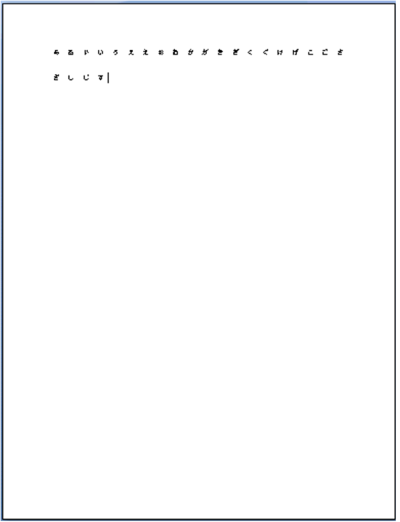

This document has a [type](type.docx) attribute of [type](type.docx) ST_DocGrid and value snapToChars, which specifies that the grid shall force East Asian characters to fit 20 to a line. end example]

This simple type's contents are a restriction of the [XML](XML.docx) Schema string datatype.

The following are possible enumeration values for this type:

|  |  |
| --- | --- |
| Enumeration Value | Description |
| [default](default.docx) (No Document Grid) | Specifies that no document grid shall be applied to the contents of the current section in the document. |
| lines (Line Grid Only) | Specifies that the parent section shall have additional line [pitch](pitch.docx) added to each line within it (as specified on the [docGrid](docGrid.docx) element (§)) in order to maintain the specified number of lines per page. |
| linesAndChars (Line and Character Grid) | Specifies that the parent section shall have both the additional line [pitch](pitch.docx) and character [pitch](pitch.docx) added to each line and character within it (as specified on the [docGrid](docGrid.docx) element (§)) in order to maintain a specific number of lines per page and characters per line.  When this value is set, the input specified via the user interface may be allowed in exact number of line/character [pitch](pitch.docx) units. |
| snapToChars (Character Grid Only) | Specifies that the parent section shall have both the additional line [pitch](pitch.docx) and character [pitch](pitch.docx) added to each line and character within it (as specified on the [docGrid](docGrid.docx) element (§)) in order to maintain a specific number of lines per page and characters per line.  When this value is set, the input specified via the user interface may be restricted to the number of lines per page and characters per line, with the consumer or producer translating this information based on the current font data to get the resulting line and character [pitch](pitch.docx) values |

|  |
| --- |
| Referenced By |
| docGrid@type (§) |

The following [XML](XML.docx) Schema fragment defines the contents of this simple type:

<simpleType [name](name.docx)="ST_DocGrid">

<restriction base="xsd:string">

<enumeration value="[default](default.docx)"/>

<enumeration value="lines"/>

<enumeration value="linesAndChars"/>

<enumeration value="snapToChars"/>

</restriction>

</simpleType>