### ST_FrameLayout (Frameset Layout Order)

This simple [type](type.docx) specifies the possible order in which the frames (and nested framesets) in a [frameset](frameset.docx) may be displayed. When a [frameset](frameset.docx) is created, it can only contain frames which are stacked in one direction:

* Vertically (one on top of another)
* Horizontally (one [next](next.docx) to another)

[Example: Consider a WordprocessingML document which serves as the [frameset](frameset.docx) container for a [frameset](frameset.docx) consisting of the following three frames:

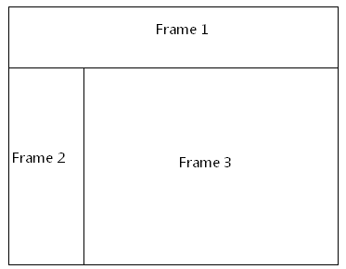

The [frameset](frameset.docx) properties for this document are specified by the following WordprocessingML within the web page settings:

<w:[frameset](frameset.docx)>

<w:[frameLayout](frameLayout.docx) w:val="rows" />

<w:[frame](frame.docx)>

…

</w:[frame](frame.docx)>

<w:[frameset](frameset.docx)>

<w:[frameLayout](frameLayout.docx) w:val="[cols](cols.docx)" />

<w:[frame](frame.docx)>

…

</w:[frame](frame.docx)>

<w:[frame](frame.docx)>

…

</w:[frame](frame.docx)>

</w:[frameset](frameset.docx)>

</w:[frameset](frameset.docx)>

The [frameLayout](frameLayout.docx) element specifies that the outer [frameset](frameset.docx) is consists of the single [frame](frame.docx) and the child [frameset](frameset.docx) stacked vertically, and an inner nested [frameset](frameset.docx) consisting of two frames stacked horizontally. end example]

This simple type's contents are a restriction of the [XML](XML.docx) Schema string datatype.

The following are possible enumeration values for this type:

|  |  |
| --- | --- |
| Enumeration Value | Description |
| [cols](cols.docx) (Stack Frames Horizontally) | Specifies that the frames in the [frameset](frameset.docx) shall be stacked horizontally [next](next.docx) to each other in left to right order. |
| none (Do Not Stack Frames) | Specifies that no frames shall be shown in the frameset. |
| rows (Stack Frames Vertically) | Specifies that the frames in the [frameset](frameset.docx) shall be stacked vertically [next](next.docx) to each other in top to bottom order. |

|  |
| --- |
| Referenced By |
| frameLayout@val (§) |

The following [XML](XML.docx) Schema fragment defines the contents of this simple type:

<simpleType [name](name.docx)="ST_FrameLayout">

<restriction base="xsd:string">

<enumeration value="rows"/>

<enumeration value="[cols](cols.docx)"/>

<enumeration value="none"/>

</restriction>

</simpleType>