### ST_FrameScrollbar (Frame Scrollbar Visibility)

This simple [type](type.docx) specifies the possible settings for when a [scrollbar](scrollbar.docx) shall be visible for the contents of the current frame.

[Example: Consider a WordprocessingML document which serves as the [frameset](frameset.docx) container for a [frameset](frameset.docx) consisting of the following three frames:

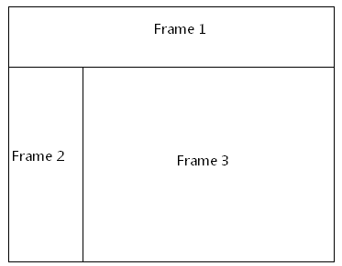

The [frameset](frameset.docx) properties for this document are specified by the following WordprocessingML within the web page settings:

<w:[frameset](frameset.docx)>

…

<w:[frameset](frameset.docx)>

…  
 <w:[frame](frame.docx)>  
 <w:name w:val="Frame 2" />  
 <w:[scrollbar](scrollbar.docx) w:val="auto" />  
 </w:[frame](frame.docx)>  
 …

</w:[frameset](frameset.docx)>

</w:[frameset](frameset.docx)>

The [scrollbar](scrollbar.docx) element has a val attribute of auto, which specifies that the [frame](frame.docx) shall only display a [scrollbar](scrollbar.docx) when it is needed to display all of its content. end example]

This simple type's contents are a restriction of the [XML](XML.docx) Schema string datatype.

The following are possible enumeration values for this type:

|  |  |
| --- | --- |
| Enumeration Value | Description |
| auto (Automatically Show Scrollbar As Needed) | Specifies that the [scrollbar](scrollbar.docx) for a [frame](frame.docx) shall automatically be [hidden](hidden.docx) and/or displayed as needed based on the length of the contents. |
| off (Never Show Scrollbar) | Specifies that the [scrollbar](scrollbar.docx) for a [frame](frame.docx) shall always be hidden. |
| on (Always Show Scrollbar) | Specifies that the [scrollbar](scrollbar.docx) for a [frame](frame.docx) shall always be displayed (even when not needed). |

|  |
| --- |
| Referenced By |
| scrollbar@val (§) |

The following [XML](XML.docx) Schema fragment defines the contents of this simple type:

<simpleType [name](name.docx)="ST_FrameScrollbar">

<restriction base="xsd:string">

<enumeration value="on"/>

<enumeration value="off"/>

<enumeration value="auto"/>

</restriction>

</simpleType>