### ST_PageBorderZOrder (Page Border Z-Order)

This simple [type](type.docx) specifies whether the page border is positioned above or below intersecting texts and objects in this document.

[Example: Consider a document in which the page border shall be displayed below any intersecting text as follows:

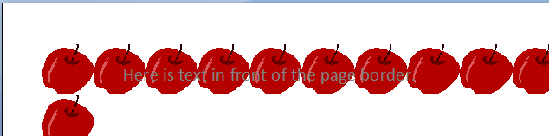

This setting is specified by setting the value of an attribute with to back, which specifies that the page border shall be displayed behind all intersecting text and objects. end example]

This simple type's contents are a restriction of the [XML](XML.docx) Schema string datatype.

The following are possible enumeration values for this type:

|  |  |
| --- | --- |
| Enumeration Value | Description |
| back (Page Border Behind Text) | Specifies that the page border shall be rendered beneath any text or [object](object.docx) which intersects it - effectively placing it at the lowest z-order on the page. |
| front (Page Border Ahead of Text) | Specifies that the page border shall be rendered above any text or [object](object.docx) which intersects it - effectively placing it at the highest z-order on the page. |

|  |
| --- |
| Referenced By |
| pgBorders@zOrder (§) |

The following [XML](XML.docx) Schema fragment defines the contents of this simple type:

<simpleType [name](name.docx)="ST_PageBorderZOrder">

<restriction base="xsd:string">

<enumeration value="front"/>

<enumeration value="back"/>

</restriction>

</simpleType>