### ST_TblOverlap (Table Overlap Setting)

This simple [type](type.docx) contains the possible settings for a floating [table](table.docx) which shall be used to determine if the [table](table.docx) can overlap with other floating tables when displayed in the document.

[Example: Consider two floating tables in a WordprocessingML document which overlap when displayed, as follows:

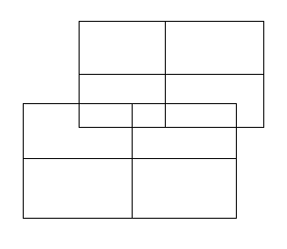

If either of these tables specifies that it shall not allow overlapping, using the following WordprocessingML:

<w:[tblPr](tblPr.docx)>  
 <w:[tblOverlap](tblOverlap.docx) w:val="never"/>  
</w:[tblPr](tblPr.docx)>

The resulting tables shall not overlap, and must be adjusted at display time to prevent any overlapping, for example:

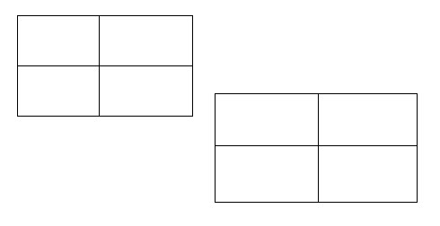

The value of never specifies that the specified [table](table.docx) cannot overlap with other floating tables in the document. end example]

This simple type's contents are a restriction of the [XML](XML.docx) Schema string datatype.

The following are possible enumeration values for this type:

|  |  |
| --- | --- |
| Enumeration Value | Description |
| never (Floating Table Cannot Overlap) | Specifies that the parent [table](table.docx), if floating, shall never be displayed in a state where it would be overlapping another floating [table](table.docx) in the document.  If two floating tables intersect and this option is set on either of them, then one or both tables shall be adjusted as needed to ensure that the [table](table.docx) whose value is never is not overlapped when displayed. |
| overlap (Floating Table Can Overlap) | Specifies that the parent [table](table.docx), if floating, may be displayed in a state where it would be overlapping another floating [table](table.docx) in the document. |

|  |
| --- |
| Referenced By |
| tblOverlap@val (§) |

The following [XML](XML.docx) Schema fragment defines the contents of this simple type:

<simpleType [name](name.docx)="ST_TblOverlap">

<restriction base="xsd:string">

<enumeration value="never"/>

<enumeration value="overlap"/>

</restriction>

</simpleType>