#### adjustLineHeightInTable (Add Document Grid Line Pitch To Lines in Table Cells)

This element specifies whether a document grid defined using the [docGrid](docGrid.docx) element (§) that specifies a line grid (manually adding additional [pitch](pitch.docx) to each line in the section) shall also be applied to lines within [table](table.docx) cells in this section.

Typically, when additional line [pitch](pitch.docx) is added to all lines in a section via the document grid, it is not applied to text in tables. This element, when present with a val attribute value of true (or equivalent), specifies that additional line [pitch](pitch.docx) shall be added to lines in [table](table.docx) cells.

[Example: Consider a WordprocessingML document with a single section, whose document grid is defined such that 25.9 points of additional line [pitch](pitch.docx) are added to each line in the section, as follows:

<w:[docGrid](docGrid.docx) w:[type](type.docx)="lines" w:linePitch="518"/>

If text was entered into this section, the default [behavior](behavior.docx) would have line [pitch](pitch.docx) only added to lines which are not in a [table](table.docx) cell:

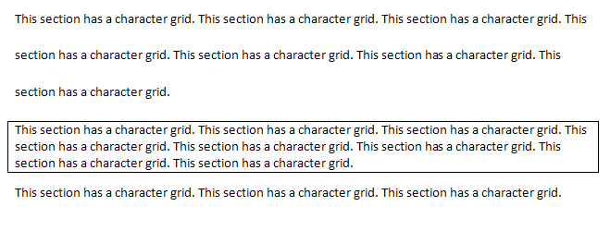

However, if this compatibility setting is turned on:

<w:[compat](compat.docx)>  
 <w:adjustLineHeightInTable />  
</w:[compat](compat.docx)>

Then all lines in this document would have the line [pitch](pitch.docx) from the document grid added to them, resulting in the following output:

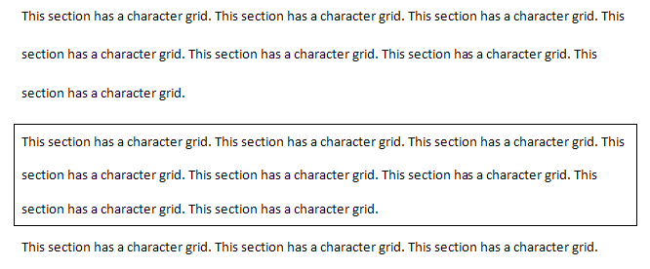

end example]

|  |
| --- |
| Parent Elements |
| [compat](compat.docx) (§) |

|  |  |
| --- | --- |
| Attributes | Description |
| val (On/Off Value) | Specifies a binary value for the property defined by the parent [XML](XML.docx) element.  A value of on, 1, or true specifies that the property shall be explicitly applied. This is the default value for this attribute, and is implied when the parent element is present, but this attribute is omitted.  A value of off, 0, or false specifies that the property shall be explicitly turned off.  [Example: For example, consider the following on/off property:  <w:… w:val="off"/>  The val attribute explicitly declares that the property is turned off. end example]  The possible values for this attribute are defined by the [ST_OnOff](ST_OnOff.docx) simple [type](type.docx) (§). |

The following [XML](XML.docx) Schema fragment defines the contents of this element:

<complexType [name](name.docx)="CT_OnOff">

<attribute [name](name.docx)="val" [type](type.docx)="[ST_OnOff](ST_OnOff.docx)"/>

</complexType>