#### alignTablesRowByRow (Align Table Rows Independently)

This element specifies whether applications shall align each row within a [table](table.docx) independently based on the alignment setting of the [jc](jc.docx) element (§) when displaying the contents of a [table](table.docx) in a WordprocessingML document.

When the justification of a [table](table.docx) using the [jc](jc.docx) element is typically applied, that alignment is applied to the contents of the [table](table.docx) (the [table](table.docx) is centered, left justified, or right-aligned), and then individual rows are laid out based on the resulting table's position. This element, when present with a val attribute value of true (or equivalent), specifies that each [table](table.docx) row shall be independently aligned based on the [table](table.docx) alignment setting, ignoring the placement of all other rows.

[Example: Consider a WordprocessingML document with a single centered [table](table.docx), whose second row is defined such that one-half of an inch is left before the row begins, as follows:

<w:[tbl](tbl.docx)>  
 <w:[tblPr](tblPr.docx)>  
 <w:[jc](jc.docx) w:val="center" />  
 </w:[tblPr](tblPr.docx)>  
 <w:[tr](tr.docx)>  
 …  
 </w:[tr](tr.docx)>  
 <w:[tr](tr.docx)>  
 <w:[trPr](trPr.docx)>

<w:[gridBefore](gridBefore.docx) w:val="1" />

<w:[wBefore](wBefore.docx) w:[w](w.docx)="720" w:[type](type.docx)="dxa" />   
 </w:[trPr](trPr.docx)>  
 …  
 </w:[tr](tr.docx)>  
 <w:[tr](tr.docx)>  
 …  
 </w:[tr](tr.docx)>  
</w:[tbl](tbl.docx)>

The default presentation would have the entire [table](table.docx) centered, then the second row indented beyond that by 720 points:

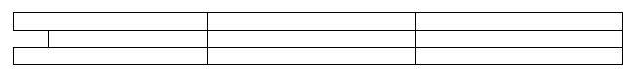

However, if this compatibility setting is turned on:

<w:[compat](compat.docx)>  
 <w:alignTablesRowByRow />  
</w:[compat](compat.docx)>

Then that second row would instead be centered on the page independently of the other [table](table.docx) rows, resulting in the following output:

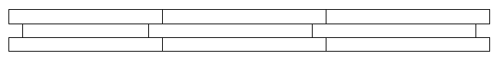

In this case, the [wBefore](wBefore.docx) element's value is ignored, since the row was centered on the line as a row, and there is no [table](table.docx) to be indented relative to. end example]

|  |
| --- |
| Parent Elements |
| [compat](compat.docx) (§) |

|  |  |
| --- | --- |
| Attributes | Description |
| val (On/Off Value) | Specifies a binary value for the property defined by the parent [XML](XML.docx) element.  A value of on, 1, or true specifies that the property shall be explicitly applied. This is the default value for this attribute, and is implied when the parent element is present, but this attribute is omitted.  A value of off, 0, or false specifies that the property shall be explicitly turned off.  [Example: For example, consider the following on/off property:  <w:… w:val="off"/>  The val attribute explicitly declares that the property is turned off. end example]  The possible values for this attribute are defined by the [ST_OnOff](ST_OnOff.docx) simple [type](type.docx) (§). |

The following [XML](XML.docx) Schema fragment defines the contents of this element:

<complexType [name](name.docx)="CT_OnOff">

<attribute [name](name.docx)="val" [type](type.docx)="[ST_OnOff](ST_OnOff.docx)"/>

</complexType>