#### bordersDoNotSurroundFooter (Page Border Excludes Footer)

This element specifies that a given WordprocessingML document’s page border specified using the [pgBorders](pgBorders.docx) element (§) should not surround contents of the footer.

If this element is omitted, then the page border shall not exclude the footer on the page. As well, this element shall be ignored if the [pgBorders](pgBorders.docx) element has an offsetFrom attribute which is not equal to text.

[Note: If the [pgBorders](pgBorders.docx) element has a offsetFrom attribute equal to page, the bordersDontSurroundFooter element shall be ignored as specifying the [pgBorders](pgBorders.docx) element with a offsetFrom attribute equal to page is to specify that the positioning of borders within the document shall be calculated relative to the edge of the page and therefore irrespective of document content in the footer. end note]

[Example: Consider the following page in a WordprocessingML document:

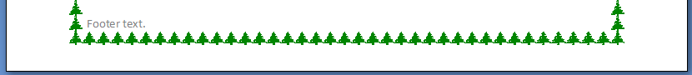

If this WordprocessingML document is modified to leverage the [behavior](behavior.docx) [enabled](enabled.docx) by this element, this setting would be specified using the following WordprocessingML fragment in the document settings:

<w:bordersDontSurroundFooter w:val="true"/>

The bordersDontSurroundFooter element's val attribute is equal to true specifying that the page border shall not surround the text extents of the footer, as follows:

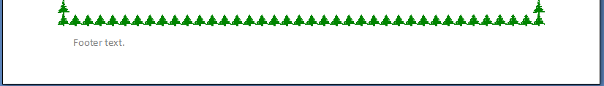

end example]

|  |
| --- |
| Parent Elements |
| settings (§) |

|  |  |
| --- | --- |
| Attributes | Description |
| val (On/Off Value) | Specifies a binary value for the property defined by the parent [XML](XML.docx) element.  A value of on, 1, or true specifies that the property shall be explicitly applied. This is the default value for this attribute, and is implied when the parent element is present, but this attribute is omitted.  A value of off, 0, or false specifies that the property shall be explicitly turned off.  [Example: For example, consider the following on/off property:  <w:… w:val="off"/>  The val attribute explicitly declares that the property is turned off. end example]  The possible values for this attribute are defined by the [ST_OnOff](ST_OnOff.docx) simple [type](type.docx) (§). |

The following [XML](XML.docx) Schema fragment defines the contents of this element:

<complexType [name](name.docx)="CT_OnOff">

<attribute [name](name.docx)="val" [type](type.docx)="[ST_OnOff](ST_OnOff.docx)"/>

</complexType>