#### [color](color.docx) (Frameset Splitter Color)

This element specifies the [color](color.docx) of the splitters within the [frameset](frameset.docx) in this WordprocessingML document. This element shall only be honored on the root [frameset](frameset.docx) for this document, and may be ignored for all nested framesets in this document.

If this element is omitted, then the default [color](color.docx) of the splitter may be automatically determined by the application displaying this WordprocessingML document (equivalent to a val attribute value of auto).

[Example: Consider a [frameset](frameset.docx) consisting of the following three frames:

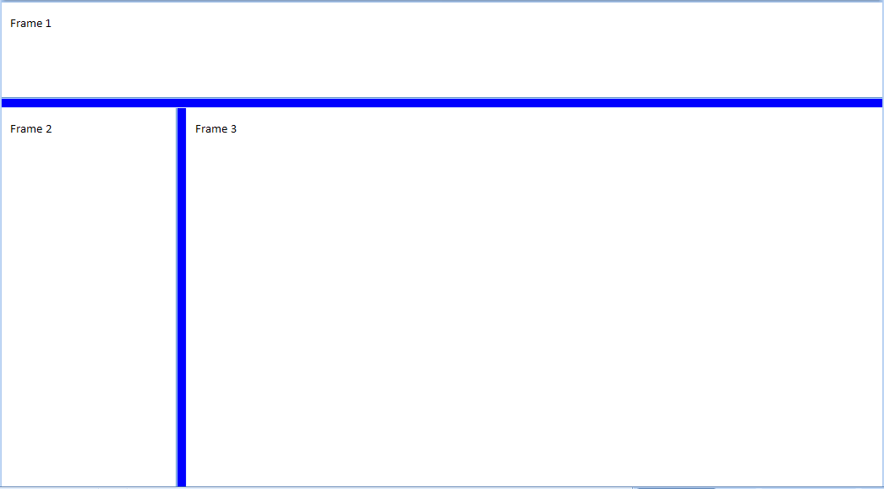

The following properties define the presentation of the splitter bars within this frameset:

<w:[frameset](frameset.docx)>  
 <w:[framesetSplitbar](framesetSplitbar.docx)>  
 <w:[w](w.docx) w:val="200" />  
 <w:[color](color.docx) w:val="0000FF" />  
 </w:[framesetSplitbar](framesetSplitbar.docx)>  
 …   
</w:[frameset](frameset.docx)>

The [color](color.docx) element's val attribute specifies that the splitters shall be displayed in the RGB [color](color.docx) 0000FF (blue) when the contents of this document are displayed. end example]

|  |
| --- |
| Parent Elements |
| [framesetSplitbar](framesetSplitbar.docx) (§) |

|  |  |
| --- | --- |
| Attributes | Description |
| themeColor (Run Content Theme Color) | Specifies a theme [color](color.docx) which should be applied to the current run.  The specified theme [color](color.docx) is a reference to one of the predefined theme colors, located in the document's Theme part,which allows for [color](color.docx) information to be set centrally in the document.  If the themeColor attribute is specified, then the val attribute is ignored for this run.  [Example: Consider a run of text which should be displayed using the accent3 theme [color](color.docx) from the document’s Theme part. This requirement would be specified as follows in the resulting WordprocessingML:  <w:[rPr](rPr.docx)>  <w:[color](color.docx) w:themeColor=”accent3” />  </w:[rPr](rPr.docx)>  The [color](color.docx) attribute specifies that the run shall use the accent3 theme color. end example]  The possible values for this attribute are defined by the [ST_ThemeColor](ST_ThemeColor.docx) simple [type](type.docx) (§). |
| themeShade (Run Content Theme Color Shade) | Specifies the shade value applied to the supplied theme [color](color.docx) (if any) for this run’s contents.  If the themeShade is supplied, then it is applied to the RGB value of the theme [color](color.docx) to determine the final [color](color.docx) applied to this run.  The themeShade value is stored as a hex [encoding](encoding.docx) of the shade value (from 0 to 255) applied to the current border.  [Example: Consider a shade of 40% applied to a run in a document. This shade is calculated as follows: $$S_{xml}=0.4*255 \\ =102 \\ =66(hex)$$ Te resulting themeShade value in the file [format](format.docx) would be 66. end example]  Given a input red, green, or blue [color](color.docx) value C (from 0-255), an output [color](color.docx) value of C' (from 0-255), and a shade value S (from 0-100), the shade is applied as follows: $$C^{'}=\left(1-\frac{S}{100}\right)C$$ [Example: Consider a document with a run using the accent6 theme [color](color.docx), whose RGB value (in RRGGBB hex format) is F79646.  The hex value for the green component is 96 - 150 in decimal. Applying the shade formula with shade of 50%, the output decimal value of the green component is 75, or a hex value of 4B. This transformed value can be seen in the resulting run [color](color.docx) WordprocessingML's val attribute:  <w:[color](color.docx) w:val="7B4B23" w:themeColor="accent6" w:themeShade="80" />  end example]  The possible values for this attribute are defined by the [ST_UcharHexNumber](ST_UcharHexNumber.docx) simple [type](type.docx) (§). |
| themeTint (Run Content Theme Color Tint) | Specifies the tint value applied to the supplied theme [color](color.docx) (if any) for this run’s contents.  If the themeTint is supplied, then it is applied to the RGB value of the theme [color](color.docx) to determine the final [color](color.docx) applied to this run.  The themeTint value is stored as a hex [encoding](encoding.docx) of the tint value (from 0 to 255) applied to the current border.  [Example: Consider a tint of 60% applied to a run in a document. This tint is calculated as follows: $$T_{xml}=0.6*255 \\ =153 \\ =99(hex)$$ The resulting themeTint value in the file [format](format.docx) would be 99. end example]  Given a input red, green, or blue [color](color.docx) value C (from 0-255), an output [color](color.docx) value of C' (from 0-255), and a tint value T (from 0-100), the tint is applied as follows: $$C^{'}=\left(1-\frac{T}{100}\right)\left(255-C\right)+C$$ [Example: Consider a document with a run using the accent1 theme [color](color.docx), whose RGB value (in RRGGBB hex format) is C0504D.  The hex value for the green component is 50 - 80 in decimal. Applying the tint formula with tint of 60%, the output decimal value of the green component is 150, or a hex value of 96. This transformed value can be seen in the resulting run color's WordprocessingML val attribute:  <w:[color](color.docx) w:val="D99694" w:themeColor="accent1" w:themeTint="99" />  end example]  The possible values for this attribute are defined by the [ST_UcharHexNumber](ST_UcharHexNumber.docx) simple [type](type.docx) (§). |
| val (Run Content Color) | Specifies the [color](color.docx) for this run.  This [color](color.docx) may either be presented as a hex value (in RRGGBB format), or auto to allow a consumer to automatically determine the run [color](color.docx) as appropriate.  If the run specifies the use of a theme [color](color.docx) via the themeColor attribute, then this value is superseded by the theme [color](color.docx) value.  [Example: Consider a run [color](color.docx) with value auto, as follows:  <w:[rPr](rPr.docx)>  <w:[color](color.docx) ... w:val="auto" />  </w:[rPr](rPr.docx)>  This [color](color.docx) therefore may be automatically be modified by a consumer as appropriate, for example, in order to ensure that the run contents can be distinguished against the page's [background](background.docx) color. end example]  The possible values for this attribute are defined by the [ST_HexColor](ST_HexColor.docx) simple [type](type.docx) (§). |

The following [XML](XML.docx) Schema fragment defines the contents of this element:

<complexType [name](name.docx)="CT_Color">

<attribute [name](name.docx)="val" [type](type.docx)="[ST_HexColor](ST_HexColor.docx)" use="required"/>

<attribute [name](name.docx)="themeColor" [type](type.docx)="[ST_ThemeColor](ST_ThemeColor.docx)" use="optional"/>

<attribute [name](name.docx)="themeTint" [type](type.docx)="[ST_UcharHexNumber](ST_UcharHexNumber.docx)" use="optional"/>

<attribute [name](name.docx)="themeShade" [type](type.docx)="[ST_UcharHexNumber](ST_UcharHexNumber.docx)" use="optional"/>

</complexType>