#### consecutiveHyphenLimit (Maximum Number of Consecutively Hyphenated Lines)

This element specifies the maximum number of consecutive lines of text that can end with a hyphen when the contents of this document are displayed. Once this limit has been reached, the following line shall not be hyphenated regardless of whether or not it meets the criteria needed for hyphenation.

If this element is omitted or has its val attribute equal to 0, the given WordprocessingML document shall have no limit on the number of consecutive lines of text that may end with a hyphen.

[Example: Consider a WordprocessingML document which should automatically be hyphenated. If the contents of this document [result](result.docx) in hyphens appearing on every line in the document, as follows:

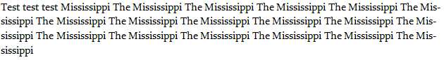

This output may be undesirable. If the document shall have a maximum of two consecutive hyphens, this requirement is specified using the following WordprocessingML in the document settings:

<w:consecutiveHyphenLimit w:val="2" />

The consecutiveHyphenLimit element's val attribute has a value of 2 specifying that a maximum of two hyphens should be allowed, limiting the hyphenation output like this:

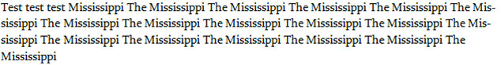

end example]

|  |
| --- |
| Parent Elements |
| settings (§) |

|  |  |
| --- | --- |
| Attributes | Description |
| val (Decimal Number Value) | Specifies that the contents of this attribute will contain a decimal number.  The contents of this decimal number are interpreted based on the context of the parent [XML](XML.docx) element.  [Example: Consider the following numeric WordprocessingML property of [type](type.docx) [ST_DecimalNumber](ST_DecimalNumber.docx):  <w:… w:val="1512645511" />  The value of the val attribute is a decimal number whose value must be interpreted in the context of the parent element. end example]  The possible values for this attribute are defined by the [ST_DecimalNumber](ST_DecimalNumber.docx) simple [type](type.docx) (§). |

The following [XML](XML.docx) Schema fragment defines the contents of this element:

<complexType [name](name.docx)="CT_DecimalNumber">

<attribute [name](name.docx)="val" [type](type.docx)="[ST_DecimalNumber](ST_DecimalNumber.docx)" use="required"/>

</complexType>