### continuationSeparator (Continuation Separator Mark)

This element specifies the presence of a continuation [separator](separator.docx) mark within the current run. A continuation [separator](separator.docx) mark is a horizontal line which spans the width of the main story's text extents.

[Note: The continuation [separator](separator.docx) mark is typically used within the context of continuation [separator](separator.docx) [footnotes](footnotes.docx) or endnotes. These [footnote](footnote.docx) and [endnote](endnote.docx) types define the [footnote](footnote.docx)/[endnote](endnote.docx) used to separate the contents of the main document story from continuation of [footnotes](footnotes.docx) or [endnotes](endnotes.docx) which began on a previous page. end note]

[Example: Consider the following two pages in a document, where some text is referenced by a [footnote](footnote.docx) that extends to the [next](next.docx) page (with the continuation [separator](separator.docx) circled in red):

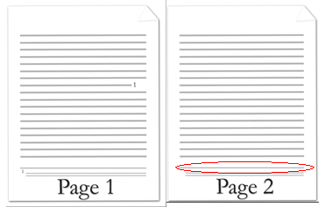

The line separating the document text from the [footnote](footnote.docx) that is continued on the [next](next.docx) page is represented by the following WordprocessingML:

<w:[footnote](footnote.docx) w:[type](type.docx)="continuationSeparator" w:[id](id.docx)="1">

<w:[p](p.docx)>

<w:[r](r.docx)>

<w:continuationSeparator />

</w:[r](r.docx)>

</w:[p](p.docx)>

</w:[footnote](footnote.docx)>

In this example, the [footnote](footnote.docx) has a content which consists of a single continuationSeparator, which is displayed as a horizontal line across the text extents. end example]

|  |
| --- |
| Parent Elements |
| [r](r.docx) (§); [r](r.docx) (§) |

The following [XML](XML.docx) Schema fragment defines the contents of this element:

<complexType [name](name.docx)="CT_Empty"/>