#### displayHorizontalDrawingGridEvery (Distance [between](between.docx) Horizontal Gridlines)

This element specifies the number of horizontal grid units defined using the [drawingGridHorizontalSpacing](drawingGridHorizontalSpacing.docx) element (§) which shall be allowed [between](between.docx) subsequent visible horizontal [drawing](drawing.docx) grid lines in this document, if gridlines are being shown. [Note: The display of gridlines is an application-level setting not specified in this Office Open [XML](XML.docx) Standard. end note] The [drawing](drawing.docx) grid is a grid which may be used by applications to help [position](position.docx) floating objects in the document.

If this element is omitted, then gridlines shall be displayed for each horizontal grid unit.

[Example: Consider the image below illustrating a WordprocessingML document in which all horizontal grid units are visible (the default setting):

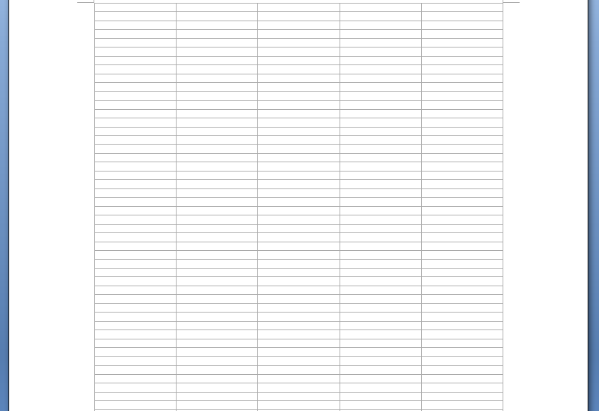

If the gridlines in this document shall only be displayed for every 4th horizontal [drawing](drawing.docx) gridline, that requirement would be specified using the following WordprocessingML in the document settings:

<w:displayHorizontalDrawingGridEvery w:val="4" />

The resulting grid would look like the following:

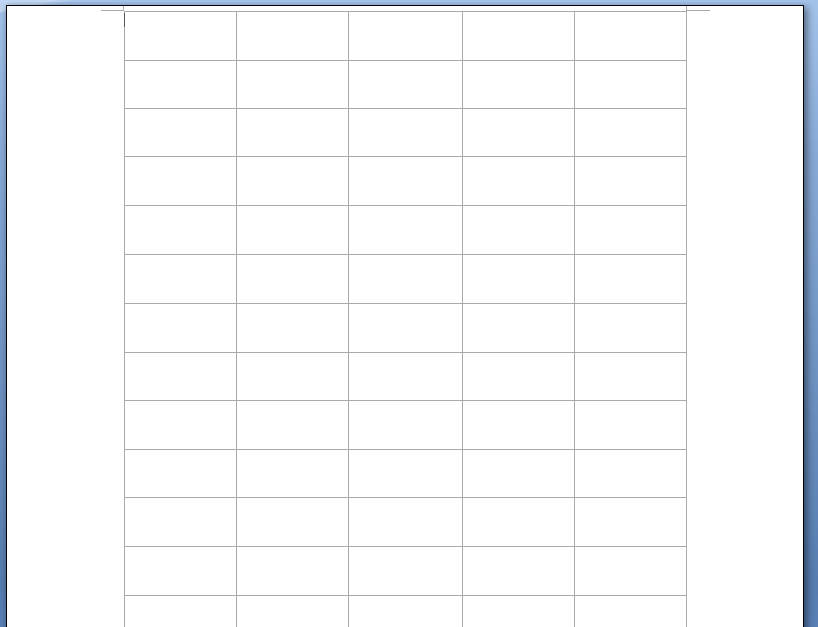

The displayHorizontalDrawingGridEvery element has its val attribute equal to 4, therefore every fourth gridline is displayed in the document when the [drawing](drawing.docx) grid is turned on. end example]

|  |
| --- |
| Parent Elements |
| settings (§) |

|  |  |
| --- | --- |
| Attributes | Description |
| val (Decimal Number Value) | Specifies that the contents of this attribute will contain a decimal number.  The contents of this decimal number are interpreted based on the context of the parent [XML](XML.docx) element.  [Example: Consider the following numeric WordprocessingML property of [type](type.docx) [ST_DecimalNumber](ST_DecimalNumber.docx):  <w:… w:val="1512645511" />  The value of the val attribute is a decimal number whose value must be interpreted in the context of the parent element. end example]  The possible values for this attribute are defined by the [ST_DecimalNumber](ST_DecimalNumber.docx) simple [type](type.docx) (§). |

The following [XML](XML.docx) Schema fragment defines the contents of this element:

<complexType [name](name.docx)="CT_DecimalNumber">

<attribute [name](name.docx)="val" [type](type.docx)="[ST_DecimalNumber](ST_DecimalNumber.docx)" use="required"/>

</complexType>