#### doNotBreakWrappedTables (Do Not Allow Floating [Tables](Tables.docx) To Break Across Pages)

This element specifies whether applications shall allow tables which have been set to floating using the [tblpPr](tblpPr.docx) element (§) shall be allowed to break across multiple pages when needed.

Typically, a [table](table.docx) whose contents cannot all be displayed on one page is broken as needed across multiple pages in order to preserve the location of the [table](table.docx) (just as a paragraph of multiple lines is broken across pages as needed). This element, when present with a val attribute value of true (or equivalent), specifies that floating tables shall never be broken across pages, and shall instead be put on the first page by adjusting the starting [position](position.docx) of the [table](table.docx) as needed to fit on that single page.

[Example: Consider a WordprocessingML document with a floating [table](table.docx) positioned at the bottom of a page , as follows:

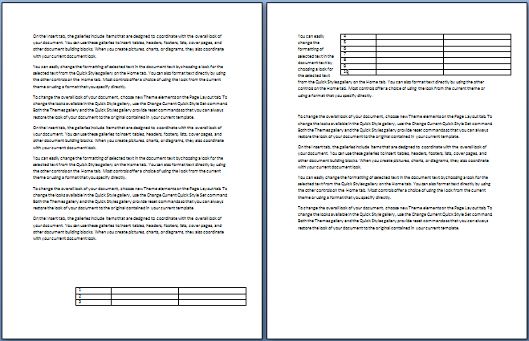

The default presentation of this document results in that [table](table.docx) being broken across two pages of content.

However, if this compatibility setting is turned on:

<w:[compat](compat.docx)>  
 <w:dontBreakWrappedTables />  
</w:[compat](compat.docx)>

Then that [table](table.docx) is not broken across the page boundary, so it must be moved further up on the first page to accommodate its entire size, resulting in the following output:

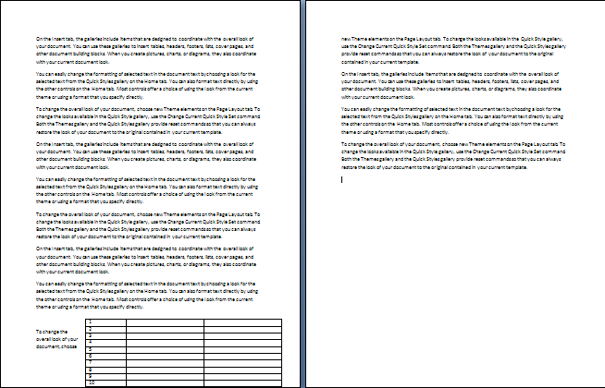

Notice that the [table](table.docx) now flows into the page margins in order to keep it on one page. end example]

|  |
| --- |
| Parent Elements |
| [compat](compat.docx) (§) |

|  |  |
| --- | --- |
| Attributes | Description |
| val (On/Off Value) | Specifies a binary value for the property defined by the parent [XML](XML.docx) element.  A value of on, 1, or true specifies that the property shall be explicitly applied. This is the default value for this attribute, and is implied when the parent element is present, but this attribute is omitted.  A value of off, 0, or false specifies that the property shall be explicitly turned off.  [Example: For example, consider the following on/off property:  <w:… w:val="off"/>  The val attribute explicitly declares that the property is turned off. end example]  The possible values for this attribute are defined by the [ST_OnOff](ST_OnOff.docx) simple [type](type.docx) (§). |

The following [XML](XML.docx) Schema fragment defines the contents of this element:

<complexType [name](name.docx)="CT_OnOff">

<attribute [name](name.docx)="val" [type](type.docx)="[ST_OnOff](ST_OnOff.docx)"/>

</complexType>