#### doNotSnapToGridInCell (Do Not Snap to Document Grid in Table Cells with Objects)

This element specifies whether a document grid defined using the [docGrid](docGrid.docx) element (§) shall be applied to the contents of [table](table.docx) cells in that section which also contain floating objects defined using the Vector Markup Language syntax. Note that the floating [object](object.docx) must be part of the cell, and simply not displayed over the cell due to its anchoring relative to another part of the document.

Typically, if a floating [object](object.docx) is present in a [table](table.docx) cell, then that setting shall have no impact on whether East Asian text in that cell is snapped to the document grid (as text is always snapped to the grid). This element, when present with a val attribute value of true (or equivalent), specifies that whenever a floating [object](object.docx) defined using VML is present in a [table](table.docx) cell, that the cell's contents shall not be snapped to the document grid.

[Example: Consider a WordprocessingML document consisting of a single section, whose document grid settings specify that each page shall be exactly 10 characters wide, as follows:

<w:[sectPr](sectPr.docx)>  
 <w:[docGrid](docGrid.docx) w:[type](type.docx)="snapToChars" w:charSpace="146636" />  
</w:[sectPr](sectPr.docx)>

If this document contains a [table](table.docx) with a single cell, containing some text and a single shape defined using the Vector Markup Language syntax, the contents of the cell are still snapped to the 10 characters per line character grid, as follows:

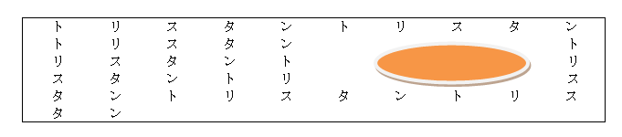

However, if this compatibility setting is turned on:

<w:[compat](compat.docx)>  
 <w:doNotSnapToGridInCell />  
</w:[compat](compat.docx)>

Then the presence of a floating [object](object.docx) in each cell shall [result](result.docx) in the document grid setting being ignored, resulting in the following output:

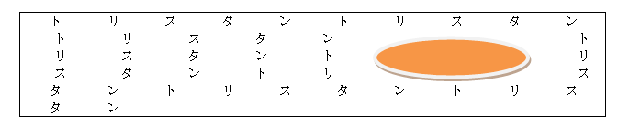

The additional character [pitch](pitch.docx) was still added to each character on the line, but those characters are no longer snapped to the document grid. end example]

|  |
| --- |
| Parent Elements |
| [compat](compat.docx) (§) |

|  |  |
| --- | --- |
| Attributes | Description |
| val (On/Off Value) | Specifies a binary value for the property defined by the parent [XML](XML.docx) element.  A value of on, 1, or true specifies that the property shall be explicitly applied. This is the default value for this attribute, and is implied when the parent element is present, but this attribute is omitted.  A value of off, 0, or false specifies that the property shall be explicitly turned off.  [Example: For example, consider the following on/off property:  <w:… w:val="off"/>  The val attribute explicitly declares that the property is turned off. end example]  The possible values for this attribute are defined by the [ST_OnOff](ST_OnOff.docx) simple [type](type.docx) (§). |

The following [XML](XML.docx) Schema fragment defines the contents of this element:

<complexType [name](name.docx)="CT_OnOff">

<attribute [name](name.docx)="val" [type](type.docx)="[ST_OnOff](ST_OnOff.docx)"/>

</complexType>