#### doNotSuppressIndentation (Do Not Ignore Floating Objects When Calculating Paragraph Indentation)

This element specifies whether applications should ignore the presence of floating objects when calculating the starting [position](position.docx) of paragraphs which are wrapped around floating objects defined using the Vector Markup Language (VML) syntax.

Typically, the presence of a floating [object](object.docx) on the same line or lines as a paragraph shall only affect the text when the floating [object](object.docx) occurs where that text would normally be presented. [Example: Text at a 1" indentation would only be displaced by a floating [object](object.docx) that appears at that [position](position.docx) and not one that appears from 0" to 0.5" on the same line. end example].

This element, when present with a val attribute value of true (or equivalent), specifies that floating objects shall always impact paragraphs on the same line in two ways:

* If the paragraph is not numbered, then it shall tightly wrap any floating [object](object.docx) which precedes it on the same line, ignoring its own indentation settings. [Example: A paragraph with a 1" left indent shall tightly wrap a floating [object](object.docx) which appears at only 0.25" on the same line. end example]
* If the paragraph is numbered using the [numPr](numPr.docx) element (§), then it shall calculate and use its full indent relative to the edge of the floating [object](object.docx), not relative to the edge of the page. [Example: A numbered paragraph with a 1" left indent shall appear 1.5" into the page if it is preceded by a floating [object](object.docx) which appears at 0.5" on the same line. end example]

[Example: Consider a WordprocessingML document with a narrow floating [object](object.docx) at 0.5" on the page, surrounded by both numbered and unnumbered paragraphs.

The default presentation would have no impact on the paragraphs based on that floating [object](object.docx), since two two do not intersect:

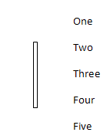

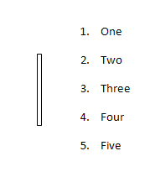

However, if this compatibility setting is turned on:

<w:[compat](compat.docx)>  
 <w:doNotSuppressIndentation />  
</w:[compat](compat.docx)>

Then the two alternate rules defined above would apply, resulting in the following output:

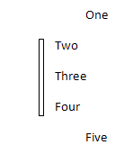

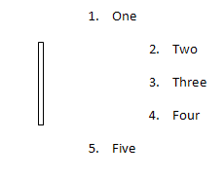

end example]

|  |
| --- |
| Parent Elements |
| [compat](compat.docx) (§) |

|  |  |
| --- | --- |
| Attributes | Description |
| val (On/Off Value) | Specifies a binary value for the property defined by the parent [XML](XML.docx) element.  A value of on, 1, or true specifies that the property shall be explicitly applied. This is the default value for this attribute, and is implied when the parent element is present, but this attribute is omitted.  A value of off, 0, or false specifies that the property shall be explicitly turned off.  [Example: For example, consider the following on/off property:  <w:… w:val="off"/>  The val attribute explicitly declares that the property is turned off. end example]  The possible values for this attribute are defined by the [ST_OnOff](ST_OnOff.docx) simple [type](type.docx) (§). |

The following [XML](XML.docx) Schema fragment defines the contents of this element:

<complexType [name](name.docx)="CT_OnOff">

<attribute [name](name.docx)="val" [type](type.docx)="[ST_OnOff](ST_OnOff.docx)"/>

</complexType>