#### doNotUseIndentAsNumberingTabStop (Ignore Hanging Indent When Creating Tab Stop After Numbering)

This element specifies whether applications shall use the custom [tab](tab.docx) stop generated by the hanging indent (if any) when advancing the text after the [numbering](numbering.docx) for a numbered paragraph.

Typically, a hanging indent on a paragraph creates a virtual custom [tab](tab.docx) stop at that location, and therefore a [tab](tab.docx) added after the [numbering](numbering.docx) on a numbered paragraph by the [suff](suff.docx) element (§) shall advance to that [tab](tab.docx) stop, so that the text of the numbered paragraph begins at that location. This element, when present with a val attribute value of true (or equivalent), specifies that a [tab](tab.docx) stop added as the suffix to the [numbering](numbering.docx) of a numbered paragraph shall ignore that virtual custom [tab](tab.docx) stop and shall instead advance to the [next](next.docx) real [tab](tab.docx) stop (custom or automatic) on the current line.

[Example: Consider a WordprocessingML document with [numbering](numbering.docx), whose first level of [numbering](numbering.docx) specifies a [tab](tab.docx) stop suffix, a hanging indent at 1", and a custom [tab](tab.docx) stop at 2":

<w:[abstractNum](abstractNum.docx) w:[numId](numId.docx)="0">  
 …  
 <w:[lvl](lvl.docx) w:[ilvl](ilvl.docx)="0">  
 <w:[suff](suff.docx) w:val="[tab](tab.docx)" />  
 <w:[pPr](pPr.docx)>  
 <w:[ind](ind.docx) w:left="1440" w:hanging="1440" />  
 <w:[tabs](tabs.docx)>  
 <w:[tab](tab.docx) w:val="2880" />  
 </w:[tabs](tabs.docx)>  
 </w:[pPr](pPr.docx)>  
 </w:[lvl](lvl.docx)>  
</w:[abstractNum](abstractNum.docx)>

The default presentation of this document results in the [tab](tab.docx) stop generated by the [numbering](numbering.docx) advancing to the virtual [tab](tab.docx) stop generated by the hanging indent at 1", as follows:

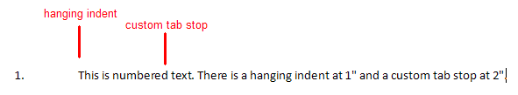

However, if this compatibility setting is turned on:

<w:[compat](compat.docx)>  
 <w:dontUseIndentAsNumberingTabStop />  
</w:[compat](compat.docx)>

Then that [tab](tab.docx) suffix ignores the virtual [tab](tab.docx) stop of the hanging indent, so it must advance to the [next](next.docx) custom [tab](tab.docx) stop on the line (at 2"), resulting in the following output:

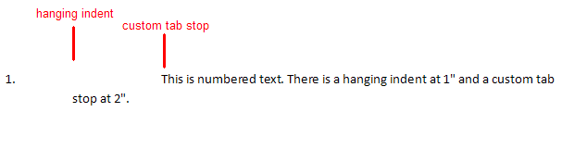

end example]

|  |
| --- |
| Parent Elements |
| [compat](compat.docx) (§) |

|  |  |
| --- | --- |
| Attributes | Description |
| val (On/Off Value) | Specifies a binary value for the property defined by the parent [XML](XML.docx) element.  A value of on, 1, or true specifies that the property shall be explicitly applied. This is the default value for this attribute, and is implied when the parent element is present, but this attribute is omitted.  A value of off, 0, or false specifies that the property shall be explicitly turned off.  [Example: For example, consider the following on/off property:  <w:… w:val="off"/>  The val attribute explicitly declares that the property is turned off. end example]  The possible values for this attribute are defined by the [ST_OnOff](ST_OnOff.docx) simple [type](type.docx) (§). |

The following [XML](XML.docx) Schema fragment defines the contents of this element:

<complexType [name](name.docx)="CT_OnOff">

<attribute [name](name.docx)="val" [type](type.docx)="[ST_OnOff](ST_OnOff.docx)"/>

</complexType>