#### doNotVertAlignCellWithSp (Don't Vertically Align Cells Containing Floating Objects)

This element specifies whether applications shall vertically align the contents of a [table](table.docx) cell, even when the contents of that [table](table.docx) cell include one or more floating objects defined using the Vector Markup Language syntax. Note that the floating [object](object.docx) must be part of the cell, and simply not displayed over the cell due to its anchoring relative to another part of the document.

Typically, if the alignment of a [table](table.docx) cell in a WordprocessingML document is specified, then the entire contents of that cell are aligned as specified [Example: The entire contents of the cell are centered vertically and moved right-aligned horizontally at that point. end example]. This element, when present with a val attribute value of true (or equivalent), specifies that whenever a floating [object](object.docx) defined using VML is present in a [table](table.docx) cell, that no vertical alignment shall be applied to the contents of that cell, and the contents of the cell shall instead always be top aligned to the cell's contents.

[Example: Consider a WordprocessingML [table](table.docx) with two cells, each containing some text and a single shape defined using the Vector Markup Language syntax. The first cell is vertically aligned to the bottom of the cell, and the second cell is vertically aligned to the center of the cell.

The default presentation of this document results in each cell (including the extents of the floating objects) being vertically aligned as specified, as follows:

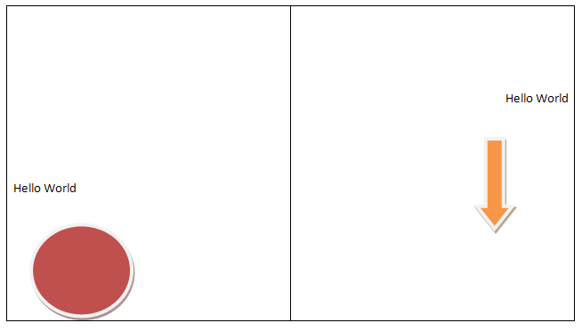

However, if this compatibility setting is turned on:

<w:[compat](compat.docx)>  
 <w:dontVertAlignCellWithSp />  
</w:[compat](compat.docx)>

Then the presence of a floating [object](object.docx) in each cell shall [result](result.docx) in the vertical alignment setting being ignored (each vertical alignment shall be top-aligned relative to the cell), resulting in the following output:

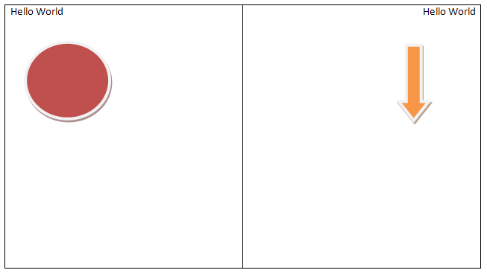

end example]

|  |
| --- |
| Parent Elements |
| [compat](compat.docx) (§) |

|  |  |
| --- | --- |
| Attributes | Description |
| val (On/Off Value) | Specifies a binary value for the property defined by the parent [XML](XML.docx) element.  A value of on, 1, or true specifies that the property shall be explicitly applied. This is the default value for this attribute, and is implied when the parent element is present, but this attribute is omitted.  A value of off, 0, or false specifies that the property shall be explicitly turned off.  [Example: For example, consider the following on/off property:  <w:… w:val="off"/>  The val attribute explicitly declares that the property is turned off. end example]  The possible values for this attribute are defined by the [ST_OnOff](ST_OnOff.docx) simple [type](type.docx) (§). |

The following [XML](XML.docx) Schema fragment defines the contents of this element:

<complexType [name](name.docx)="CT_OnOff">

<attribute [name](name.docx)="val" [type](type.docx)="[ST_OnOff](ST_OnOff.docx)"/>

</complexType>