### docGrid (Document Grid)

This element specifies the settings for the document grid, which enables precise layout of full-width East Asian language characters within a document by specifying the desired number of characters per line and lines per page for all East Asian text content in this section.

[Example: Consider a document with the document grid defined to allow 20 characters per line, and 20 lines per page by snapping characters to the grid ([type](type.docx) attribute of snapToChars) as follows:

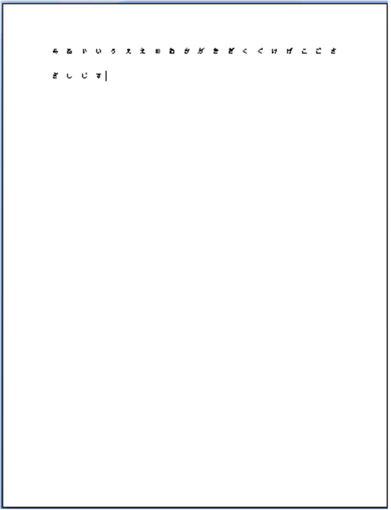

As shown, this document allows for only 20 East Asian characters per line by adjusting the inter-character [spacing](spacing.docx) to ensure that there are only 20 characters per line. end example]

If Latin text is interspersed on this line, then it is placed across the number of grid units needed to fit the content, but all other grid positions are unaffected.

[Example: Consider the example above with the addition of the text "Latin text" in English, as follows:

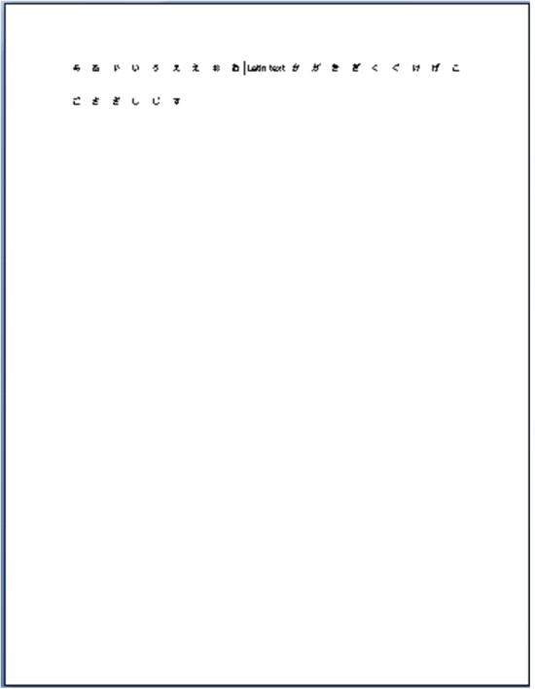

The Latin text spans two grid units, so it is placed in the center of those two units; no other grid positions are affected, so the text on the second line now spans two additional grid units. end example]

|  |
| --- |
| Parent Elements |
| [sectPr](sectPr.docx) (§); [sectPr](sectPr.docx) (§); [sectPr](sectPr.docx) (§) |

|  |  |
| --- | --- |
| Attributes | Description |
| charSpace (Document Grid Character Pitch) | Specifies the number of characters to be allowed on the document grid for each line in this section.  This attribute's value shall be specified by multiplying the difference [between](between.docx) the desired character [pitch](pitch.docx) and the character [pitch](pitch.docx) for that character in the font size of the Normal font by 4096.  This value shall then be used to add the character [pitch](pitch.docx) for the specified point size to each character in the section [Note: This results in text in the Normal style having a specific number of characters per line. end note]  [Example: Consider a section with a Normal font size of 11 points on which a 21 point [pitch](pitch.docx) document grid has been defined.. The resulting WordprocessingML would be defined as follows:  <w:docGrid w:charSize="40960" …/>  The charSpace attribute specifies a value of 40960, which means that the delta [between](between.docx) the character [pitch](pitch.docx) of each character in the grid and the Normal font is 10 points, resulting in a character [pitch](pitch.docx) of 11+10 = 21 points for all characters in this section. end example]  Individual runs of text can override the line [pitch](pitch.docx) information specified for the document grid by specifying that the run text shall not snap to the document grid via the [snapToGrid](snapToGrid.docx) element (§).  The possible values for this attribute are defined by the [ST_DecimalNumber](ST_DecimalNumber.docx) simple [type](type.docx) (§). |
| linePitch (Document Grid Line Pitch) | Specifies the number of lines to be allowed on the document grid for the current page assuming all lines have equal line [pitch](pitch.docx) applied to them. This line [pitch](pitch.docx) shall not be added to any line which appears within a [table](table.docx) cell unless the [adjustLineHeightInTable](adjustLineHeightInTable.docx) element (§) is present in the document's compatibility settings.  This attribute is specified in twentieths of a point, and defines the [pitch](pitch.docx) for each line of text on this page such that the desired number of single spaced lines of text fits on the current page.  [Example: Consider a standard 8.5x11" page on which a 20 character wide, 20 line document grid has been defined. The resulting WordprocessingML would be defined as follows:  <w:docGrid w:linePitch="684" …/>  The linePitch attribute specifies that 34.2 points is to the amount of [pitch](pitch.docx) allowed for each line on this page in order to maintain the specific document grid. end example]  Individual paragraphs can override the line [pitch](pitch.docx) information specified for the document grid by either:   * Specifying an exact line [spacing](spacing.docx) value using the lineRule attribute of value exact on the [spacing](spacing.docx) element (§). * Specifying that the paragraph text shall not snap to the document grid via the [snapToGrid](snapToGrid.docx) element (§).   The possible values for this attribute are defined by the [ST_DecimalNumber](ST_DecimalNumber.docx) simple [type](type.docx) (§). |
| [type](type.docx) (Document Grid Type) | Specifies the [type](type.docx) of the current document grid, which defines the grid behavior.  The grid can define a grid which snaps all East Asian characters to grid positions, but leaves Latin text with its default spacing; a grid which adds the specified character [pitch](pitch.docx) to each character on each row; or a grid which affects only the line [pitch](pitch.docx) for the current section.  [Example: Consider the document discussed above with the document grid defined to allow 20 characters per line, and 20 lines per page by snapping characters to the grid as follows:    This document has a [type](type.docx) attribute of snapToChars, which specifies that the grid shall force East Asian characters to fit 20 to a line. end example]  The possible values for this attribute are defined by the [ST_DocGrid](ST_DocGrid.docx) simple [type](type.docx) (§). |

The following [XML](XML.docx) Schema fragment defines the contents of this element:

<complexType [name](name.docx)="CT_DocGrid">

<attribute [name](name.docx)="[type](type.docx)" [type](type.docx)="[ST_DocGrid](ST_DocGrid.docx)"/>

<attribute [name](name.docx)="linePitch" [type](type.docx)="[ST_DecimalNumber](ST_DecimalNumber.docx)"/>

<attribute [name](name.docx)="charSpace" [type](type.docx)="[ST_DecimalNumber](ST_DecimalNumber.docx)"/>

</complexType>