#### drawingGridVerticalSpacing (Drawing Grid Vertical Grid Unit Size)

This element specifies the width of vertical grid units in this document. The [drawing](drawing.docx) grid is a grid which may be used by applications to help [position](position.docx) floating objects in the document.

If this element is omitted, then each vertical grid unit shall be 180 twentieths of a point (0.125") in width.

[Example: Consider the image below illustrating a WordprocessingML document in which all vertical grid units are each 144 twentieths of a point high (and all are showing):



If the vertical gridlines in this document shall only be displayed for every half an inch, that requirement would be specified using the following WordprocessingML in the document settings:

<w:drawingGridVerticalSpacing w:val="720" />

The resulting grid would look like the following:

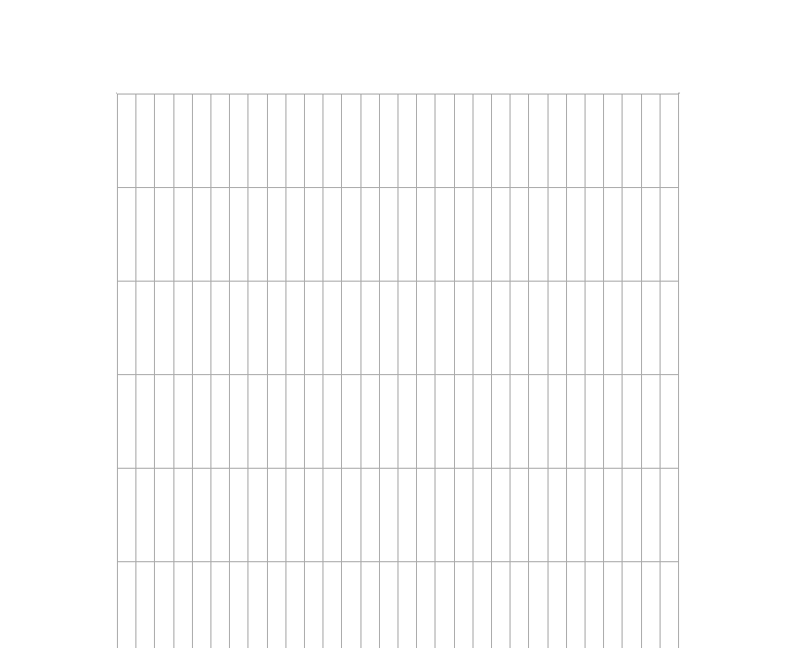

The drawingGridVerticalSpacing element has its val attribute equal to 720, therefore every vertical gridline has a height of one half of an inch (720 twentieths of a point). end example]

|  |
| --- |
| Parent Elements |
| settings (§) |

|  |  |
| --- | --- |
| Attributes | Description |
| val (Measurement in Twentieths of a Point) | Specifies a positive measurement value, specified in twentieths of a point. This value is interpreted based on the context of the parent [XML](XML.docx) element.  [Example: Consider the following WordprocessingML element with a val attribute containing a positive measurement in twentieths of a point:  <w:… w:val="720" />  The val attribute has a value of 720, specifying that this measurement value is 720 twentieths of a point (0.5"). This value is interpreted by the parent element as needed. end example]  The possible values for this attribute are defined by the [ST_TwipsMeasure](ST_TwipsMeasure.docx) simple [type](type.docx) (§). |

The following [XML](XML.docx) Schema fragment defines the contents of this element:

<complexType [name](name.docx)="CT_TwipsMeasure">

<attribute [name](name.docx)="val" [type](type.docx)="[ST_TwipsMeasure](ST_TwipsMeasure.docx)" use="required"/>

</complexType>