### [endnotePr](endnotePr.docx) (Document-Wide Endnote Properties)

This element specifies the [endnote](endnote.docx) properties for the current document. Each of these properties are stored as a child element within the [endnotePr](endnotePr.docx) element.

These properties may be overridden for a specific section via the section-wide [endnotePr](endnotePr.docx) element (§).

[Example: Consider the following document with two sections, where the [endnotes](endnotes.docx) for each section appears at the end of that section and use lower case roman numerals:

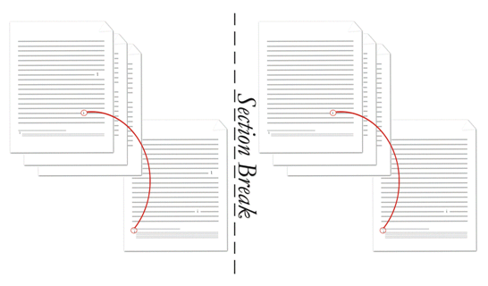

Since both sections are identical, the [endnote](endnote.docx) properties are specified as document-wide level properties (this is not necessary but is most efficient) as follows:

<w:[settings](settings.docx)>

…

<w:[endnotePr](endnotePr.docx)>

<w:[numFmt](numFmt.docx) w:val="lowerRoman" />

<w:[pos](pos.docx) w:val="sectEnd"/>

</w:[endnotePr](endnotePr.docx)>

…

</w:[settings](settings.docx)>

Note that the [pos](pos.docx) element could have been omitted since it is using its default value. end example]

|  |
| --- |
| Parent Elements |
| settings (§) |

|  |  |
| --- | --- |
| Child Elements | Subclause |
| [endnote](endnote.docx) (Special Endnote List) | § |
| [numFmt](numFmt.docx) (Endnote [Numbering](Numbering.docx) Format) | § |
| [numRestart](numRestart.docx) (Footnote and Endnote [Numbering](Numbering.docx) Restart Location) | § |
| [numStart](numStart.docx) (Footnote and Endnote [Numbering](Numbering.docx) Starting Value) | § |
| [pos](pos.docx) (Endnote Placement) | § |

The following [XML](XML.docx) Schema fragment defines the contents of this element:

<complexType [name](name.docx)="CT_EdnDocProps">

<complexContent>

<extension base="CT_EdnProps">

<sequence>

<element name="[endnote](endnote.docx)" [type](type.docx)="CT_FtnEdnSepRef" minOccurs="0" maxOccurs="3"/>

</sequence>

</extension>

</complexContent>

</complexType>