### endnoteRef (Endnote Reference Mark)

This element specifies the presence of an [endnote](endnote.docx) reference mark. An [endnote](endnote.docx) reference mark is a run of automatically numbered text which follows the [numbering](numbering.docx) [format](format.docx) set forth via the [numFmt](numFmt.docx) element (§).

If an [endnote](endnote.docx) reference mark is specified within a run which is not part of an [endnote](endnote.docx), then that [endnote](endnote.docx) reference mark may be ignored.

[Example: Consider the following document where some text is referenced by an [endnote](endnote.docx) at the end of the document:

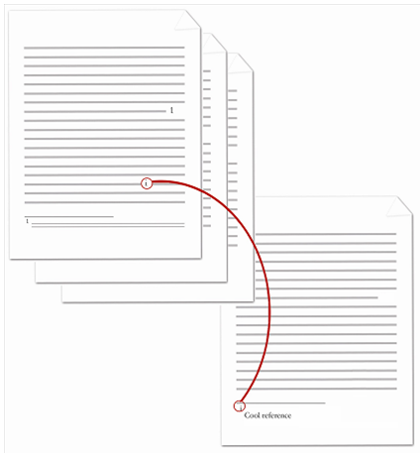

The [endnote](endnote.docx) reference mark is the lower case roman numeral within the actual [endnote](endnote.docx) itself in the diagram above. The contents of the [endnote](endnote.docx) (including the [endnote](endnote.docx) reference mark) are represented by the following WordprocessingML:

<w:[endnote](endnote.docx) w:[id](id.docx)="2">

<w:[p](p.docx)>

<w:[pPr](pPr.docx)>

<w:[pStyle](pStyle.docx) w:val="EndnoteText" />

</w:[pPr](pPr.docx)>

<w:[r](r.docx)>

<w:[rPr](rPr.docx)>

<w:[rStyle](rStyle.docx) w:val="EndnoteReference" />

</w:[rPr](rPr.docx)>

<w:endfootnoteRef />

</w:[r](r.docx)>

<w:[r](r.docx)>

<w:[t](t.docx)>Cool reference</w:[t](t.docx)>

</w:[r](r.docx)>

</w:[p](p.docx)>

</w:[endnote](endnote.docx)>

The resulting [endnote](endnote.docx) contains the literal [endnote](endnote.docx) content of Cool reference, preceding by an automatically numbered [endnote](endnote.docx) reference mark. Since this is the first [endnote](endnote.docx) in the document, that automatically numbered reference mark uses the lower case roman numeral [i](i.docx). end example]

|  |
| --- |
| Parent Elements |
| [r](r.docx) (§); [r](r.docx) (§) |

The following [XML](XML.docx) Schema fragment defines the contents of this element:

<complexType [name](name.docx)="CT_Empty"/>