### endnoteReference (Endnote Reference)

This element specifies the presence of an [endnote](endnote.docx) reference. An [endnote](endnote.docx) reference is a run of automatically numbered text which references a particular [endnote](endnote.docx) within the parent document, and inherits the [endnote](endnote.docx) reference mark's numbering.

If an [endnote](endnote.docx) reference is specified within a [footnote](footnote.docx) or [endnote](endnote.docx), then the document shall be considered non-conformant.

[Example: Consider the following document where some text is referenced by an [endnote](endnote.docx) at the end of the document:

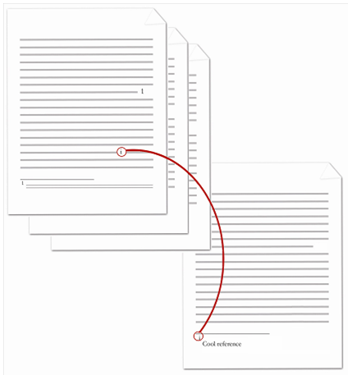

The [endnote](endnote.docx) reference is the lower case roman numeral within the document content in the diagram above. The contents of the paragraph which contains the [endnote](endnote.docx) reference are represented by the following WordprocessingML:

<w:[p](p.docx)>  
 <w:[r](r.docx)>  
 <w:[t](t.docx)>This text is followed by an endnote</w:[t](t.docx)>  
 </w:[r](r.docx)>  
 <w:[r](r.docx)>  
 <w:[rPr](rPr.docx)>  
 <w:[rStyle](rStyle.docx) w:val="EndnoteReference" />  
 </w:[rPr](rPr.docx)>  
 <w:endnoteReference w:[id](id.docx)="2" />  
 </w:[r](r.docx)>  
 <w:[r](r.docx)>  
 <w:[t](t.docx)>.</w:[t](t.docx)>  
 </w:[r](r.docx)>  
</w:[p](p.docx)>

The resulting paragraph contains the literal text content of This text is followed by an [endnote](endnote.docx), followed by an automatically numbered [endnote](endnote.docx) reference. Since this is the first [endnote](endnote.docx) in the document, that automatically numbered reference inherits the lower case roman numeral [i](i.docx) from the [endnote](endnote.docx) reference mark. end example]

|  |
| --- |
| Parent Elements |
| [r](r.docx) (§); [r](r.docx) (§) |

|  |  |
| --- | --- |
| Attributes | Description |
| customMarkFollows (Suppress Footnote/Endnote Reference Mark) | Specifies that the current [footnote](footnote.docx) or [endnote](endnote.docx) shall not have an associated [footnote](footnote.docx) or [endnote](endnote.docx) reference mark, as appropriate.  This attribute shall be used to specify that a particular [footnote](footnote.docx) or [endnote](endnote.docx) shall not increment the [numbering](numbering.docx) for its associated [footnote](footnote.docx)/[endnote](endnote.docx) [numbering](numbering.docx) [format](format.docx), so that the use of a [footnote](footnote.docx) with a custom [footnote](footnote.docx) mark does not cause a missing value in the [footnote](footnote.docx)/[endnote](endnote.docx) values. The display of the mark is specified via the [footnoteRef](footnoteRef.docx)/[endnoteRef](endnoteRef.docx) elements, as appropriate.  If this attribute is omitted, then the [footnote](footnote.docx) or [endnote](endnote.docx) reference mark shall not be skipped when incrementing over this [footnote](footnote.docx) or endnote.  [Example: Consider a [footnote](footnote.docx) with an [id](id.docx) value of 1 that uses a custom [footnote](footnote.docx) mark:  <w:[footnotes](footnotes.docx)>  <w:[footnote](footnote.docx) w:[id](id.docx)="0">  …  </w:[footnote](footnote.docx)>  <w:[footnote](footnote.docx) w:suppressRef="1" w:[id](id.docx)="2">  …  </w:[footnote](footnote.docx)>  <w:[footnote](footnote.docx) w:[id](id.docx)="2">  …  </w:[footnote](footnote.docx)>  </w:[footnotes](footnotes.docx)>  If the [numbering](numbering.docx) [format](format.docx) for [footnotes](footnotes.docx) in this document is upperRoman, then the first [footnote](footnote.docx) shall be I, the second is suppressed, and the third is II, noticing that the second does not increment the [numbering](numbering.docx) sequence. end example]  The possible values for this attribute are defined by the [ST_OnOff](ST_OnOff.docx) simple [type](type.docx) (§). |
| [id](id.docx) (Footnote/Endnote ID Reference) | Specifies the [footnote](footnote.docx) or [endnote](endnote.docx) which is being referenced by the current [footnote](footnote.docx) or [endnote](endnote.docx) reference in the document.  If the resulting [footnote](footnote.docx) or [endnote](endnote.docx) ID is not present in the [footnotes](footnotes.docx) or [endnote](endnote.docx) part (as appropriate), then this document shall be considered non-conformant.  [Example: Consider a paragraph with an [endnote](endnote.docx) reference, represented by the following WordprocessingML:  <w:[p](p.docx)>  <w:[r](r.docx)>  <w:[t](t.docx)>This text is followed by an endnote</w:[t](t.docx)>  </w:[r](r.docx)>  <w:[r](r.docx)>  <w:endnoteReference w:[id](id.docx)="2" />  </w:[r](r.docx)>  <w:[r](r.docx)>  <w:[t](t.docx)>.</w:[t](t.docx)>  </w:[r](r.docx)> </w:[p](p.docx)>  This text references the [endnote](endnote.docx) in the document's [endnotes](endnotes.docx) part which has an [id](id.docx) value of 2. end example]  The possible values for this attribute are defined by the [ST_DecimalNumber](ST_DecimalNumber.docx) simple [type](type.docx) (§). |

The following [XML](XML.docx) Schema fragment defines the contents of this element:

<complexType [name](name.docx)="CT_FtnEdnRef">

<attribute [name](name.docx)="customMarkFollows" [type](type.docx)="[ST_OnOff](ST_OnOff.docx)" use="optional"/>

<attribute [name](name.docx)="[id](id.docx)" use="required" [type](type.docx)="[ST_DecimalNumber](ST_DecimalNumber.docx)"/>

</complexType>