### [footnotePr](footnotePr.docx) (Document-Wide Footnote Properties)

This element specifies the [footnote](footnote.docx) properties for this document. Each property is stored as a unique element within the [footnotePr](footnotePr.docx) element.

These properties may be overridden for a specific section via the section-wide [footnotePr](footnotePr.docx) element (§).

[Example: Consider the following one page document, where the [footnote](footnote.docx) appears beneath the text it references:

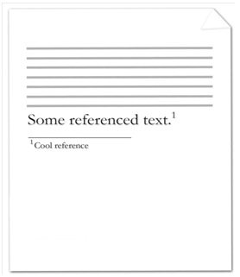

Since the document consists of a single [footnote](footnote.docx), the [footnote](footnote.docx) properties may be stored in either the section-wide or document-wide [footnote](footnote.docx) properties. Assuming that they are stored in the latter, the [footnote](footnote.docx) properties are represented by the following WordprocessingML:

<w:[settings](settings.docx)>

…

<w:[footnotePr](footnotePr.docx)>

<w:[pos](pos.docx) w:val="beneathText" />

</w:[footnotePr](footnotePr.docx)>

…

</w:[settings](settings.docx)>

The [footnote](footnote.docx) properties specify that [footnotes](footnotes.docx) will appear below the noted text end example]

|  |
| --- |
| Parent Elements |
| settings (§) |

|  |  |
| --- | --- |
| Child Elements | Subclause |
| [footnote](footnote.docx) (Special Footnote List) | § |
| [numFmt](numFmt.docx) (Footnote [Numbering](Numbering.docx) Format) | § |
| [numRestart](numRestart.docx) (Footnote and Endnote [Numbering](Numbering.docx) Restart Location) | § |
| [numStart](numStart.docx) (Footnote and Endnote [Numbering](Numbering.docx) Starting Value) | § |
| [pos](pos.docx) (Footnote Placement) | § |

The following [XML](XML.docx) Schema fragment defines the contents of this element:

<complexType [name](name.docx)="CT_FtnDocProps">

<complexContent>

<extension base="CT_FtnProps">

<sequence>

<element name="[footnote](footnote.docx)" [type](type.docx)="CT_FtnEdnSepRef" minOccurs="0" maxOccurs="3"/>

</sequence>

</extension>

</complexContent>

</complexType>