### footnoteRef (Footnote Reference Mark)

This element specifies the presence of a [footnote](footnote.docx) reference mark. A [footnote](footnote.docx) reference mark is a run of automatically numbered text which follows the [numbering](numbering.docx) [format](format.docx) set forth via the [footnote](footnote.docx) [numFmt](numFmt.docx) element (§).

If a [footnote](footnote.docx) reference mark is specified within a run which is not part of a [footnote](footnote.docx), then that [footnote](footnote.docx) reference mark may be ignored.

[Example: Consider the following document where some text is referenced by an [footnote](footnote.docx) at the end of the page:

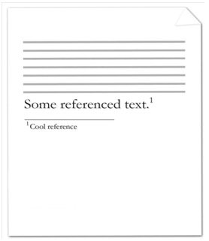

The [footnote](footnote.docx) reference mark is the decimal number within the actual [footnote](footnote.docx) itself in the image above. The contents of the [footnote](footnote.docx) (including the [footnote](footnote.docx) reference mark) are represented by the following WordprocessingML:

<w:[footnote](footnote.docx) w:[id](id.docx)="2">

<w:[p](p.docx)>

<w:[pPr](pPr.docx)>

<w:[pStyle](pStyle.docx) w:val="FootnoteText" />

</w:[pPr](pPr.docx)>

<w:[r](r.docx)>

<w:[rPr](rPr.docx)>

<w:[rStyle](rStyle.docx) w:val="FootnoteReference" />

</w:[rPr](rPr.docx)>

<w:footnoteRef />

</w:[r](r.docx)>

<w:[r](r.docx)>

<w:[t](t.docx)>Cool reference</w:[t](t.docx)>

</w:[r](r.docx)>

</w:[p](p.docx)>

</w:[footnote](footnote.docx)>

The resulting [footnote](footnote.docx) contains the literal [endnote](endnote.docx) content of Cool reference, preceding by an automatically numbered [footnote](footnote.docx) reference mark. Since this is the first [footnote](footnote.docx) in the document, that automatically numbered reference mark uses the first decimal number 1. It is also important to note that the use of [styles](styles.docx) FootnoteText and FootnoteReference is not required, these may simply be added by a particular producer automatically to give the [footnote](footnote.docx) contents are particular style (just like any other use of styles). end example]

|  |
| --- |
| Parent Elements |
| [r](r.docx) (§); [r](r.docx) (§) |

The following [XML](XML.docx) Schema fragment defines the contents of this element:

<complexType [name](name.docx)="CT_Empty"/>