#### frame (Single Frame Properties)

This element specifies the properties for a single frame within a [frameset](frameset.docx) document. When a document defines a [frameset](frameset.docx) using the [frameset](frameset.docx) element; that [frameset](frameset.docx) is composed of a set of frames, each of which is specified by a single frame element.

[Example: Consider a WordprocessingML document which serves as the [frameset](frameset.docx) container for a [frameset](frameset.docx) consisting of the following three frames:

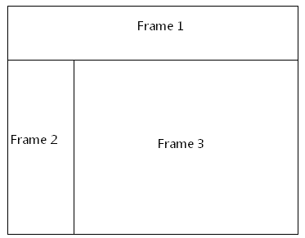

The [frameset](frameset.docx) properties for this document are specified by the following WordprocessingML within the web page settings:

<w:[frameset](frameset.docx)>

…

<w:frame>

<w:[sz](sz.docx) w:val="20%" />  
 <w:name w:val="Frame 1" />  
 <w:[sourceFileName](sourceFileName.docx) r:id="rId1" />

</w:frame>

<w:[frameset](frameset.docx)>

…

</w:[frameset](frameset.docx)>

</w:[frameset](frameset.docx)>

The frame element specifies the set of properties for a single frame in the document. In this case, these properties (for the frame marked with Frame 1 in the diagram above) specify that the frame shall have the following properties:

* A height of 20% of the height of the document
* A name of Frame 1
* The contents of the frame shall be pulled from the document that is the target of the relationship with ID rId1

end example]

|  |
| --- |
| Parent Elements |
| [frameset](frameset.docx) (§); [frameset](frameset.docx) (§) |

|  |  |
| --- | --- |
| Child Elements | Subclause |
| [linkedToFile](linkedToFile.docx) (Maintain Link to Existing File) | § |
| [marH](marH.docx) (Top and Bottom Margin for Frame) | § |
| [marW](marW.docx) (Left and Right Margin for Frame) | § |
| [name](name.docx) (Frame Name) | § |
| [noResizeAllowed](noResizeAllowed.docx) (Frame Cannot Be Resized) | § |
| [scrollbar](scrollbar.docx) (Scrollbar Display Option) | § |
| [sourceFileName](sourceFileName.docx) (Source File for Frame) | § |
| [sz](sz.docx) (Frame Size) | § |

The following [XML](XML.docx) Schema fragment defines the contents of this element:

<complexType [name](name.docx)="CT_Frame">

<sequence>

<element [name](name.docx)="[sz](sz.docx)" [type](type.docx)="CT_String" minOccurs="0"/>

<element [name](name.docx)="[name](name.docx)" [type](type.docx)="CT_String" minOccurs="0"/>

<element [name](name.docx)="[sourceFileName](sourceFileName.docx)" [type](type.docx)="CT_Rel" minOccurs="0"/>

<element [name](name.docx)="[marW](marW.docx)" [type](type.docx)="CT_PixelsMeasure" minOccurs="0"/>

<element [name](name.docx)="[marH](marH.docx)" [type](type.docx)="CT_PixelsMeasure" minOccurs="0"/>

<element [name](name.docx)="[scrollbar](scrollbar.docx)" [type](type.docx)="CT_FrameScrollbar" minOccurs="0"/>

<element [name](name.docx)="[noResizeAllowed](noResizeAllowed.docx)" [type](type.docx)="CT_OnOff" minOccurs="0"/>

<element [name](name.docx)="[linkedToFile](linkedToFile.docx)" [type](type.docx)="CT_OnOff" minOccurs="0"/>

</sequence>

</complexType>