#### frameLayout (Frameset Layout)

This element specifies the order in which the frames (and nested framesets) in a [frameset](frameset.docx) shall be displayed. When a [frameset](frameset.docx) is created, it can only contain frames which are stacked in one direction:

* Vertically (one on top of another)
* Horizontally (one [next](next.docx) to another)

This element specifies how the frames in this [frameset](frameset.docx) are stacked, which shall also be used to interpret the sizes defined by the [sz](sz.docx) element (§) for each frame. In order to determine the ordering of the constituent frames within this [frameset](frameset.docx), the ordering of the child [frame](frame.docx) and [frameset](frameset.docx) elements shall be used.

If this element is omitted, then the frames in this [frameset](frameset.docx) shall be stacked vertically on top of one another (a row frameset).

[Example: Consider a WordprocessingML document which serves as the [frameset](frameset.docx) container for a [frameset](frameset.docx) consisting of the following three frames:

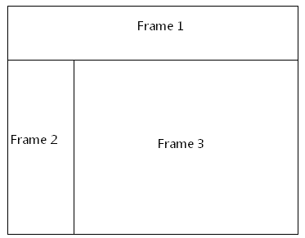

The [frameset](frameset.docx) properties for this document are specified by the following WordprocessingML within the web page settings:

<w:[frameset](frameset.docx)>

<w:frameLayout w:val="rows" />

<w:[frame](frame.docx)>

…

</w:[frame](frame.docx)>

<w:[frameset](frameset.docx)>

<w:frameLayout w:val="[cols](cols.docx)" />

<w:[frame](frame.docx)>

…

</w:[frame](frame.docx)>

<w:[frame](frame.docx)>

…

</w:[frame](frame.docx)>

</w:[frameset](frameset.docx)>

</w:[frameset](frameset.docx)>

The frameLayout element specifies that the outer [frameset](frameset.docx) is a consists of the single [frame](frame.docx) and the child [frameset](frameset.docx) stacked vertically, and an inner nested [frameset](frameset.docx) consisting of two frames stacked horizontally. end example]

|  |
| --- |
| Parent Elements |
| [frameset](frameset.docx) (§); [frameset](frameset.docx) (§) |

|  |  |
| --- | --- |
| Attributes | Description |
| val (Frameset Layout Value) | Specifies the [type](type.docx) of layout which shall be used to display the contents of the frames and nested framesets within this [frameset](frameset.docx), as defined by the simple [type](type.docx) referenced below.  [Example: Consider a [frameset](frameset.docx) definition within a WordprocessingML document which defines the following [frameset](frameset.docx) layout setting:  <w:[frame](frame.docx)>  <w:frameLayout w:val="[cols](cols.docx)" />  … </w:[frame](frame.docx)>  The val attribute value of [cols](cols.docx) specifies that the contents of this [frameset](frameset.docx) shall be stacked horizontally (in columns). end example]  The possible values for this attribute are defined by the [ST_FrameLayout](ST_FrameLayout.docx) simple [type](type.docx) (§). |

The following [XML](XML.docx) Schema fragment defines the contents of this element:

<complexType [name](name.docx)="CT_FrameLayout">

<attribute [name](name.docx)="val" [type](type.docx)="[ST_FrameLayout](ST_FrameLayout.docx)" use="required"/>

</complexType>