#### framesetSplitbar (Frameset Splitter Properties)

This element specifies the properties for the splitters associated with this frameset. A splitter is a horizontal or vertical line which visually separates the contents of one [frame](frame.docx) from another within a frameset.

If this element is omitted, then the default parameters for each of the child [frameset](frameset.docx) properties shall be used for all splitters in this frameset.

[Example: Consider a [frameset](frameset.docx) consisting of the following three frames:

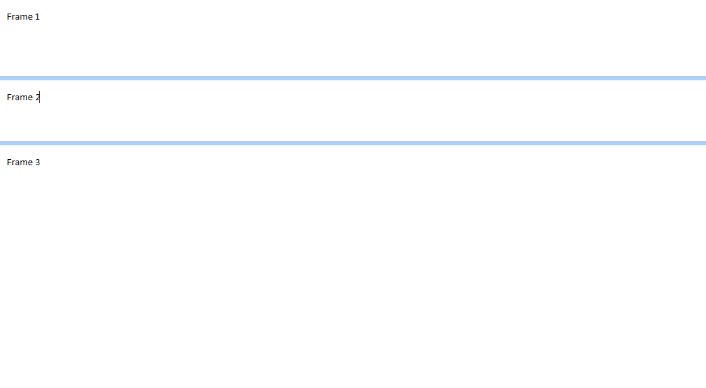

The following properties define the presentation of the splitter bars within this frameset:

<w:[frameset](frameset.docx)>  
 <w:framesetSplitbar>  
 <w:[w](w.docx) w:val="90" />  
 <w:[color](color.docx) w:val="auto" />  
 </w:framesetSplitbar>  
 …   
</w:[frameset](frameset.docx)>

The framesetSplitbar element specifies the properties for all splitters in this frameset; in this case, those properties are that the splitter shall be 4.5 points (90 twentieths of a point) wide, and that the [color](color.docx) of the splitter shall be automatically determined via the attribute value of auto. end example]

|  |
| --- |
| Parent Elements |
| [frameset](frameset.docx) (§); [frameset](frameset.docx) (§) |

|  |  |
| --- | --- |
| Child Elements | Subclause |
| [color](color.docx) (Frameset Splitter Color) | § |
| [flatBorders](flatBorders.docx) (Frameset Splitter Border Style) | § |
| [noBorder](noBorder.docx) (Do Not Display Frameset Splitters) | § |
| [w](w.docx) (Frameset Splitter Width) | § |

The following [XML](XML.docx) Schema fragment defines the contents of this element:

<complexType [name](name.docx)="CT_FramesetSplitbar">

<sequence>

<element [name](name.docx)="[w](w.docx)" [type](type.docx)="CT_TwipsMeasure" minOccurs="0"/>

<element [name](name.docx)="[color](color.docx)" [type](type.docx)="CT_Color" minOccurs="0"/>

<element [name](name.docx)="[noBorder](noBorder.docx)" [type](type.docx)="CT_OnOff" minOccurs="0"/>

<element [name](name.docx)="[flatBorders](flatBorders.docx)" [type](type.docx)="CT_OnOff" minOccurs="0"/>

</sequence>

</complexType>