#### [frameset](frameset.docx) (Root Frameset Definition)

This element specifies that this document is the container for a frameset. This WordprocessingML element is analogous to the [frameset](frameset.docx) element in HTML.

When the [frameset](frameset.docx) element is present within a document, that document shall serve as a [frameset](frameset.docx) definition only; all of its normal document content shall therefore not be displayed as long as it contains at least one child [frame](frame.docx) or [frameset](frameset.docx) element.

If this element is omitted, then the currently document shall not be treated as a [frameset](frameset.docx) definition; its regular document content shall be displayed.

[Example: Consider a WordprocessingML document which serves as the [frameset](frameset.docx) container for a [frameset](frameset.docx) consisting of the following three frames:

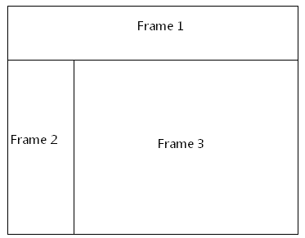

The [frameset](frameset.docx) properties for this document are specified by the following WordprocessingML within the web page settings:

<w:[frameset](frameset.docx)>

<w:[frameLayout](frameLayout.docx) w:val="rows" />

<w:[frame](frame.docx)>

…

</w:[frame](frame.docx)>

<w:[frameset](frameset.docx)>

<w:[frameLayout](frameLayout.docx) w:val="[cols](cols.docx)" />

<w:[frame](frame.docx)>

…

</w:[frame](frame.docx)>

<w:[frame](frame.docx)>

…

</w:[frame](frame.docx)>

</w:[frameset](frameset.docx)>

</w:[frameset](frameset.docx)>

The parent [frameset](frameset.docx) element specifies that the current document is a [frameset](frameset.docx) definition; that [frameset](frameset.docx) consists of a single [frame](frame.docx) and another nested [frameset](frameset.docx) stacked vertically. end example]

|  |
| --- |
| Parent Elements |
| [webSettings](webSettings.docx) (§) |

|  |  |
| --- | --- |
| Child Elements | Subclause |
| [frame](frame.docx) (Single Frame Properties) | § |
| [frameLayout](frameLayout.docx) (Frameset Layout) | § |
| [frameset](frameset.docx) (Nested Frameset Definition) | § |
| [framesetSplitbar](framesetSplitbar.docx) (Frameset Splitter Properties) | § |
| [sz](sz.docx) (Nested Frameset Size) | § |

The following [XML](XML.docx) Schema fragment defines the contents of this element:

<complexType [name](name.docx)="CT_Frameset">

<sequence>

<element [name](name.docx)="[sz](sz.docx)" [type](type.docx)="CT_String" minOccurs="0"/>

<element [name](name.docx)="[framesetSplitbar](framesetSplitbar.docx)" [type](type.docx)="CT_FramesetSplitbar" minOccurs="0"/>

<element [name](name.docx)="[frameLayout](frameLayout.docx)" [type](type.docx)="CT_FrameLayout" minOccurs="0"/>

<choice minOccurs="0" maxOccurs="unbounded">

<element name="[frameset](frameset.docx)" [type](type.docx)="CT_Frameset" minOccurs="0" maxOccurs="unbounded"/>

<element name="[frame](frame.docx)" [type](type.docx)="CT_Frame" minOccurs="0" maxOccurs="unbounded"/>

</choice>

</sequence>

</complexType>