#### marBottom (Bottom Margin for HTML div)

This element specifies the margin which shall be displayed at the bottom of the boundaries of the current HTML [div](div.docx) object.

If this element is omitted, then this HTML [div](div.docx) [object](object.docx) shall not have a bottom margin.

[Example: Consider a simple HTML document defined as follows:

<html>  
 <[body](body.docx)>  
 <[div](div.docx) style="margin-top:100px; margin-left:200px; margin-right:50px; margin-bottom:100px">

<[p](p.docx)>paragraph of text</[p](p.docx)>

</[div](div.docx)>

<[p](p.docx)>another paragraph of text</[p](p.docx)>

</[body](body.docx)>  
</html>

This HTML would therefore normally appear as follows (image scaled appropriately):

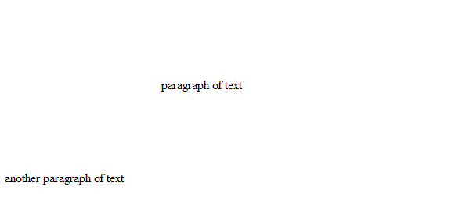

Now, when this document is saved in the WordprocessingML [format](format.docx), the information stored on the [div](div.docx) elements is stored in the web setting part as follows:

<w:[divs](divs.docx)>  
 <w:[div](div.docx) w:[id](id.docx)="1785730240">  
 <w:[marLeft](marLeft.docx) w:val="3000" />  
 <w:[marRight](marRight.docx) w:val="750" />  
 <w:[marTop](marTop.docx) w:val="1500" />  
 <w:marBottom w:val="1500" />  
 </w:[div](div.docx)>  
</w:[divs](divs.docx)>

The marBottom element specifies margin information about the bottom margin for the single HTML [div](div.docx) structure in the document; in this case, a 75 point bottom margin. The initial 100 pixel margin was converted to 75 points using the following logic:

$$100px*\frac{1 inch}{96 px}*\frac{1440 twentieth points}{1 inch}=1500 twentieth points (75 points)$$

end example]

|  |
| --- |
| Parent Elements |
| [div](div.docx) (§) |

|  |  |
| --- | --- |
| Attributes | Description |
| val (Positive or Negative Value in Twentieths of a Point) | Specifies a value whose contents shall contain a positive whole number, whose contents consist of a positive or negative measurement in twentieths of a point (equivalent to 1/1440th of an inch).  The contents of this measurement shall be interpreted based on the context of the parent [XML](XML.docx) element.  [Example: Consider an attribute value of -720 whose [type](type.docx) is [ST_SignedTwipsMeasure](ST_SignedTwipsMeasure.docx). This attribute value specifies a value of negative one-half of an inch or -36 points (-720 twentieths of a point = -36 points = -0.5 inches). end example]  The possible values for this attribute are defined by the [ST_SignedTwipsMeasure](ST_SignedTwipsMeasure.docx) simple [type](type.docx) (§). |

The following [XML](XML.docx) Schema fragment defines the contents of this element:

<complexType [name](name.docx)="CT_SignedTwipsMeasure">

<attribute [name](name.docx)="val" [type](type.docx)="[ST_SignedTwipsMeasure](ST_SignedTwipsMeasure.docx)" use="required"/>

</complexType>