#### marH (Top and Bottom Margin for Frame)

This element specifies the top and bottom margin height for a single [frame](frame.docx) in a [frameset](frameset.docx) document, as follows:

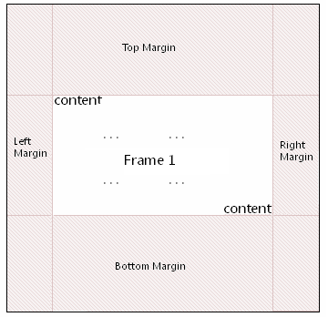

This height is expressed in pixels.

If this element is omitted, then no top or bottom margin shall be used for this frame.

[Example: Consider a document that has a [frame](frame.docx), where the margin height has been specified and is represented as the following WordprocessingML:

<w:[frame](frame.docx)>

<w:marH w:val="594"/>

</w:[frame](frame.docx)>

The marH element has a val attribute value of 594, which specifies that this [frame](frame.docx) has a top and bottom margin value of 594 pixels, resulting in 594 pixels of space [between](between.docx) the content and the top and bottom margins of the frame. end example]

|  |
| --- |
| Parent Elements |
| [frame](frame.docx) (§) |

|  |  |
| --- | --- |
| Attributes | Description |
| val (Measurement in Pixels) | Specifies a value whose contents shall contain a positive whole number, whose contents consist of a positive measurement in pixels.  The contents of this measurement shall be interpreted based on the context of the parent [XML](XML.docx) element.  [Example: Consider an attribute value of 960 whose [type](type.docx) is [ST_PixelsMeasure](ST_PixelsMeasure.docx). This attribute value specifies a value of 960 pixels. end example]  The possible values for this attribute are defined by the [ST_PixelsMeasure](ST_PixelsMeasure.docx) simple [type](type.docx) (§). |

The following [XML](XML.docx) Schema fragment defines the contents of this element:

<complexType [name](name.docx)="CT_PixelsMeasure">

<attribute [name](name.docx)="val" [type](type.docx)="[ST_PixelsMeasure](ST_PixelsMeasure.docx)" use="required"/>

</complexType>