#### mirrorMargins (Mirror Page Margins)

This element specifies that the left and right margins defined in the section properties shall be swapped on facing pages.

[Guidance: This setting is generally used when printing on both sides of pages and binding them like a book. end guidance]

[Example: Consider a graphical representation (below) of a three page WordprocessingML document with a left margin of 1" and a right margin of 2".

If the mirrorMargins element is present in the document settings with its val attribute equal to true, as follows:

<w:mirrorMargins w:val="true" />

The resulting pages will have mirrored margins as follows (un this representation, the gray rectangles representing the text extents on each page):

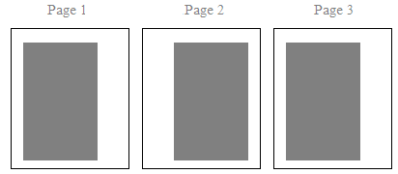

end example]

|  |
| --- |
| Parent Elements |
| settings (§) |

|  |  |
| --- | --- |
| Attributes | Description |
| val (On/Off Value) | Specifies a binary value for the property defined by the parent [XML](XML.docx) element.  A value of on, 1, or true specifies that the property shall be explicitly applied. This is the default value for this attribute, and is implied when the parent element is present, but this attribute is omitted.  A value of off, 0, or false specifies that the property shall be explicitly turned off.  [Example: For example, consider the following on/off property:  <w:… w:val="off"/>  The val attribute explicitly declares that the property is turned off. end example]  The possible values for this attribute are defined by the [ST_OnOff](ST_OnOff.docx) simple [type](type.docx) (§). |

The following [XML](XML.docx) Schema fragment defines the contents of this element:

<complexType [name](name.docx)="CT_OnOff">

<attribute [name](name.docx)="val" [type](type.docx)="[ST_OnOff](ST_OnOff.docx)"/>

</complexType>