#### mwSmallCaps (Emulate Word 5.x for the Macintosh Small Caps Formatting)

This element specifies that applications shall emulate the [behavior](behavior.docx) of a previously existing word processing application (Microsoft Word 5.x for the Macintosh) when determining the resulting formatting when the [smallCaps](smallCaps.docx) element (§) is applied to runs of text within this WordprocessingML document. This emulation typically results in small [caps](caps.docx) which are smaller than typical small [caps](caps.docx) at most font sizes.

[Guidance: To faithfully replicate this [behavior](behavior.docx), applications must imitate the [behavior](behavior.docx) of that application, which involves many possible [behaviors](behaviors.docx) and cannot be faithfully placed into narrative for this Office Open [XML](XML.docx) Standard. If applications wish to match this [behavior](behavior.docx), they must utilize and duplicate the output of those applications. It is recommended that applications not intentionally replicate this [behavior](behavior.docx) as it was deprecated due to issues with its output, and is maintained only for compatibility with existing documents from that application. end guidance]

Typically, applications shall not perform this compatibility. This element, when present with a val attribute value of true (or equivalent), specifies that applications shall attempt to mimic that existing word processing application in this regard.

[Example: Consider a WordprocessingML document with small [caps](caps.docx) on its text contents.

If this compatibility setting is turned on:

<w:[compat](compat.docx)>  
 <w:mwSmallCaps />  
</w:[compat](compat.docx)>

Then applications should mimic the [behavior](behavior.docx) of Microsoft Word 5.x for the Macintosh when determining the formatting for small [caps](caps.docx) of characters which specify this formatting, as needed.

As an example of the typical differences, the output of a normal small [caps](caps.docx) implementation (in black) and one intended to replicate Word 5.x for the Macintosh (in red) are displayed below for several font sizes:

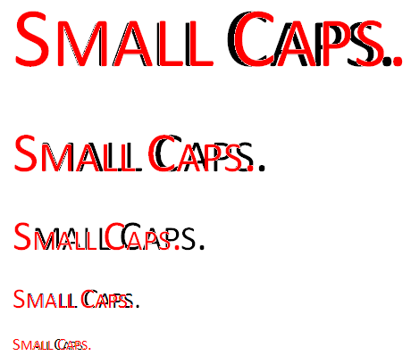

end example]

|  |
| --- |
| Parent Elements |
| [compat](compat.docx) (§) |

|  |  |
| --- | --- |
| Attributes | Description |
| val (On/Off Value) | Specifies a binary value for the property defined by the parent [XML](XML.docx) element.  A value of on, 1, or true specifies that the property shall be explicitly applied. This is the default value for this attribute, and is implied when the parent element is present, but this attribute is omitted.  A value of off, 0, or false specifies that the property shall be explicitly turned off.  [Example: For example, consider the following on/off property:  <w:… w:val="off"/>  The val attribute explicitly declares that the property is turned off. end example]  The possible values for this attribute are defined by the [ST_OnOff](ST_OnOff.docx) simple [type](type.docx) (§). |

The following [XML](XML.docx) Schema fragment defines the contents of this element:

<complexType [name](name.docx)="CT_OnOff">

<attribute [name](name.docx)="val" [type](type.docx)="[ST_OnOff](ST_OnOff.docx)"/>

</complexType>