#### [name](name.docx) (Frame Name)

This element specifies the name of a single [frame](frame.docx) within a [frameset](frameset.docx) document. This property is analogous to the name attribute on the [frame](frame.docx) element in HTML.

[Note: The name of a [frame](frame.docx) may be used in web pages that reference a [frame](frame.docx) via targeted links, etc. end note]

If this element is omitted, then the current [frame](frame.docx) shall have no name associated with it.

[Example: Consider a WordprocessingML document which serves as the [frameset](frameset.docx) container for a [frameset](frameset.docx) consisting of the following three frames:

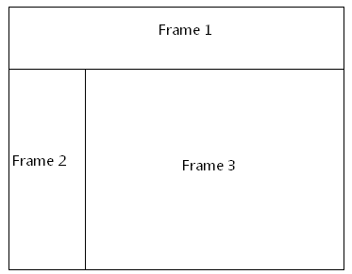

The [frameset](frameset.docx) properties for this document are specified by the following WordprocessingML within the web page settings:

<w:[frameset](frameset.docx)>

…

<w:[frame](frame.docx)>  
 <w:name w:val="Frame 1" />

</w:[frame](frame.docx)>

<w:[frameset](frameset.docx)>

…  
 <w:[frame](frame.docx)>  
 <w:name w:val="Frame 2" />  
 </w:[frame](frame.docx)>  
 <w:[frame](frame.docx)>  
 <w:name w:val="Frame 3" />  
 </w:[frame](frame.docx)>

</w:[frameset](frameset.docx)>

</w:[frameset](frameset.docx)>

The name element specifies the name for each [frame](frame.docx) within this frameset; in this case, the frames have names of Frame 1, Frame 2, and Frame 3 respectively. end example]

|  |
| --- |
| Parent Elements |
| [frame](frame.docx) (§) |

|  |  |
| --- | --- |
| Attributes | Description |
| val (String Value) | Specifies that its contents will contain a string.  The contents of this string are interpreted based on the context of the parent [XML](XML.docx) element.  [Example: Consider the following WordprocessingML fragment:  <w:[pPr](pPr.docx)>  <w:[pStyle](pStyle.docx) w:val="heading1" />  </w:[pPr](pPr.docx)>  The value of the val attribute is the ID of the associated paragraph style's styleId.  However, consider the following fragment:  <w:[sdtPr](sdtPr.docx)>  <w:[alias](alias.docx) w:val="SDT Title Example" />  ...  </w:[sdtPr](sdtPr.docx)>  In this case, the decimal number in the val attribute is the [caption](caption.docx) of the parent structured document tag. In each case, the value is interpreted in the context of the parent element. end example]  The possible values for this attribute are defined by the [ST_String](ST_String.docx) simple [type](type.docx) (§). |

The following [XML](XML.docx) Schema fragment defines the contents of this element:

<complexType [name](name.docx)="CT_String">

<attribute [name](name.docx)="val" [type](type.docx)="[ST_String](ST_String.docx)" use="required"/>

</complexType>