#### noExtraLineSpacing (Do Not Center Content on Lines With Exact Line Height)

This element specifies whether an exact line height using the [spacing](spacing.docx) element (§) in the paragraph’s properties, each line shall not be automatically centered within the given amount of line spacing.

Typically, if the exact amount of [spacing](spacing.docx) allotted to a line via the paragraph properties exceeds the amount of space required by that line, then the line of text shall be automatically centered when the text of the document is displayed. This element, when present with a val attribute value of true (or equivalent), specifies thatall additional [spacing](spacing.docx) shall instead be placed below the normal layout of the line of text.

[Example: Consider a WordprocessingML document with a line with an exact height of 32 points:

<w:[p](p.docx)>  
 <w:[pPr](pPr.docx)>  
 <w:[spacing](spacing.docx) w:line="640" w:lineRule="exact" />  
 </w:[pPr](pPr.docx)>  
 <w:[r](r.docx)>  
 <w:[t](t.docx)>This is text on a line that's exactly 32 points high.</w:[t](t.docx)>  
 </w:[r](r.docx)>  
</w:[p](p.docx)>

The default presentation would have the resulting text centered on that line:

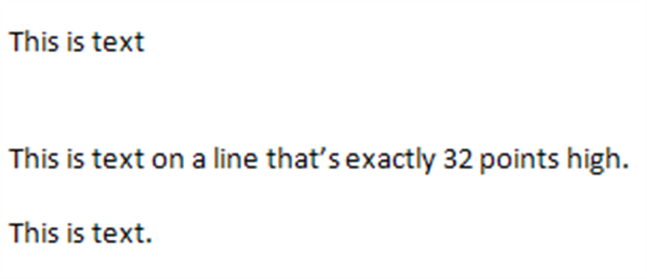

However, if this compatibility setting is turned on:

<w:[compat](compat.docx)>  
 <w:noExtraLineSpacing />  
</w:[compat](compat.docx)>

Then all line [spacing](spacing.docx) is added after the text, resulting in the following output:

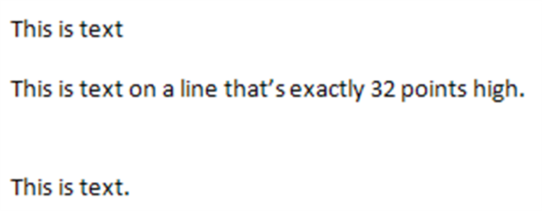

end example]

|  |
| --- |
| Parent Elements |
| [compat](compat.docx) (§) |

|  |  |
| --- | --- |
| Attributes | Description |
| val (On/Off Value) | Specifies a binary value for the property defined by the parent [XML](XML.docx) element.  A value of on, 1, or true specifies that the property shall be explicitly applied. This is the default value for this attribute, and is implied when the parent element is present, but this attribute is omitted.  A value of off, 0, or false specifies that the property shall be explicitly turned off.  [Example: For example, consider the following on/off property:  <w:… w:val="off"/>  The val attribute explicitly declares that the property is turned off. end example]  The possible values for this attribute are defined by the [ST_OnOff](ST_OnOff.docx) simple [type](type.docx) (§). |

The following [XML](XML.docx) Schema fragment defines the contents of this element:

<complexType [name](name.docx)="CT_OnOff">

<attribute [name](name.docx)="val" [type](type.docx)="[ST_OnOff](ST_OnOff.docx)"/>

</complexType>