#### noResizeAllowed (Frame Cannot Be Resized)

This element specifies whether or not the size of the current [frame](frame.docx) shall be modifiable (i.e. whether the [frame](frame.docx) can be resized) when the contents of this document are saved as HTML and displayed in a web browser. When this element is set, the size of the [frame](frame.docx) shall be set to its current values. This property is analogous to the noresize attribute on the [frame](frame.docx) element in HTML.

If this element is omitted, the size of the [frame](frame.docx) shall be modifiable (the [frame](frame.docx) may be resized when it is displayed).

[Example: Consider a WordprocessingML document which serves as the [frameset](frameset.docx) container for a [frameset](frameset.docx) consisting of the following three frames:

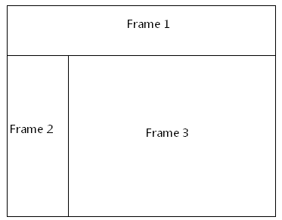

The [frameset](frameset.docx) properties for this document are specified by the following WordprocessingML within the web page settings:

<w:[frameset](frameset.docx)>

…

<w:[frameset](frameset.docx)>

…  
 <w:[frame](frame.docx)>  
 <w:name w:val="Frame 2" />  
 <w:noResizeAllowed w:val="true" />  
 </w:[frame](frame.docx)>  
 …

</w:[frameset](frameset.docx)>

</w:[frameset](frameset.docx)>

The noResizeAllowed element has a val attribute of true, which specifies that the size of the [frame](frame.docx) specified by Frame 2 shall not be modifiable (the two borders which intersect that [frame](frame.docx) cannot be resized). end example]

|  |
| --- |
| Parent Elements |
| [frame](frame.docx) (§) |

|  |  |
| --- | --- |
| Attributes | Description |
| val (On/Off Value) | Specifies a binary value for the property defined by the parent [XML](XML.docx) element.  A value of on, 1, or true specifies that the property shall be explicitly applied. This is the default value for this attribute, and is implied when the parent element is present, but this attribute is omitted.  A value of off, 0, or false specifies that the property shall be explicitly turned off.  [Example: For example, consider the following on/off property:  <w:… w:val="off"/>  The val attribute explicitly declares that the property is turned off. end example]  The possible values for this attribute are defined by the [ST_OnOff](ST_OnOff.docx) simple [type](type.docx) (§). |

The following [XML](XML.docx) Schema fragment defines the contents of this element:

<complexType [name](name.docx)="CT_OnOff">

<attribute [name](name.docx)="val" [type](type.docx)="[ST_OnOff](ST_OnOff.docx)"/>

</complexType>