### numRestart (Footnote and Endnote [Numbering](Numbering.docx) Restart Location)

This element specifies when all automatic [numbering](numbering.docx) for the [footnote](footnote.docx) or [endnote](endnote.docx) reference marks shall be restarted. When restarted, the [next](next.docx) automatically numbered [footnote](footnote.docx) or [endnote](endnote.docx) in the document (each [type](type.docx) is handled independently) shall restart to the specified [numStart](numStart.docx) value (§).

If this element is omitted, then automatic [numbering](numbering.docx) shall not be restarted [between](between.docx) each page or section (a vlaue of continuous).

[Example: Consider the following two page document where the [numbering](numbering.docx) shall be reset after each page to its starting value:

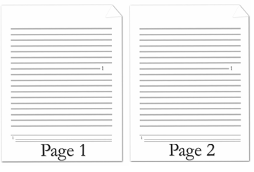

The [footnote](footnote.docx) automatic restarting of the [numbering](numbering.docx) is represented by the following WordprocessingML:

<w:[footnotePr](footnotePr.docx)>

<w:numRestart w:val="eachPage" />

</w:[footnotePr](footnotePr.docx)>

end example]

|  |
| --- |
| Parent Elements |
| [endnotePr](endnotePr.docx) (§); [endnotePr](endnotePr.docx) (§); [footnotePr](footnotePr.docx) (§); [footnotePr](footnotePr.docx) (§) |

|  |  |
| --- | --- |
| Attributes | Description |
| val (Automatic [Numbering](Numbering.docx) Restart Value) | Specifies when the automatic [numbering](numbering.docx) shall be restarted for the current set of [footnotes](footnotes.docx) or endnotes.  [Example: Consider a WordprocessingML document where the [numbering](numbering.docx) for its [endnotes](endnotes.docx) shall be restarted after each section shall be restarted after each page. This setting is represented by the following WordprocessingML:  <w:[footnotePr](footnotePr.docx)>  <w:numRestart w:val="eachSect" />  </w:[footnotePr](footnotePr.docx)>  The val attribute value of eachSect specifies that [numbering](numbering.docx) shal be restarted after each section. end example]  The possible values for this attribute are defined by the [ST_RestartNumber](ST_RestartNumber.docx) simple [type](type.docx) (§). |

The following [XML](XML.docx) Schema fragment defines the contents of this element:

<complexType [name](name.docx)="CT_NumRestart">

<attribute [name](name.docx)="val" [type](type.docx)="[ST_RestartNumber](ST_RestartNumber.docx)" use="required"/>

</complexType>