### numStart (Footnote and Endnote [Numbering](Numbering.docx) Starting Value)

This element specifies the starting number or character for the first automatically numbered [footnotes](footnotes.docx) or [endnote](endnote.docx) in the document, as well as the first automatically numbered [footnotes](footnotes.docx) after each restart point specified by the [numRestart](numRestart.docx) element (§). This value shall be specified in decimal number units, then translated accordingly to the appropriate [numbering](numbering.docx) format.

If this element is omitted, then the starting value shall be 1.

[Example: Consider the following [footnote](footnote.docx) reference with the number [format](format.docx) set to upper case letters and starting character set to D:

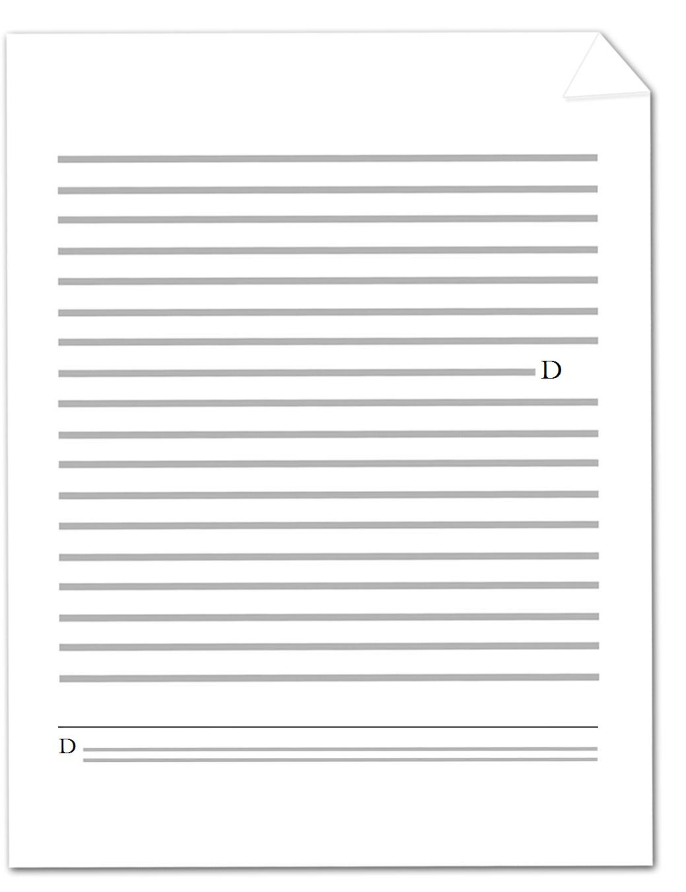

The number [format](format.docx) is specified by the following WordprocessingML:

<w:[footnotePr](footnotePr.docx)>

<w:[numFmt](numFmt.docx) w:val="upperLetter" />

<w:numStart w:val="4" />

</w:[footnotePr](footnotePr.docx)>

Since D is the fourth letter in the alphabet, the starting character is set to 4. end example]

|  |
| --- |
| Parent Elements |
| [endnotePr](endnotePr.docx) (§); [endnotePr](endnotePr.docx) (§); [footnotePr](footnotePr.docx) (§); [footnotePr](footnotePr.docx) (§) |

|  |  |
| --- | --- |
| Attributes | Description |
| val (Decimal Number Value) | Specifies that the contents of this attribute will contain a decimal number.  The contents of this decimal number are interpreted based on the context of the parent [XML](XML.docx) element.  [Example: Consider the following numeric WordprocessingML property of [type](type.docx) [ST_DecimalNumber](ST_DecimalNumber.docx):  <w:… w:val="1512645511" />  The value of the val attribute is a decimal number whose value must be interpreted in the context of the parent element. end example]  The possible values for this attribute are defined by the [ST_DecimalNumber](ST_DecimalNumber.docx) simple [type](type.docx) (§). |

The following [XML](XML.docx) Schema fragment defines the contents of this element:

<complexType [name](name.docx)="CT_DecimalNumber">

<attribute [name](name.docx)="val" [type](type.docx)="[ST_DecimalNumber](ST_DecimalNumber.docx)" use="required"/>

</complexType>