#### pageBreakBefore (Start Paragraph on Next Page)

This element specifies that when rendering this document in a paginated [view](view.docx), the contents of this paragraph are rendered on the [start](start.docx) of a new page in the document.

This means that if the contents of the current paragraph would normally be rendered on the middle of a page in the host document, then the paragraph shall be rendered on a new page as if the paragraph was preceded by a page break in the WordprocessingML contents of the document. This property supersedes any use of the [keepNext](keepNext.docx) property, so that if any paragraph wishes to be on the same page as this paragraph, they will still be separated by a page break.

If this element is omitted on a given paragraph, its value is determined by the setting previously set at any level of the style hierarchy (i.e. that previous setting remains unchanged). If this setting is never specified in the style hierarchy, then this property shall not be applied.

[Example: Consider the following document with three paragraphs:

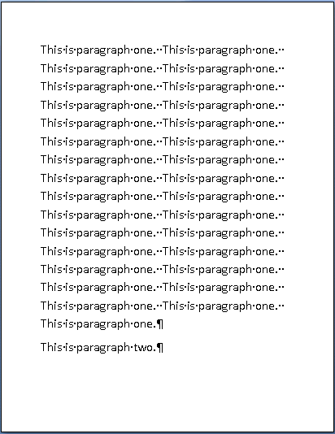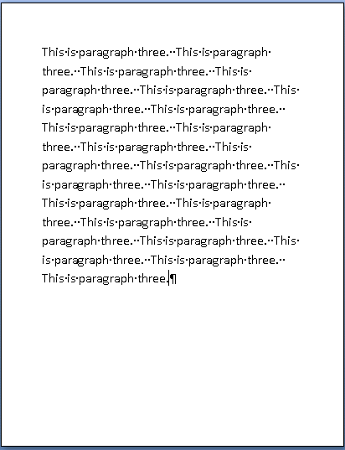

As shown above, the second paragraph is rendered at the bottom of page one. However, a producer can specify that the second paragraph should be displayed at the top of a new page by setting the pageBreakBefore element as follows:

<w:[pPr](pPr.docx)>

<w:pageBreakBefore/>

</w:[pPr](pPr.docx)>

This would ensure that the second paragraph is displayed on a new page:

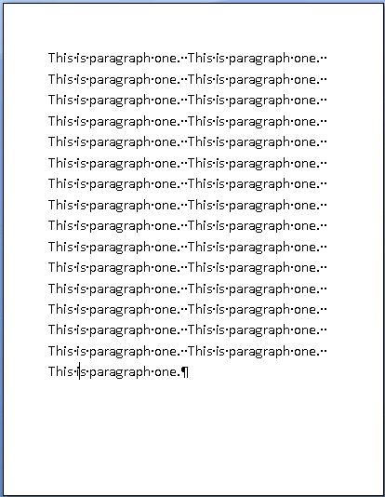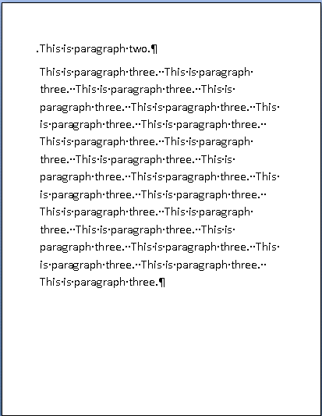

Since the paragraph is specified to [start](start.docx) on a new page, it begins page two even though it could have fit on page one. end example]

|  |
| --- |
| Parent Elements |
| [pPr](pPr.docx) (§); [pPr](pPr.docx) (§); [pPr](pPr.docx) (§); [pPr](pPr.docx) (§); [pPr](pPr.docx) (§); [pPr](pPr.docx) (§) |

|  |  |
| --- | --- |
| Attributes | Description |
| val (On/Off Value) | Specifies a binary value for the property defined by the parent [XML](XML.docx) element.  A value of on, 1, or true specifies that the property shall be explicitly applied. This is the default value for this attribute, and is implied when the parent element is present, but this attribute is omitted.  A value of off, 0, or false specifies that the property shall be explicitly turned off.  [Example: For example, consider the following on/off property:  <w:… w:val="off"/>  The val attribute explicitly declares that the property is turned off. end example]  The possible values for this attribute are defined by the [ST_OnOff](ST_OnOff.docx) simple [type](type.docx) (§). |

The following [XML](XML.docx) Schema fragment defines the contents of this element:

<complexType [name](name.docx)="CT_OnOff">

<attribute [name](name.docx)="val" [type](type.docx)="[ST_OnOff](ST_OnOff.docx)"/>

</complexType>