### [pos](pos.docx) (Footnote Placement)

This element specifies where [footnotes](footnotes.docx) shall be placed on the page when they are referenced by text in the current document.

If this element is present at the section level, then it shall be ignored.

If this element is omitted at the document level, then [footnotes](footnotes.docx) shall be located at the bottom of the current page.

[Example: Consider the following one page document, where the [footnote](footnote.docx) appears beneath the text that it is referencing:

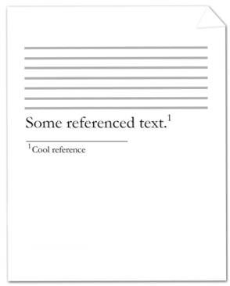

The [footnote](footnote.docx) references the text reading Some reference text. and is represented by the following WordprocessingML:

<w:[p](p.docx)>  
 <w:[r](r.docx)>  
 <w:[t](t.docx)>Some referenced text</w:[t](t.docx)>  
 </w:[r](r.docx)>  
 <w:[r](r.docx)>  
 <w:[rPr](rPr.docx)>  
 <w:[rStyle](rStyle.docx) w:val="FootnoteReference" />  
 </w:[rPr](rPr.docx)>  
 <w:[footnoteReference](footnoteReference.docx) w:[id](id.docx)="2" />  
 </w:[r](r.docx)>  
</w:[p](p.docx)>

Since the [footnote](footnote.docx) location must be beneath the current text, the section properties shall be declared as follows:

<w:settings>  
 …  
 <w:[footnotePr](footnotePr.docx)>  
 <w:[pos](pos.docx) w:val="beneathText" />  
 </w:[footnotePr](footnotePr.docx)>  
 …  
</w:[sectPr](sectPr.docx)>

The [footnote](footnote.docx) references the [footnote](footnote.docx) in the [footnotes](footnotes.docx) part with an [id](id.docx) attribute value equal to 2. Within the section properties of the document, the [position](position.docx) of [footnotes](footnotes.docx) is specified to be beneath the page's text. end example]

|  |
| --- |
| Parent Elements |
| [footnotePr](footnotePr.docx) (§); [footnotePr](footnotePr.docx) (§) |

|  |  |
| --- | --- |
| Attributes | Description |
| val (Footnote Position Type) | Specifies the [position](position.docx) of [footnotes](footnotes.docx) in the document.  [Example: Consider a document in which [footnotes](footnotes.docx) shall be positioned beneath their text. The [footnote](footnote.docx) properties for this document shall be declared as follows:  <w:[sectPr](sectPr.docx)>  <w:[footnotePr](footnotePr.docx)>  <w:[pos](pos.docx) w:val="beneathText" />  </w:[footnotePr](footnotePr.docx)>  … </w:[sectPr](sectPr.docx)>  The val attribute is beneathText, therefore the [position](position.docx) of [footnotes](footnotes.docx) is specified to be beneath the page's text. end example]  The possible values for this attribute are defined by the [ST_FtnPos](ST_FtnPos.docx) simple [type](type.docx) (§). |

The following [XML](XML.docx) Schema fragment defines the contents of this element:

<complexType [name](name.docx)="CT_FtnPos">

<attribute [name](name.docx)="val" [type](type.docx)="[ST_FtnPos](ST_FtnPos.docx)" use="required"/>

</complexType>